Classroom language
TASK 1 Match the sentences and the pictures. Use the useful phrases to talk about your answers:
- Sentence … and picture … match because there’s a … in the picture.
- I think that sentence … and picture … go together.
A. Can I go to the bathroom, please?
B. What’s ‘Katze’ in English? – It’s ‘cat’.
C. I don’t understand this exercise. Can you explain it to me, please?
D. What page are we on? – We’re on page 18.
E. Can I borrow your pen, please? - Of course. Here you go.
F. Is this right / wrong? – Yes, it is. / No, it isn’t. / I’m not sure.
G. Can you help me, please? – Of course. What’s the problem?
H. Thank you! – No problem. You’re welcome.
I. Could you say that again, please?
J. How do you spell „Wednesday“? – It’s W-E-D-N-E-S-D-A-Y.
K. Sorry, I don’t have my homework.
L. Can I close the window, please?
1.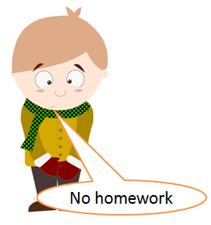 | 2.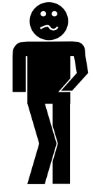 | 3.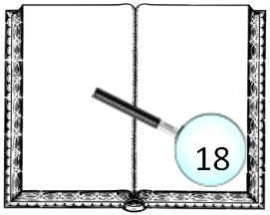 | 4.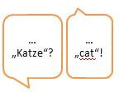
5.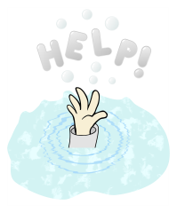 | 6.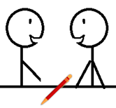 | 7.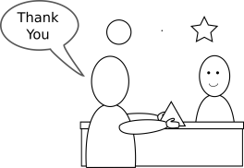 | 8.?
9. 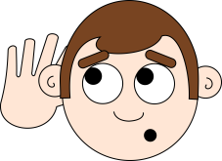 | 10.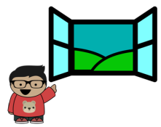 | 11. W-E-D-N-E-S-D-A-Y. | 12.
TASK 2 How do you say these things in English? Underline the expressions in the sentences above.
a) Hier, bitteschön. b) Keine Ursache. Gern geschehen.
b) Wie buchstabiert man …? c) Wie sagt man … auf Deutsch?
d) Kann ich mir dein … ausleihen? e) Ja, natürlich.
TASK 3 Now play the classroom phrases memory game with your group mates. Some useful phrases:
- Whose turn is it? – It’s your / my / Nick’s turn.
- Who’s next?
- I’ve found a match! So now I can try again.
TASK 4 PARTNER A Now practice this classroom dialogue with a partner! Once you can do it without looking at the text, exchange roles! You begin.
YOU say this in English: | YOUR PARTNER says this (help him / her):
Frage deine(n) Mitschüler(in) höflich, ob er/sie dir helfen kann.
 | Yes, of course. What’s the problem?
Sage, dass du die Aufgabe nicht verstehst. Bitte deinen Partner, sie dir zu erklären.
 | You must read the text and answer the questions.
Du versuchst die Aufgabe zu lösen, aber du weißt ein Wort nicht. Frage deinen Partner, was „Fahrrad“ auf Englisch heißt.
 | It’s „bike“.
Frage deinen Partner, wie man „bike“ buchstabiert.
 | It’s b – i – k – e.
Du hast die Aufgabe gelöst. Frage deinen Partner, ob sie richtig ist.
 | Yes, it’s right. But one word is wrong.
Frage, ob du den Radiergummi deines Partners ausleihen darfst.
 | Yes, of course. Here you go.
Bedanke dich für die Hilfe.
 | No problem. You’re welcome!

TASK 4 PARTNER B Now practice this classroom dialogue with a partner! Once you can do it without looking at the text, exchange roles! Your partner begins.
YOU say this in English: | YOUR PARTNER says this (help him / her):
 | Can you help me, please?
Sage, dass du natürlich helfen kannst. Frage, was das Problem ist.
 | I don’t understand the exercise. Can you explain it to me?
Sage, dass er/sie den Text lesen und die Fragen beantworten muss.
 | What’s „Fahrrad“ in English?
Sage, dass es „bike“ heißt.
 | How do you spell „bike“?
Buchstabiere das Wort “bike”.
 | Is this right?
Sage, dass es richtig ist, aber dass ein Wort falsch ist.
 | Can I borrow your rubber, please?
Sage “ja” und “hier, bitte”.
 | Thanks for your help.
Sage „kein Problem“ und „gern geschehen“.

A Can I go to the bathroom, please? |  | B What’s ‘Katze’ in English? – It’s ‘cat’.
C I don’t understand this exercise. Can you explain it to me, please? |  | D What page are we on? - We’re on page 18. | 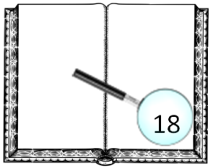
E Can I borrow your pen, please? - Of course. Here you go. |  | F Is this right?  – Yes, it is. /  – No, it isn’t. /  – I’m not sure. | ?
G Can you help me, please? |  | H Thank you! – You’re welcome. | 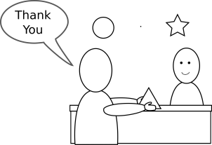
I Could you say that again, please? |  | J How do you spell „Wednesday“? | W-E-D-N-E-S-D-A-Y.  4
K Sorry, I don’t have my homework. |  | L Can I close the window, please? | 