Puzzles 11 – Autumn
VOCABULARY A Dominoes. Verbinde die Dominosteine. Wenn du alles richtig machst, kommst du am Schluss wieder beim ersten Stein heraus.
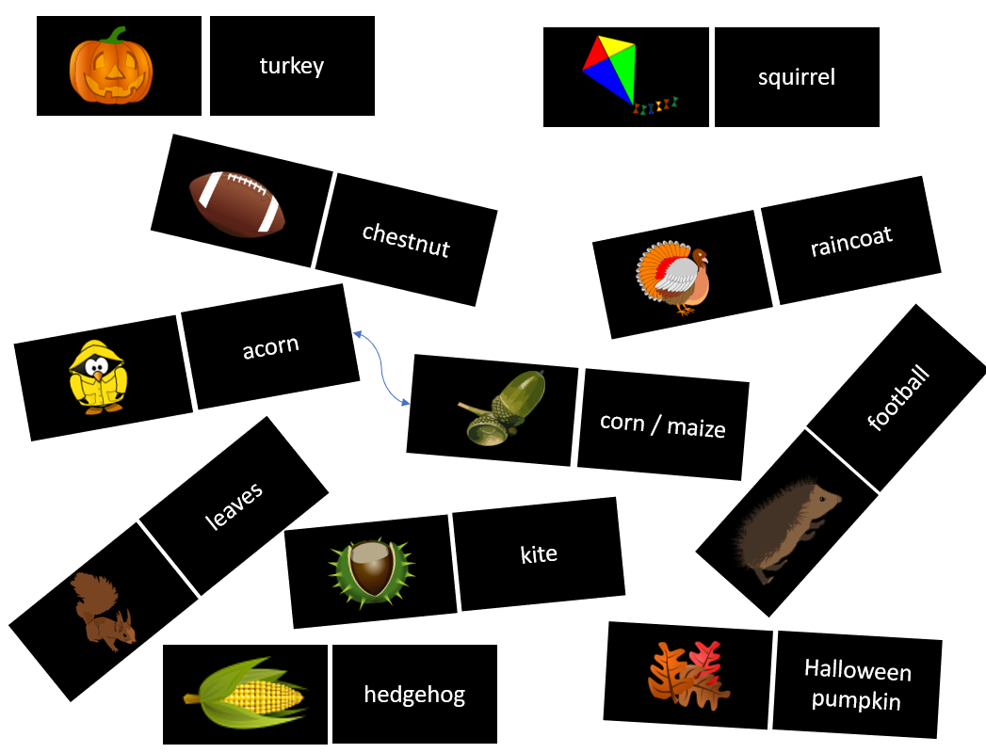
READING Saving a hedgehog. Fill in the words from the box.
play - forget - pick - feed - drink - build - take
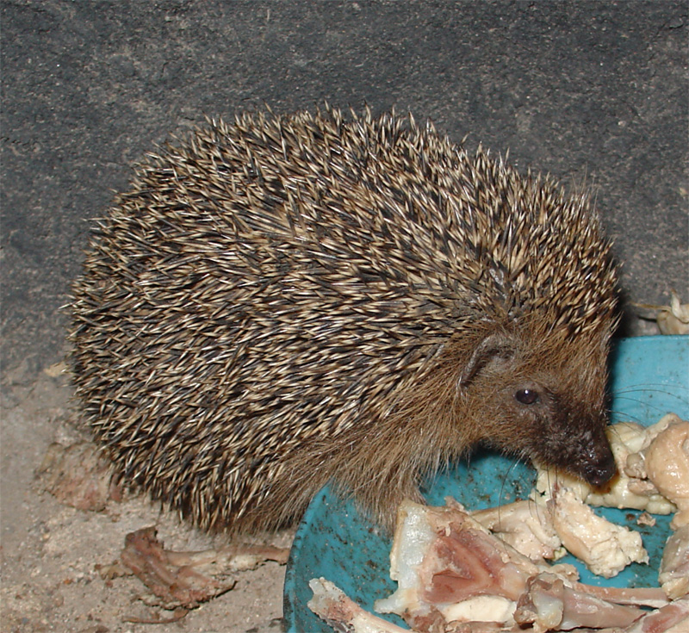
Hedgehogs hibernate, so they need to find a lot of food in autumn to survive winter. If you see a hedgehog still looking for food in winter, it might need help. Here are a few tips:
1 ________________ it: Hedgehogs like cat or dog food. They also need a lot of water. However, they mustn’t ________________ milk - it can make them sick!
2 ________________ a hedgehog house in your garden. A simple wooden box with an entrance tunnel makes a great home for a hedgehog.
3 If the hedgehog looks very weak or ill, ________________ it to the vet!
4 Don’t ________________ that a hedgehog is not a pet. Don’t ________________ with it or ________________it up - it will be scared!

Lösungen
VOCABULARY A In the correct order:
acorn (Eichel) - corn / maize (Mais) - hedgehog (Igel) - football (American Football) - chestnut (Kastanie) - kite (Drachen) - squirrel (Eichhörnchen) - leaves (Blätter) - Halloween pumpkin (Halloween-Kürbis) - turkey (Truthahn) - raincoat (Regenmantel)
READING
1 feed, drink
2 build
3 take
4 forget, play, pick

to hibernate: Winterschlaf halten
Entrance tunnel: Eingangstunnel

