A Controversial Historical Figure

TASK 1 Write the words in the grid. The letters in the yellow boxes form the name of a famous person.

merchant - Caribbean - explore - invade - slave - discover - colony - crew - governor - expedition - Bahamas - map - natives - trade - sail - voyage - equip - spices - route

- The people who work on a ship: the ...
- A group of islands in the Atlantic: the ...
- When two group exchange goods, they ... them.
- In 1939, Germany ...d Poland.
- To travel by ship = to ... | S | A | I | L
- The people who were the first to live in a country = the...
- To find something new = to ... it
- A trip with a certain purpose, e.g. to find new resources
- A person who sells goods: a ...
- A trip or journey
- A person who runs a state government: the ... of California
- Pepper and vanilla are ...
- Neil Armstrong ...d the moon.
- India used to be a British ... (= The British ruled there.)
o) They ...ped us with clothes, food and tents for the trip.
p) A ... of London shows you what the city looks like.
q) Cuba and Haiti are in the ...
r) a way or course to a certain destination
s) a person who is forced to work for somebody else: a ...

TASK 2 What do you know about the person from TASK 1? Write down three pieces of information that come to your mind; then compare with a partner.

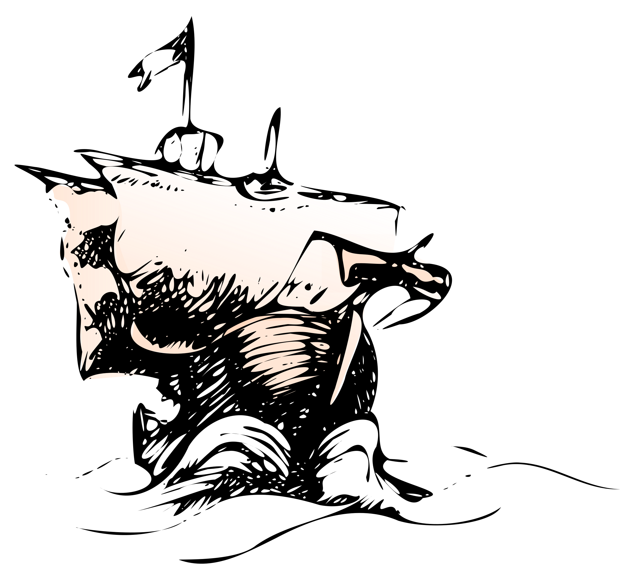 | ________________________________________________________________________________________________________________________________________________________________________________________________________________________________________________________________________________________________________________________________
T
ASK 3 Would you say these statements are true? Explain your choice.
- Columbus discovered America.  - Columbus wanted to prove that the Earth was a globe.  - When Columbus reached the Bahamas, he thought that he had landed in India.  - Columbus was a great sailor.  - During his lifetime, almost everybody thought Columbus was a great man. | 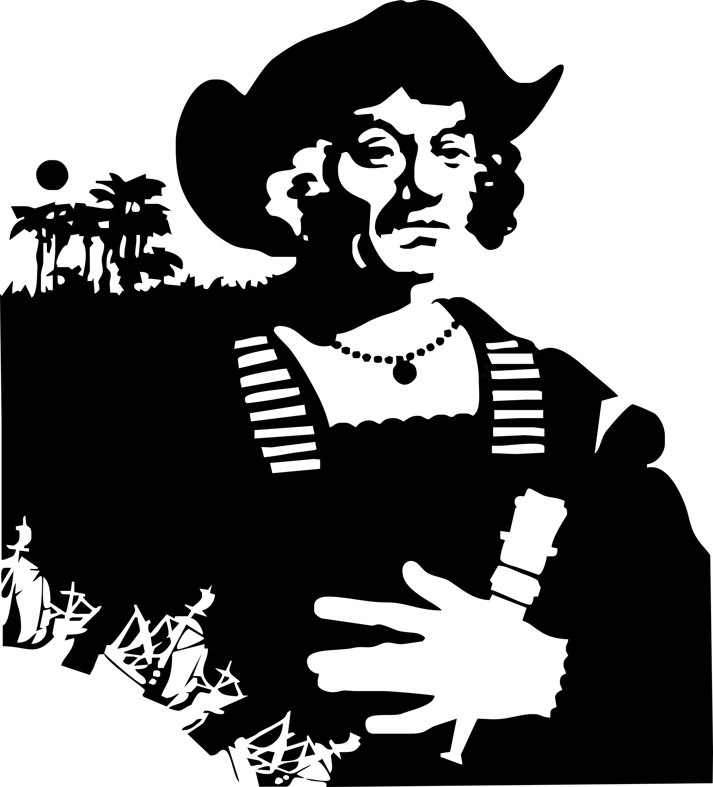

TASK 4 Watch the video “Christopher Columbus - What really happened” (https://www.youtube.com/watch?v=aF_unlvjccA). What does it say about the statements from TASK 2?

TASK 5 - BEFORE THE FIRST JOURNEY Now watch the first part of the video (0:00-1:27) again and tick the right answers.

- After moving to Portugal, Columbus became a ...
□ | soldier. | □ | merchant. | □ | scholar.
- How did the Portuguese benefit from discovering a new route to India?
□ | They were able to colonize India. | □ | They gained access to valuable trade goods. | □ | They were able to colonize Africa.
- During that time, a group of European scholars thought that the Earth ...
□ | was bigger than people had thought before. | □ | was a globe. | □ | was smaller than people had thought before.
- In how many countries did Columbus try to get funding for his expedition?
□ | three | □ | four | □ | five

TASK 6 - THE FIRST JOURNEY Now watch the second part of the video (1:28-2:45). Decide which statements are true and correct those that are wrong.
A) The trip from Palos in Spain to the Bahamas took five weeks.
- The natives called themselves the Taino.
- Columbus forced the Indians to give him gold.
- Columbus left some men on Hispaniola because one of his ships was broken.
- Back in Spain, Columbus was celebrated.

TASK 7 - THE SECOND JOURNEY Now watch 2:45-4:12 and put the events in the right order.

 | Columbus finds a gold quarry. | 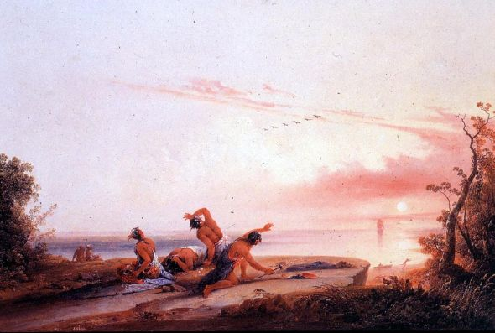  Coming of the White Man (1850):  Painting by Joshua Shaw
 | Columbus kills three natives as a warning to the others.
 | The colonists on Hispaniola are killed by a local chief.
 | Columbus ships natives to Spain to sell them as slaves.
 | A large number of the natives dies.
2 | Columbus returns to Hispaniola.
 | Columbus lies to the King and Queen of Spain.
 | The fighting between the invaders and the natives begins.
 | Columbus makes the natives pay tributes.
 | The remaining natives rebel against Columbus’s rule.
TASK 8 - THE THIRD AND FOURTH JOURNEY Now watch the last part of the video and answer the questions in your own words.
- Why did Columbus sail back to Spain?
- What was the situation on Hispaniola when Columbus returned?
- What happened to the Columbus brothers after an investigator was sent to Hispaniola?
- What was Columbus not allowed to do on his fourth voyage?
- According to the video, why is Columbus important?
TASK 9 Read this short news article. Tick the headline that fits best.

□ | - Controversial Statement by Senator McCaskill
□ | - St Louis Residents Discuss if Columbus Statue should be Removed
□ | - Local Activists Demand Destruction of Ancient Statue

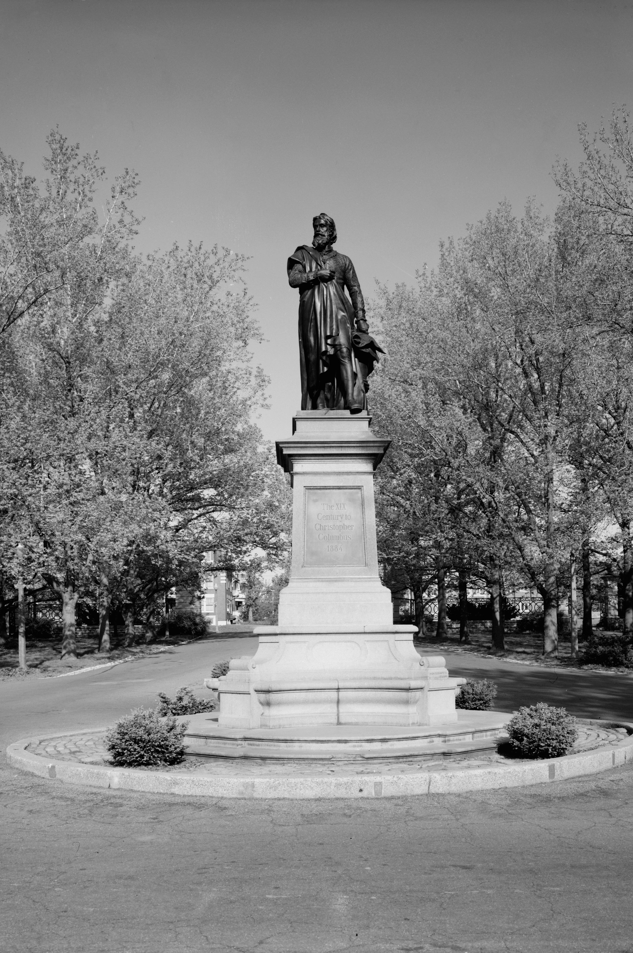 | Since 1886, Ferdinand von Miller’s Columbus Statue has been a landmark of Tower Grove Park in St. Louis, Missouri. But now a local activist group demands the removal of the controversial object that has lately been a target of vandalism . They argue that it glorifies the killing and enslavement of the Taino Indians at Columbus’s hands and the centuries of oppression of native peoples that were to follow.  Others, however, want the statue to stay. Senator Clair McCaskill expresses her understanding for the group’s concerns but also sees the removal of historical statues as an attempt to “wipe out history”. She believes that controversial monuments can help people learn about the past and avoid making the same mistakes again.  A commission has now been formed to discuss whether the statue should be removed. It includes members of the Native American and Italian communities as well as experts from the Missouri Historical Society. Park officials stress that Tower Grove Park will continue to be a welcoming place for people of all ethnic backgrounds.

TASK 10 True or wrong? | true | wrong
- The Tower Grove Park Columbus statue is over 130 years old. | □ | □
- The activist group wants to install a monument for the Taino. | □ | □
- McCaskill sees no problem with the statue. | □ | □
- McCaskill thinks that monuments have an educational function. | □ | □
- There are representatives of different groups in the commission. | □ | □
- Park officials don’t want people to feel excluded from the park. | □ | □

TASK 11 Write a comment in reply to the article. Use the useful phrases below. Ideas:
- In your opinion, why should the statue (not) be removed? Give reasons.
- Is there a compromise that both parties could live with?

Giving an opinion | Showing cause and effect
In my opinion / view, ...  Personally, I believe / think / feel that ...  It seems to me that ... / The way I see it, ... | As a result, ... / Consequently, ... /  Therefore, ... / That’s why ...  ..., which is why ...
Structuring | Giving reasons
Firstly ... secondly ... lastly ...  In addition, / Furthermore, / Besides, ...  In short, / To sum up, / All in all, / In conclusion, ... | because / as  because of / due to
Balancing | Giving examples
On the one hand ...; on the other hand ...  It may be true that ...; however, ...  While ..., you shouldn’t forget that ...  Although there are many arguments against..., I’d still say that ... | For example, ... / For instance, ... / To illustrate, ...

ENGLISH-GERMAN VOCABULARY LIST
(to) attempt  Bahamas  Caribbean  chief  colony  concern  controversial  crew  to discover  to equip  to exclude  expedition  to explore  - explorer  globe  governor  Hispaniola  to invade  - invader  - invasion  to investigate  - investigator  map  merchant  native  official  oppression  to prove  quarry  to rebel against  to remove  - removal  representative  resident  route  to sail  - sailor  scholar  slave  - enslavement  - slavery  spice  Taino  to trade  - trade good  tribute  vandalism  voyage | versuchen; Versuch  die Bahamas  die Karibik  hier: Häuptling  Kolonie  Sorge, Bedenken  umstritten, kontrovers  Mannschaft  entdecken  ausrüsten  ausschließen  Expedition  erforschen  Forscher, Entdecker  Kugel  Gouverneur  Insel, auf der die Dominikanische Republik und Kuba liegen  einfallen, einmarschieren  Eindringling, Angreifer, Invasor  Invasion  untersuchen, ermitteln  Ermittler  Karte  Kaufmann  einheimisch; Einheimische(r)  offiziell; Angestellte(r)  Unterdrückung  beweisen  Steinbruch, Bergwerk  gegen etw. rebellieren  entfernen  das Entfernen  Vertreter  Anwohner, Bewohner  Route  segeln  Seemann  Wissenschaftler, Gelehrter  Sklave  Versklavung  Sklaverei  Gewürz  ein Indianervolk, das auf den karibischen Inseln lebte  handeln  Handelsgut  Abgabe  Vandalismus  Reise

SOLUTIONS

TASK 1 a) crew (Mannschaft), b) Bahamas, c) trade (handeln / der Handel), d) invade (einfallen, einmarschieren), e) sail (segeln / Segel), f) natives (Einheimische), g) discover (entdecken), h) expedition (Expedition, Forschungsreise), i) merchant (Händler), j) voyage (Reise), k) governor (Gouverneur, Statthalter), l) spices (Gewürze), m) explore (erforschen), n) colony (Kolonie), o) equip (ausrüsten), p) map (Karte), q) Caribbean (Karibik), r) route (Route, Wegstrecke), s) slave (Sklave)

TASK 2 Individual solution. Examples: He was an Italian explorer; he travelled to America in 1492; he is world-famous today...

TASK 3 Individual solution.

TASK 4 A) Columbus discovered America. - Only true from a European perspective, as many people were already living there when Columbus arrived.
B) Columbus wanted to prove that the Earth was a globe. - Not true; it only says that Columbus believed in the “Small World” theory and therefore thought he could reach Asia by ship. His main motivation was to get rich.
C) When Columbus reached the Bahamas, he thought that he had landed in India. - Yes - and no: He believed that he was somewhere near Japan. However, at the time it was common to refer to all of Asia as “India”.
D) Columbus was a great sailor.- The video agrees: Columbus managed to find his way back to Hispaniola.
E)During his lifetime, almost everybody thought Columbus was a great man. - No: He was criticized for his treatment of both natives and Spaniards in his new colony. He was even arrested for it.
TASK 5 - BEFORE THE FIRST JOURNEY Now watch the first part of the video (0:00-1:27) again and tick the right answers.

- After moving to Portugal, Columbus became a ...
 | soldier. | x | merchant. |  | scholar.
- How did the Portuguese benefit from discovering a new route to India?
 | They were able to colonize India. | x | They gained access to valuable trade goods. |  | They were able to colonize Africa.
- During that time, a group of European scholars thought that the Earth ...
 | was bigger than people had thought before. |  | was a globe. | x | was smaller than people had thought before.
- In how many countries did Columbus try to get funding for his expedition?
 | three | x | four |  | five

TASK 6 - THE FIRST JOURNEY A) The trip from Palos in Spain to the Bahamas took five weeks. - wrong; the trip from the Canary Islands to the Bahamas took five weeks; we don’t know how long it took Columbus to travel there from Palos.
- The natives called themselves the Taino. - true
- Columbus forced the Indians to give him gold. - wrong; at least in this section of the video, it only says that they traded goods.
- Columbus left some men on Hispaniola because one of his ships was broken. - wrong; they video says that it was their purpose to found a colony.
- Back in Spain, Columbus was celebrated. - true

TASK 7 - THE SECOND JOURNEY
3 | Columbus finds a gold quarry.
5 | Columbus kills three natives as a warning to the others.
1 | The colonists on Hispaniola are killed by a local chief.
7 | Columbus ships natives to Spain to sell them as slaves.
10 | A large number of the natives dies.
2 | Columbus returns to Hispaniola.
6 | Columbus lies to the King and Queen of Spain.
4 | The fighting between the invaders and the natives begins.
9 | Columbus makes the natives pay tributes.
8 | The remaining natives rebel against Columbus’s rule.
TASK 8 - THE THIRD AND FOURTH JOURNEY
- Why did Columbus sail back to Spain? - He had to answer to Isabella and Ferdinand ,who had heard about the problems in the new colony.
- What was the situation on Hispaniola when Columbus returned? - It was worse than before, as a rebellion had started among the Spanish settlers.
- What happened to the Columbus brothers after an investigator was sent to Hispaniola? - They were found guilty of crimes against both Spanish and native inhabitants of Hispanola and taken to Spain in chains.
- What was Columbus not allowed to do on his fourth voyage? - He didn’t get permission to return to Hispaniola.
- According to the video, why is Columbus important? - He was the first to establish a link between the Old and New World.

TASK 9 Read this short news article. Tick the headline that fits best.

□ | - Controversial Statement by Senator McCaskill
☑ | - St Louis Residents Discuss if Columbus Statue should be Removed
□ | - Local Activists Demand Destruction of Ancient Statue

- Is wrong because the senator’s statement is not the topic of the article. C) is wrong because it does not say anywhere that the activists want the statue to be destroyed; they just want it to be removed.

TASK 10 True or wrong? | true | wrong
- The Tower Grove Park Columbus statue is over 130 years old. (-> It has been in the park since 1886) | ☑ | □
- The activist group wants to install a monument for the Taino. (-> That might be the case, but it is not mentioned anywhere) | □ | ☑
- McCaskill sees no problem with the statue. (-> She says she understands the group’s concerns, which means that she recognizes the problem.) | □ | ☑
- McCaskill thinks that monuments have an educational function. (-> She says that it “helps people learn”) | ☑ | □
- There are representatives of different groups in the commission. (-> e.g. Native Americans, Italian Americans, Historians) | ☑ | □
- Park officials don’t want people to feel excluded from the park. (-> They want it to be “welcoming” for everybody.) | ☑ | □

TASK 11 - Individual solution

