Kids View: Edinburgh

TASK 1 Have you ever visited a big city? What did you do there? Tell the class. Examples:

Famous sights    We went to Paris last year and saw the Eiffel Tower. | museums  I’ve been to the Naturmuseum Senckenberg in Frankfurt. It was really fun because they have lots of dinosaur skeletons!   | USEFUL PHRASES  - I’ve been to ...  - I’ve visited ...  - I saw ... there.  - I liked / didn’t like it because ...  - It was fun / interesting / boring / ...
activities
We went on a bus tour in London. It was really interesting.


TASK 2 Watch the video „Kids View - What to do in Edinburgh (Insider tips from local kids)“ on youtube without sound. What can you see? Write down the most interesting things.

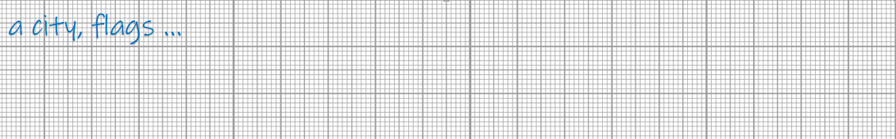

TASK 3 Now watch the video again, this time with sound. What do the kids say about these tourist attractions? Match the attractions and the sentences!

1. Edinburgh Castle |  | a. They’ve got pandas and penguins.
2. Dynamic Earth |  | b. They’ve got lots of mirrors.
3. Edinburgh Zoo |  | c. Edinburgh is most famous for this sight.
4. Camera Obscura |  | d. You can walk up and enjoy an amazing view.
5. National Museum |  | e. It teaches you about Edinburgh’s history in a scary way.
6. Arthur’s Seat |  | f. It’s great for tourists who don’t know a lot about the city.
7. Edinburgh Dungeon |  | g. You can see toys that your parents might have played with.
8. Museum of Childhood |  | h. You can learn about the past and the present.
9. Sightseeing Buses |  | i. You can learn about volcanoes and icebergs.
10. Princes Street |  | j. There are lots of shops and places to eat.

- The first boy’s name is ... | ☐ Dennis | ☐ Duncan | ☐ David
- The castle is on top of a(n) ... volcano. | ☐ active | ☐ new | ☐ old
- In the Gardens, you can see the ... Monument. | ☐ Scott | ☐ Hott | ☐ Pott
- The ... are new at Edinburgh Zoo. | ☐ pandas | ☐ penguins | ☐ parrots
- On a ghost tour, you learn about Edinburgh’s ... | ☐ past | ☐ present | ☐ future
- Arthur’s Seat is next to ... | ☐ a volcano | ☐ a palace | ☐ a place to eat
- The boy thinks that their parents played with ... stuff. | ☐ interesting | ☐ boring | ☐ fun
- Edinburgh is a great place for adults ... children. | ☐ with | ☐ and | ☐ without
TASK 4 Watch the video again and tick the right answers.
TASK 5 Imagine you’re an exchange student in Edinburgh. It’s Saturday, and your host family wants to show you the city. Your exchange partner asks you what you’d like to do.
Make a dialogue with a partner. Use the useful phrases from the box.

Exchange partner | Making suggestions | Explaining
Exchange partner | ● Would you like to see...?  ● I’ve got another idea: Let’s go to ...  ● Why don’t we visit ...?  ● There’s another place we could go to. It’s ... | ● It’s a ...  ● They have lots of ... / They don’t have any ...  ● You can see ... there. / You can learn a lot about ...  ● I think it’s really interesting / fun / amazing because ...  ● I think it’s OK / a bit boring because ...
Exchange student | Asking questions | You like an idea: | You don’t like an idea:
Exchange student | ● What can you do / see there?  ● Is it fun?  ● Do they have ... there?  ● Is there a (zoo) in Edinburgh? | ● That sounds great.  ● I’d love to go to ...  ● OK, let’s do that! | ● Sorry, I don’t really like ...  ● I’m not very interested in (history).  ● I’d rather do something else. Maybe we can ...

You can start like this:
Hey Tom, let’s do something fun at the weekend.

Sure, what would you like to do?

Well, there are lots of interesting places in Edinburgh. For example, we could visit ...

TASK 6 - POSTER PROJECT
Make your own “Kids View“ presentation about fun sights in your hometown or area. Work in groups of three or four.
- Decide on the best sights (two per person). | “We must talk about the ‘Kölner Dom’. It’s the most famous sight.“  “I think the zoo is really fun. So we should say something about it, too.“
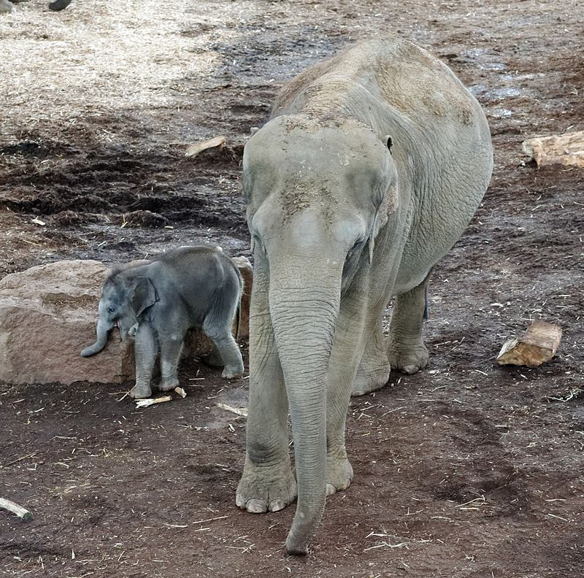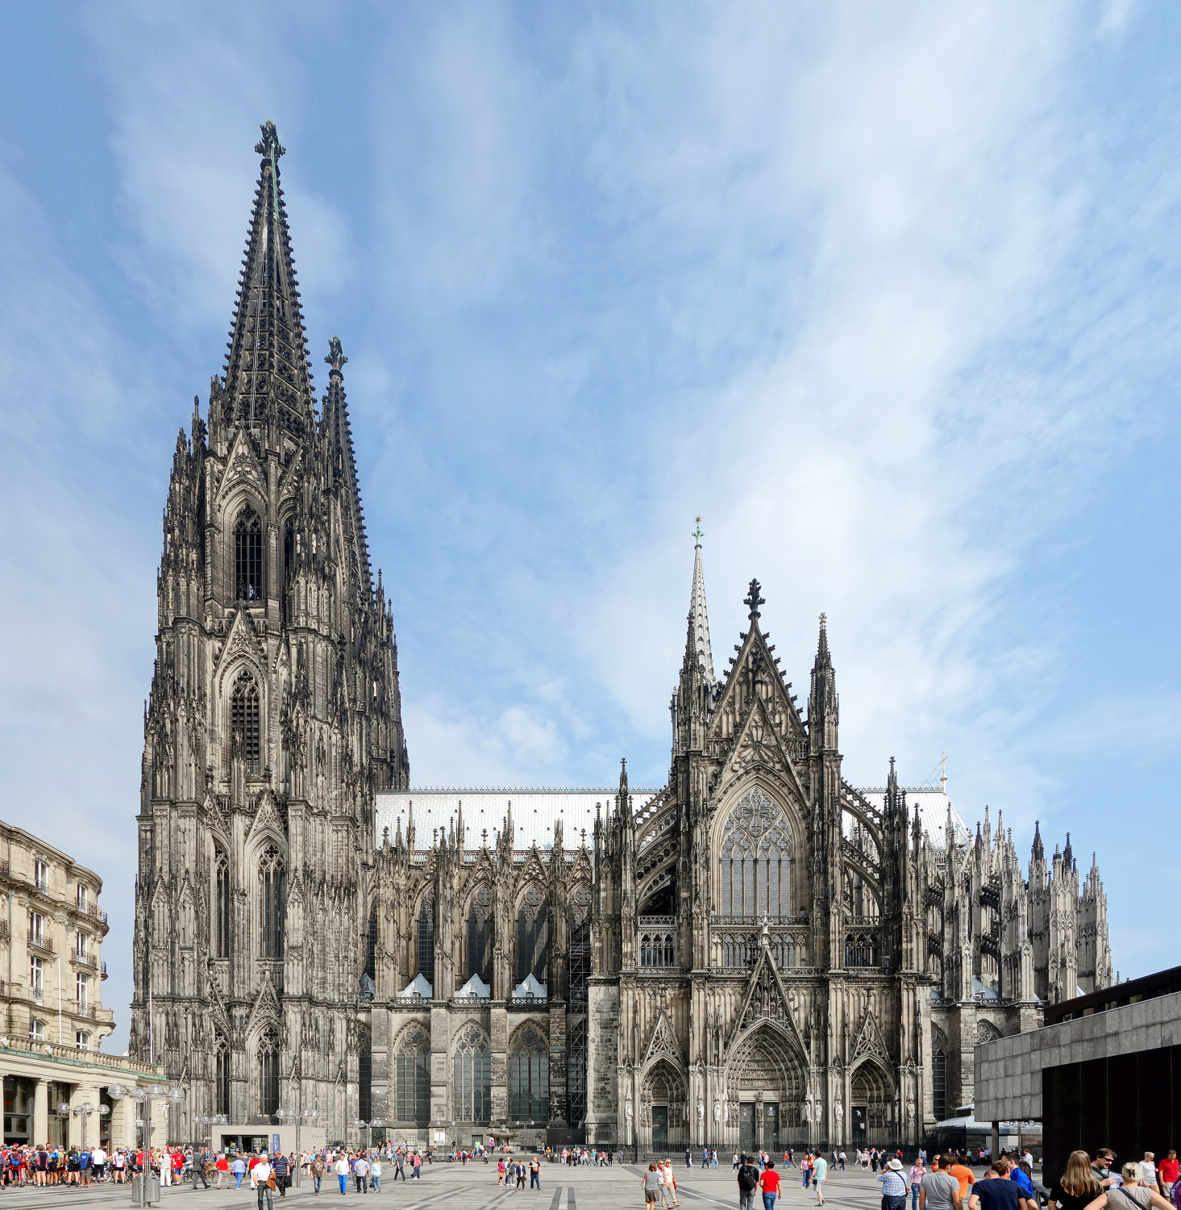 | - Pick some nice pictures of the sights.  You can use your own images or you find pictures on the internet (for example on Wikimedia Commons).
- Collect some information about the sights.  Say what you can do or see there and why you like it. Use books, brochures or the internet for information. | “You can see more than 10,000 animals at Cologne Zoo. I like the rainforest hall and the elephant park best. Also, there are two big playgrounds.“

- Stick the pictures on a poster and present it to the class.

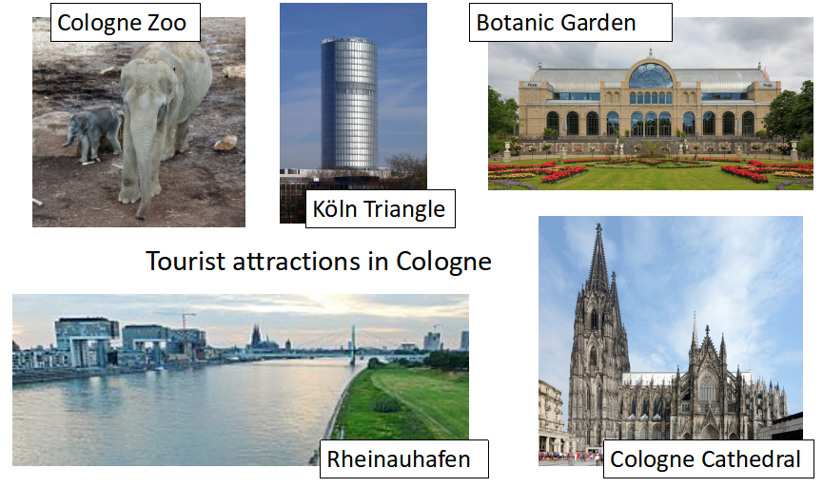

Vocabulary list

amazing erstaunlich; toll
annual event jährlich wiederkehrende Veranstaltung
to blow up in die Luft gehen
capital Hauptstadt
castle Schloss
childhood Kindheit
chilly kühl, frisch (Wetter)
dungeon Kerker, Verlies
- Edinburgh Dungeon Gruselkabinett über die Geschichte von Edinburgh
exchange student Austauschstudent
to explain sth. to sb. jm. etw. erklären
famous for berühmt für
to give sb. frights jm. Angst machen
ghost Geist
history Geschichte
host family Gastfamilie
iceberg Eisberg
to be interested in sich interessieren für
local örtlich, einheimisch
mirror Spiegel
monument Monument, Denkmal
on top of auf
palace Palast
- Hollyrood Palace Schloss der britischen Königin in Edinburgh
past Vergangenheit
to point out zeigen, hinweisen auf
present Gegenwart
rather lieber
to recommend empfehlen
seat Sitz
- Arthur’s Seat Berg in Edinburgh
sight Sehenswürdigkeit
sightseeing Besichtigung
suggestion Vorschlag
to teach sb. about sth. jm. etw. beibringen
tourist attraction Touristenattraktion
toy Spielzeug
view Aussicht
volcano Vulkan
wonky schief, wackelig

Solutions

TASK 1 - own solution

TASK 2 - Examples: a castle, cannons, a park, a museum about the earth / nature / science, zoo animals ...

TASK 3 - 1c, 2i, 3a, 4b, 5h, 6d, 7e, 8g, 9f, 10j

TASK 4 - Watch the video again and tick the right answers.
- The first boy’s name is ... | ☐ Dennis | ☐ Duncan | ☐ David
- The castle is on top of a(n) ... volcano. | ☐ active | ☐ new | ☐ old
- In the Gardens, you can see the ... Monument. | ☐ Scott | ☐ Hott | ☐ Pott
- The ... are new at Edinburgh Zoo. | ☐ pandas | ☐ penguins | ☐ parrots
- On a ghost tour, you learn about Edinburgh’s ... | ☐ past | ☐ present | ☐ future
- Arthur’s Seat is next to ... | ☐ a volcano | ☐ a palace | ☐ a place to eat
- The boy thinks that their parents played with ... stuff. | ☐ interesting | ☐ boring | ☐ fun
- Edinburgh is a great place for adults ... children. | ☐ with | ☐ and | ☐ without

TASKS 5 and 6 - own solution

Bildnachweise
Kölner Zoo Marlar und Moma.
By Michael Kramer - Own work, CC BY-SA 3.0, https://commons.wikimedia.org/w/index.php?curid=58066599

Cologne Cathedrale vue sud.
By Velvet - Own work, CC BY-SA 4.0, https://commons.wikimedia.org/w/index.php?curid=35472522

Cologne (Rhein) Rhine River View:
By Neuwieser - Flight over Cologne, CC BY-SA 2.0, https://commons.wikimedia.org/w/index.php?curid=12358919

Köln Flora:
By © CEphoto, Uwe Aranas, CC BY-SA 4.0, https://commons.wikimedia.org/w/index.php?curid=33384615

Köln Triangle in 2008:
By © Raimond Spekking / CC BY-SA 4.0 (via Wikimedia Commons), CC BY-SA 4.0, https://commons.wikimedia.org/w/index.php?curid=3588057

