Discover Scotland!

TASK 1 - CONTENT. Your family is plannig a trip to Scotland. You have found a brochure with some information about activities and places to visit. Match the texts in the brochure (a-g) on the next page and the pictures below (1-6).

1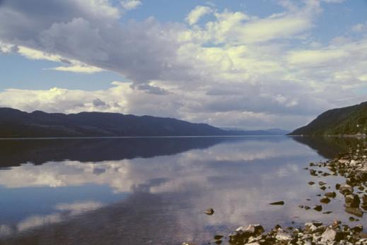  © Rebel yell (→ Wikimedia Commons) | 2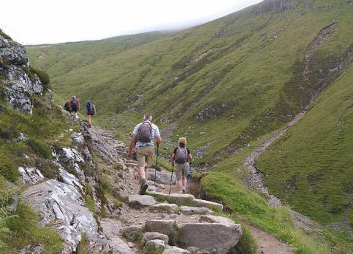  © Ruben de Smet, (→ Wikimedia Commons) | 3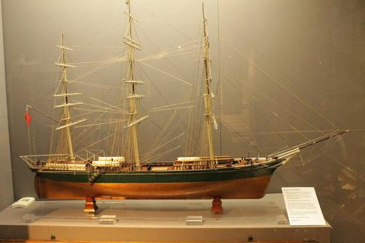  © Stephencdickson (→ Wikimedia Commons)
4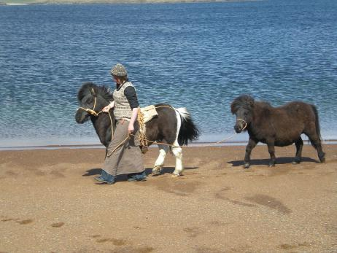  © Roberto Getto (→ Wikimedia Commons ) | 5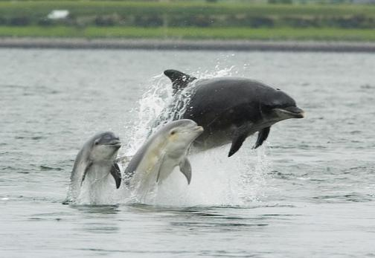  © Peter Asprey (→ WIkimedia Commons) | 6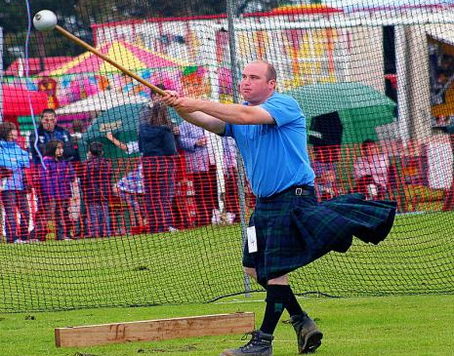  © foxypar4 (→ Wikimedia Commons)
 | 7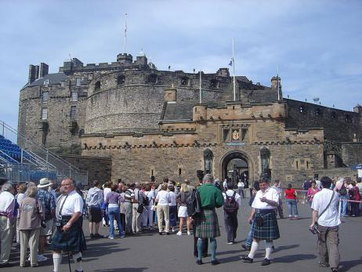 © David Monniaux (→Wikimedia Commons)

TASK 2 - MEDIATION. Your family members all want to do different things in Scotland. Tell them in German which places they should visit. Often more than one place fits.
- Your sister: „Ich will auf jeden Fall reiten gehen.“
- Your mum: „Ich fände es interessant, mehr über schottische Geschichte zu erfahren.“
- Your brother: „Wo kann man eine Bootstour machen?“
- Your father: „Irgendetwas mit Sport wäre gut.“
- Your grandma: „Wo kann man traditionelles Essen probieren?“

Ex. A) „Reiten kann man auf den Shetland-Inseln und auf dem Ben Nevis.“

TASK 3 Which place(s) from the brochure would you like to visit? Say why.

b

Do you like sea animals? Then you should take a boat trip on Moray Firth! With a bit of luck, you’ll see dolphins and seals!

Edinburgh is the capital of Scotland. Long ago, the kings of Scotland lived here. At Edinburgh Castle, you can learn more about Scotland’s history. But the city is great for shopping, too!

a

The city of Aberdeen was a fishing harbour once. If you want to learn more about life and work at sea, you should visit the Aberdeen Maritime Museum!

But the city is great for shopping, too!

c

If you like sandy beaches, the Shetland Islands are the right place for you! You can take boat trips and ride along the beach on a real Shetland pony.

d

Loch Ness is a big lake in Scotland. People say that a monster lives in the lake! You can also visit a museum about Loch Ness and its monster – and a theme park called Nessieland!

e

Ben Nevis is the highest mountain in the UK. It is great for hiking, climbing, horseback-riding and mountain- biking.

In summer, you can visit the Highland Games. They’re events with different sports competitions like tug-of-war and hammer throwing. And there are traditional clothes (kilts!), food and music!

f
g

TASK 4 Fill in the crossword puzzle with words from the text. If you don’t know the translation of a word, look for it in the text in brackets.

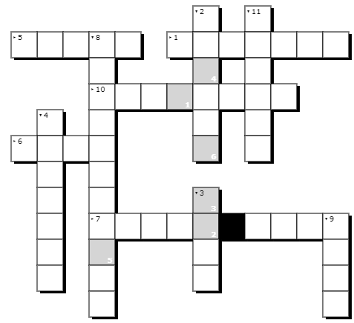 |  |  |  |  |  |  |  | - Hauptstadt (a)  - Schloss (a)  - Robbe (b)  - Hafen (c)  - Strand (d)  - (der) See (e)  - Vergnügungspark (e)  - Wettbewerb (f)  - Schottenrock (f)  - Berg (g)  - Wandern (g)
Solution word:
 | 1 | 2 | 3 | 4 | 5 | 6

TASK 5 - WRITING. Imagine an exchange student from Great Britain is planning to visit you. He has asked you about interesting places in or near your home town. You can use the words and phrases from the box below. You can start like this:
JASON What can we do when I visit you in March?
YOU There are lots of great places where we can go. For example, there is a ... where you can ...

places | Nature: lake - beach - forest - mountain - national park  City: castle - cinema - swimming pool - museum - theme park - zoo
activities | go sightseeing - learn about - hike - ride a bike - ride a horse - swim - take a boat trip - visit - watch
phrases | There is a(n) interesting / famous / great ... near where I live. It’s called ...  We could visit / go to ...  You can see / watch / learn about ... there.  You can do lots of activities there, for example ...  It’s really fun / interesting / beautiful because ...
Anwers key:

TASK 1:
1e, 2g, 3c, 4d, 5b, 6f, 7a

TASK 2
- Your mum: „Ich fände es interessant, mehr über schottische Geschichte zu erfahren.“
→ „Du könntest Edinburgh Castle oder das Maritime Museum in Aberdeen besuchen.“
- Your brother: „Wo kann man eine Bootstour machen?“
→ “Man kann auf den Shetland-Inseln und auf dem Moray Firth eine Bootstour machen.“ (Anm. Auf Loch Ness wahrscheinlich auch, es wird allerdings nicht im Text erwähnt.)
D) Your father: „Irgendetwas mit Sport wäre gut..“
→ “Man kann auf Ben Nevis wandern, klettern und reiten. Außerdem kann man bei den Highland Games Sportwettbewerbe sehen.“
- Your grandma: „Wo kann man traditionelles Essen probieren?“
→ “Bei den HIghland Games gibt es traditionelles Essen.“

TASK 3 Individual answer

TASK 4
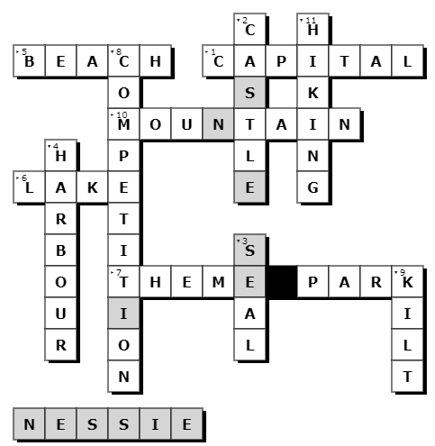

TASK 5 Individual answer

Images:

Edinburgh Castle: By David Monniaux - Own work, CC BY-SA 3.0, https://commons.wikimedia.org/w/index.php?curid=230091

Loch Ness: By Rebel yell, CC BY-SA 3.0, https://commons.wikimedia.org/w/index.php?curid=1703711

Shetland Ponies: By Roberto Getto - originally posted to Flickr as May 2010 031, CC BY 2.0, https://commons.wikimedia.org/w/index.php?curid=10719548

Aberdeen Maritime Museum: By Stephencdickson - Own work, CC BY-SA 4.0, https://commons.wikimedia.org/w/index.php?curid=82324225

Ascend of the Ben Nevis: By Ruben De Smet, CC BY-SA 4.0, https://commons.wikimedia.org/wiki/File:Ascend_of_the_Ben_Nevis_01.jpg

Adult female Bottlenose Dolphin with two young at side, Inner Moray Firth, Scotland May 2005. By Peter Asprey, Creative Commons Attribution-Share Alike 3.0 Unported, https://commons.wikimedia.org/wiki/File:Bottlenose_dolphin_with_young.JPG

Highland Games By foxypar4 - https://www.flickr.com/photos/foxypar4/1004465151/, CC BY 2.0, https://commons.wikimedia.org/w/index.php?curid=3365046

