The “Friendly Indian”: Tisquantum and the First Thanksgiving
TASK 1a Match the words and the sentences.
a. expedition |  | 1. A holiday in November, usually celebrated with a turkey dinner.
b. tribe |  | 2. A disease that infects many people in a certain area at the same time.
c. Thanksgiving |  | 3. A mission to explore an unknown area.
d. epidemic |  | 4. The people who were already living in America when the Europeans arrived.
e. Mayflower |  | 5. There are 574 legally recognized Indian …s in the US, such as the Cherokee.
f. Native Americans |  | 6. A person who moves to live in a new area.
g. interpreter |  | 7. People who do not speak the same language need an … to communicate.
h. settler / colonist |  | 8. The name of a ship that brought a group of English settlers to America.

1b What do you know about the time period when the first European settlers came to America? Share your knowledge with your classmates. Use the words from TASK 1a.
1c Read the short text about the First Thanksgiving and fill in the gaps with words from TASK 1a.
In the year 1620, a ship called the ______________________ (1) arrived in North America. The men and women on board wanted to start a new life there, but they were not well-prepared. In the first winter, half of the ______________________s (2) died because they did not have enough food. Luckily for them, the ______________________s (3) who already lived the area decided to help them. They showed them how to grow corn and other plants and to collect seafood. One Native American by the name of Tisquantum was particularly important to them. As he was fluent in English, he could serve as an ______________________ (4). After the successful harvest, colonists and natives celebrated together – an event which is today remembered as the First ______________________ (5). | 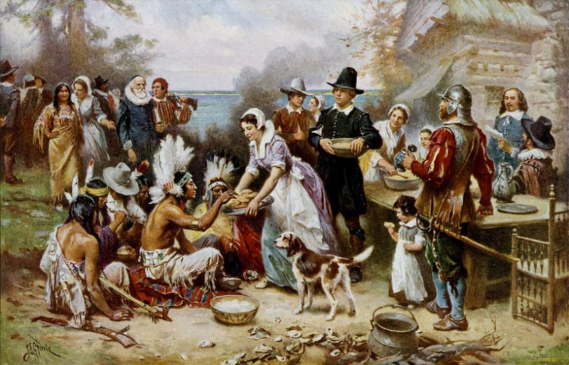  The First Thanksgiving, 1621, by Jean Leon Gerome Ferris.  Please note that the scene is not historically accurate (e.g. the clothing of both Indians and colonists is incorrect.)
1d Questions about the interpreter: What do you think? In groups, discuss the following questions.
- Why did the natives decide to help the colonists?
- How did Tisquantum learn to speak English?
TASK 2 Work in groups. Each group picks a section ([1]-[5]) from the text. Look at the title of the section and describe the picture that goes with it. Do not start reading yet. Based on the sub-heading and the picture, come up with two questions about the content of the section. Afterwards, note down all questions on the board, on an overhead transparency or similar.
Ex. Question about section [1]: Why did Tisquantum visit the places on the map?
TASK 3 Now read the text on the next pages. While reading, try and answer your questions from TASK 2.

The “Friendly Indian”: Tisquantum and the First Thanksgiving
[0] It’s the year 1619. An expedition ship is approaching the coast of New England. Captain Thomas Dermer and his crew have come all the way from England to explore the resources of the New World. One man on board, however, does not care much about the gold, fertile soil and rich fishing grounds they might find there. For him, the sight of the coastline means that after five long years of travels, he is finally coming home. His friends and family have no idea that he is about to return. They haven’t seen him since he left and probably believe he is dead. The man’s name is Tisquantum, and it’s safe to say that his heart is beating fast as they are nearing his home village Patuxet.
[1] Tisquantum’s travels
Five years ago, in 1614, Tisquantum had been kidnapped by another British explorer by the name of Thomas Hunt, who took him to Spain to sell him as a slave. What happened next is controversial. It seems that Tisquantum managed to escape slavery, somehow made it to England, and (after learning to speak English fluently) boarded a ship bound for Newfoundland. Now he was back in North America, but still about a thousand miles away from his home village. Luckily, he met the adventurer Thomas Dermer and convinced him to launch an expedition to New England. He would accompany the expedition as a guide and interpreter.
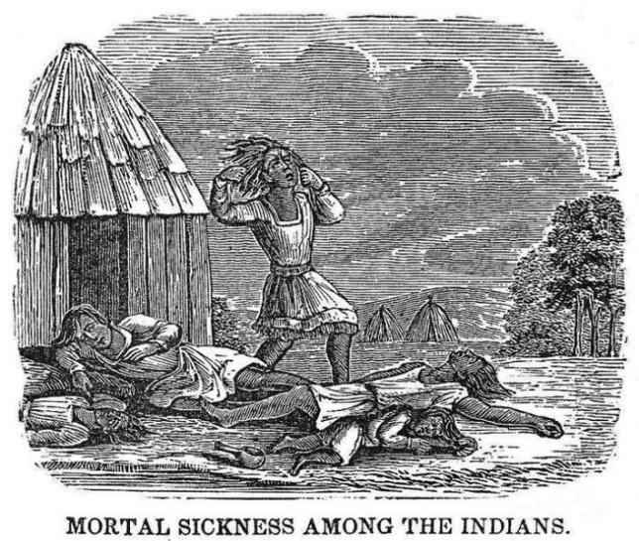
[2] The disease
So in June 1619, Tisquantum had finally made his way back home. But as the shore came into sight, it became clear that something was terribly wrong. The fields were overgrown by weeds, and not a single person was to be seen. When the men disembarked, they discovered sun-bleached bones and skulls in the deserted villages. An epidemic had killed about 90 percent of the natives in the area, among them the whole Patuxet tribe; nobody had been left alive to bury the dead bodies. At the time, many Native Americans died from diseases that the Europeans had brought in and against which they had no immunity. The disease that killed Tisquantum’s people may have been introduced by French sailors.
© Nikater, adapted to English by Hydrargyrum  (→ Wikimedia Commons) | [3] The Wampanoag  After the expedition, Tisquantum did not want to return to England with Dermer. As there were no Patuxet Indians left, he probably went on to live with another Indian tribe.  In the early 17th century, the east coast was already densely populated. Tisquantum’s tribe, the Patuxet, were part of a larger group of tribes called the Wampanoag. These Native Americans lived in the northeast of what is today the USA; they hunted, fished, collected seafood and grew corn, beans and pumpkins. Before the epidemic, the Wampanoag confederation had consisted of about 70 groups and about 20,000 people in total. Each group had a so-called sachem (= leader), which were in turn subject to one head sachem.  The Wampanoag were not the only Native Americans in New England. They had plenty of native neighbours, among them both allies and enemies.
[4] Massasoit and the arrival of the Pilgrim Fathers
When Tisquantum returned from Europe, a man called Ousamequin was the sachem of the Wampanoag confederation. Today he is usually known by his title Massasoit, which means „great leader“. Ousamequin / Massasoit was in a dangerous position. The disease had killed most of his people, but it had hardly affected his enemies, the Narraganset. It was likely that they would use his weakness to attack. So he got very interested when he found out that an English ship, the Mayflower, had landed near Patuxet.
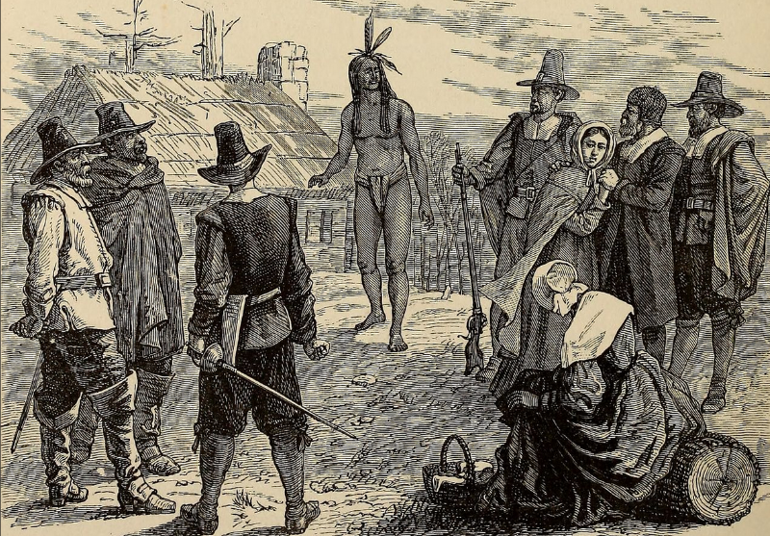
The men, women and children on board were a mixed lot. Some of them were Puritans who had left England for religious freedom; others were adventurers looking for opportunities in the New World. However, all of them were in bad shape, weakened by hunger, cold and scurvy. The newcomers were not well-prepared for a life as colonists. They arrived in November when it was already very cold, and they had not brought enough provisions. In the first winter, half of them died; the rest probably only survived on stashed corn that they found in the deserted Indian villages.
On March 22, 1621, Massasoit paid the colonists’ camp a visit. Tisquantum and another native called Samoset, who had already visited the colony before, came along as interpreters. At the end of the conversation, Massasoit allowed the colonists to stay and agreed to let Tisquantum help them. We do not know exactly what Massasoit’s motives were; maybe he believed that a treaty with the Englishmen would protect his people against the Narraganset.
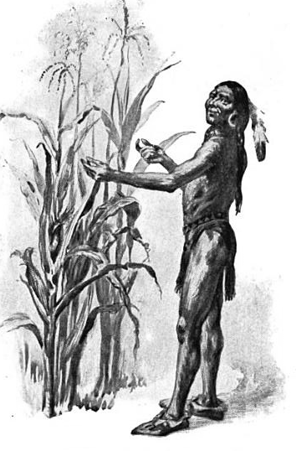
[5] The “friendly Indian”
From then on, Tisquantum lived with the settlers and became close friends with their governor, William Bradfort. He taught them how to grow corn, to fish and to gather seafood and helped them communicate with the Natives who lived in the area. In 1621, the colonists and their native neighbours celebrated the good harvest together – the famous “First Thanksgiving”.
Today Tisquantum is often referred to as the “friendly Indian” who helped the “Pilgrim Fathers”. It is true that without his help, the colonists probably would not have survived. However, according to Bradford’s journal, Tisquantum also had his own agenda. Apparently, he used his position as an interpreter to his own advantage. He spread rumours among the natives that the Englishmen could unleash a “plague” on them, and said that they had to give him presents to appease them – which he then kept for himself. In the end, he even told the colonists that Massasoit was planning to attack them, hoping they would strike first. When Massasoit heard of Tisquantum’s plans, he demanded his execution, but the colonists refused to hand him over; he was too valuable as an interpreter. Tisquantum stayed with the settlers, but from thereon, he could not leave Plymouth without a guard. Soon after, he died of a fever.
In the following years, more and more Englishmen would land at the coast of Massachusetts and occupy more and more land. Many Native Americans were killed in wars and in attacks, but even more died from epidemics like the one that had wiped out Tisquantum’s tribe.
Tisquantum himself remains a mysterious figure. As all the information about his life is from other sources – such as the colonists’ journals or Thomas Dermer’s letters – we will never know how he really felt about the Wampanoag and the English, his role as an interpreter, and that historical Thanksgiving celebration.
TASK 4a Read sections [0] and [1] again and fill in the gaps with the words from the box.
England (1) – New England (2) – Hunt (3) – Dermer (4) – Spain (5) – Newfoundland (6)

- Tisquantum was a Native American from _______.
- He joined Thomas _______, who he had met in _______, on an expedition to his home country.
- He could work as an interpreter because he had lived in _______ for a while.
- The first European country he visited was _______.
- He was taken there by the explorer Thomas _______.
4b Now read sections [2] and [3] and decide whether the statements are true or false.
 | true | false | line(s)
- When Tisquantum got to Patuxet, everybody there was sick. | □ | □
- Back then, deadly epidemics were quite common among the natives. | □ | □
- After the expedition, Tisquantum stayed in New England. | □ | □
- Very few people lived in New England in the early 1600s. | □ | □
- The Wampanoag and the Patuxet were two different tribes. | □ | □
- The Wampanoag were friends with all their neighbors. | □ | □
4c Now take a closer look at section [4]. Connect the two parts of the sentences.
a) The Narraganset were stronger than the Wampanoag |  | 1. they did not have enough food.
b) Massasoit was afraid that |  | 2. they had to give him presents.
c) Many of the settlers died because |  | 3. he had plotted against him.
d) Massassoit visited the settlers so |  | 4. the Narraganset would attack his tribe.
e) Massasoit took Tisquantum along because |  | 5. they could make a treaty.
f) The settlers celebrated a good harvest because |  | 6. because the disease had hardly affected them.
g) Tisquantum told the natives that |  | 7. he needed an interpreter.
h) Massasoit wanted Tisquantum dead because |  | 8. Tisquantum had helped them.

TASK 5 Tisquantum himself did not leave any letters or a diary behind. We have no idea what his thoughts and feelings on the events of the First Thanksgiving were, and there are many gaps in his story. With a partner, write an interview with him. You could ask him:
how he felt when he was kidnapped and taken to Spain ● how he made it from Spain to England ● how he learned to speak English ● how he felt when he returned to Patuxet ● how he felt about the English colonists living where his home village had been ● what the other Wampanoag thought about him being friends with the English ● why he lied to the settlers and told them that Massassoit was going to attack ● what he thinks about Thanksgiving as it is celebrated today ...
TASK 6 Research. Use the internet to find out more about one of the following topics. Take notes and tell your classmates about ...
- the “Pilgrim Fathers” and why they left England,
- the life of the Wampanoag in the 17th century, or
- the Wampanoag today.

VOCABULARY

adventurer | Abenteurer
agenda | (here) Plan, Absichten
to affect | betreffen
ally | Verbündete(r)
to appease | Besänftigen, beruhigen
to be in bad shape | in schlechtem Zustand sein
to board | (ein Schiff) besteigen
bound for | mit Kurs auf
to bury | begraben
colonist | Siedler
confederation | Konföderation, Bund
controversial | umstritten
disease | Krankheit
enemy | Feind
epidemic | Epidemie
expedition | Expedition
to explore | erkunden
to discover | entdecken
governor | Gouverneur
inaccurate | ungenau, fehlerhaft
interpreter | Dolmetscher
immunity | Immunität
journal | here: Tagebuch, persönliche Aufzeichnungen
Mayflower | Name des Schiffes, das die Pilgrim Fathers nach Amerika brachte
motive | Motiv, Beweggrund
Native Americans | amerikanische Ureinwohner / Indianer
newcomer | Neuankömmling
to occupy | besetzen
to plot against sb. | gegen jn. Intrigieren / sich verschwören
populated | bevölkert
provisions | Vorräte
resource | Ressource
scurvy | Skorbut (eine Krankheit, die durch Vitamin-C-Mangel ausgelöst wird)
settler | Siedler
source | Quelle
to stash | verstecken, bunkern
treaty | Vertrag, Abkommen (zwischen Staaten)
tribe | Stamm (Volksgruppe)
to unleash sth. on sb. | etw. auf jn. loslassen
weeds | Unkraut
to wipe out | auslöschen

Sources:
Mann, Charles C. “Native Intelligence.” Smithsonian.com, Smithsonian Institution, 1 Dec. 2005, www.smithsonianmag.com/history/native-intelligence-109314481/?c=y%3Fno-ist.
Historic Ipswich, et al. “The Great Dying 1616-1619, ‘By God's Visitation, a Wonderful Plague.’” Historic Ipswich, 12 Nov. 2020, historicipswich.org/2017/09/01/the-great-dying/.
Pictures:
- The First Thanksgiving, 1621. By Jean Leon Gerome Ferris. https://en.wikipedia.org/wiki/File:The_First_Thanksgiving_cph.3g04961.jpg
- Map of tribal territories in New England: Von Nikater; adapted to English by Hydrargyrum - Wikimedia Commons - Image:Wohngebiet_Südneuengland.png, as of 5 July 2006, CC BY-SA 3.0, https://commons.wikimedia.org/w/index.php?curid=5276243
- Blank map of the world: BlankMap-World-noborders - Maps of the world - Wikimedia Commons (arrows added by www.englischtipps.com)
- Smallpox epidemic: Drawn by a missionary in Maine, 1740. www.historicipswich.org/2017/09/01/the-great-dying/
- Squanto demonstrating corn: By The German Kali Works, New York - Bricker, Garland Armor. The Teaching of Agriculture in the High School. New York: Macmillan, 1911. Page 112., Public Domain, https://commons.wikimedia.org/w/index.php?curid=6767488
- Samoset’s arrival in Plymouth: By Internet Archive Book Images - https://www.flickr.com/photos/internetarchivebookimages/14597125217/Source book page: https://archive.org/stream/popularhistoryof00brya/popularhistoryof00brya#page/n471/mode/1up, No restrictions, https://commons.wikimedia.org/w/index.php?curid=43579483

Answers
1a) a3, b5, c1, d2, e8, f4, g7, h6
1b) individual answer
1c) Mayflower (1), settler/colonist (2), Native Americans (3), interpreter (4), Thanksgiving (5)
1d), 2) and 3) individual answer
4a) a2, b4 / b6, c1, d5, e3
4b) a - false (lines 26/27) - Everybody was already dead.
b - true (lines 28/29)
c - true (lines 34/35) - He did not want to return to England, so he stayed in North America.
d - false (lines 37/38) - The area was densely populated.
e - false (lines 38/39) - The Wampanoag were a confederation of tribes, one of which were the Patuxet.
f - false (lines 46/47) - Some of their neighbors were enemies.
4c) a6, b4, c1, d5, e7, f8, g2, h3
- and 6) individual answers

