Interesting facts about kangaroos
EXERCISE 1 What do you know about kangaroos? Add facts to the mindmap below.

VOCABULARY
diet = what kangaroos eat; habitat = where they live; physical abilities = what they can do

EXERCISE 2 Now read the text on page 2. Match the paragraphs [1]-[5] and the headings [A]-[E].
[A] Dangers to kangaroos
[B] A friendly kangaroo
[C] How do kangaroos fight?
[D] A childhood in the pouch
[E] Life in the heart of Australia

EXERCISE 3 Now complete your mind map from EXERCISE 1 with information from the text. You can also add your own branches and sub-branches to the mind map.
STUDY TIP Re-organizing the content of a text in a mind map is a great way to summarize a text and also to study for an exam! Make sure to use your own categories and sub-categories.
1  2  3  4  5  6 |  | [1] Red kangaroos live almost everywhere in Australia, even in the hot and dry centre of the continent. They eat grass and other plants and need very little water. Thanks to their strong legs, they can leap as far as 9 meters and hop as fast as 70 km/h. That way, they can travel large distances when there is little food.  Picture: PanBK, CC BY-SA 3.0, via Wikimedia Commons
7  8  9  10  11  12  13  14  15 | [2] A baby kangaroo is called a joey. A new-born kangaroo is only a few centimetres long. Right after birth, the new-born climbs into its mother’s pouch and stays there for the first few months of its life. Because the baby also poops and pees in there, the mother cleans her pouch by licking it out.  Even after the joey leaves the pouch, it still drinks mother’s milk for some time. Kangaroo mothers produce a different kind of milk for their babies when they are a bit older. When they have a younger and an older joey, they can even produce two kinds of milk at the same time!  Picture: SeanMack - Own work, CC BY 2.5, Wikimedia Commons |  | 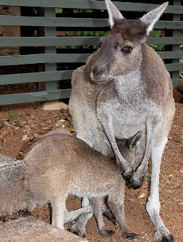
16  17  18  19  20  21  22 | 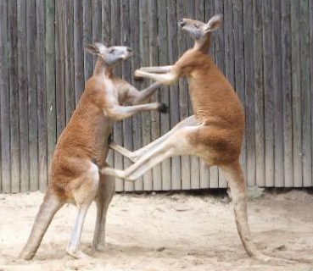 | [3] Kangaroos can be dangerous, too. For example, if a dingo (= a wild dog) attacks a kangaroo, the kangaroo can kick it with its strong feet and sharp claws. They’re also very good swimmers and can fight in the water. They can push a dog under water with their arms and drown it. Kangaroos also box and wrestle with each other. However, they usually don’t hurt humans.  Picture: Dellex, CC BY-SA 3.0, via Wikimedia Commons
23  24  25  26  27  28  29 | [4] Red kangaroos are very big and don’t have many natural predators, although dingoes and eagles sometimes eat young kangaroos. However, when they cross a road at night, they are often hit and killed by cars. People also hunt kangaroos for their meat. Kangaroo meat is actually quite healthy (low-fat and rich in protein) and better for the environment than beef or pork. Nevertheless, many people are against kangaroo hunting because they think it’s cruel.  Picture: By Jpp - Made by Jpp, CC BY-SA 3.0, via Wikimedia Commons
29  30  31  32  33  34 | 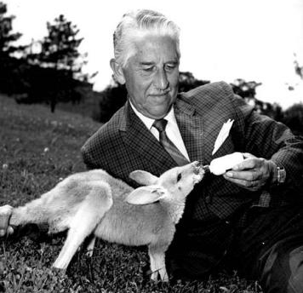 | [5] In 2000, a farmer’s family saved a baby kangaroo from its dead mother’s pouch. They named the baby Lulu, bottle-fed it and kept it as a pet. Four years later, the father of the family had an accident. Lulu made loud noises until his wife found him. Thanks to Lulu, the farmer could be taken to hospital in time.  Picture: NBC Television, Public domain, via Wikimedia Commons
EXERCISE 4 Which information from the text did you find the most interesting?
Useful phrases
I didn’t know before that kangaroos … ▪ I think it’s really interesting that … ▪ What surprised me most was that kangaroos … ▪ I’d like to know more about …
EXERCISE 5 Look at these words from the text and underline the word that doesn’t fit. Explain your choice. If you put the letters behind the words together, you get the name of another Australian marsupial.
- box (K) ▪ wrestle (D) ▪ hide (W) ▪ kick (P) ▪ attack (M)
- climb (I) ▪ leap (R) ▪ hop (P) ▪ swim (A) ▪ hunt (O)
- legs (N) ▪ arms (A) ▪ feet (U) ▪ pouch (S) ▪ road (M)
- joey (L) ▪ baby (G) ▪ dingo (B) ▪ new-born (S)
- drown (O) ▪ hurt (A) ▪ kill (U) ▪ cross (A)
- plant (S) ▪ grass (M) ▪ meat (Q) ▪ milk (L) ▪ centre (T)
Solution word: ___ ___ ___ ___ ___ ___
EXERCISE 6 – PARTNER A Imagine there is an exchange student from England (= your partner) in your form who doesn’t speak German well. For your biology class, you had to read a text about saltwater crocodiles for homework. Using your notes (see below), summarize the content of the text for him/her. Your partner has to take notes.
Afterwards, swap roles: Now your partner summarizes a text about koalas for you and you take notes.
Biologie: Leistenkrokodile  Lebensraum: Indien, Australien, Südostasien  Größe: 6m, 1300kg  Fähigkeiten:  - können sehr weit und schnell schwimmen (590 km in 25 Tagen!)  - überleben lange ohne Nahrung  Nahrung:  - junge Krokodile: Fische, Frösche, Insekten, etc.  - große Krokodile: fast alle Tiere  Krokodile und Menschen  - Greifen Menschen nur selten an (Australien: 1 Angriff in den letzten 10 Jahren)  - Menschen jagen sie & zerstören Lebensraum |  | Biology: Koalas  Habitat: ________________________________ ________________________________  Size: ________________________________  _________________________________  Physical abilities:  _________________________________  _________________________________  _________________________________  _________________________________  Diet:  _________________________________  _________________________________  _________________________________  _________________________________  Koalas and humans:  _________________________________  _________________________________  _________________________________  _________________________________

EXERCISE 5 Look at these words from the text and underline the word that doesn’t fit. Explain your choice. If you put the letters behind the words together, you get the name of another Australian marsupial.
- box (K) ▪ wrestle (D) ▪ hide (W) ▪ kick (P) ▪ attack
- climb (I) ▪ leap (R) ▪ hop (O) ▪ swim (O) ▪ hunt (O)
- legs (N) ▪ arms (A) ▪ feet (U) ▪ pouch (S) ▪ road (M)
- joey (L) ▪ baby (G) ▪ dingo (B) ▪ new-born (S)
- drown (O) ▪ hurt (A) ▪ kill (U) ▪ cross (A)
- plant (S) ▪ grass (M) ▪ meat (Q) ▪ milk (L) ▪ centre (T)
Solution word: ___ ___ ___ ___ ___ ___
EXERCISE 6 – PARTNER A
Imagine you’re an exchange student from England in your form who doesn’t speak German well. For your biology class, you had to read a text about koalas for homework. Using his/her notes (see below), your partner will summarize the content of the text for you. You have to take notes.
Afterwards, swap roles: Now you summarize a text about koalas for your partner while he / she takes notes.
Biology: Saltwater crocodiles  Habitat: _____________________________ ________________________________  Size: ________________________________  ________________________________  Physical abilities:  ________________________________  ________________________________  ________________________________  ________________________________  Diet:  ________________________________  ________________________________  ________________________________  ________________________________  Saltwater crocodiles and humans:  ________________________________  ________________________________  ________________________________  ________________________________ |  | Biologie: Koalas  Lebensraum: nur in Australien  Größe: bis zu 85 cm und 15kg  Fähigkeiten:  - Kann gut klettern  - Muss fast nicht trinken (Name bedeutet „ohne Wasser“)  - Babys leben im Beutel der Mutter  Nahrung:  - Frisst nur Eukalyptusblätter  - schläft 20 Stunden am Tag, um Energie zu sparen  Koalas und Menschen:  - Menschen lieben Koalas – oft in Spielen, Fernsehen oder als Spielzeug zu sehen  - Autos und Haushunde töten viele Koalas

Vocabulary
to attack angreifen
to bottle-feed mit der Flasche füttern
to box boxen
claw Kralle, Klaue
to climb klettern
to cross überqueren
cruel grausam
diet Ernährung
dingo Dingo (australischer wilder Hund)
distance Entfernung
drown ertrinken; ertränken
to hide verstecken
eagle Adler
habitat Lebensraum
to hop hüpfen
human Mensch
to hunt jagen
joey (bei Beuteltieren) Junges
kangaroo Känguru
koala Koala
to kick treten
to leap springen
to lick lecken
new-born neugeboren; Neugeborenes
to pee (coll.) pinkeln
plant Pflanze
to poop koten
pouch Beutel
predator Räuber
road Straße
saltwater crocodile Leistenkrokodil
sharp scharf, spitz
to wrestle ringen

Answer key
EXERCISE 1 Individual answer; examples:
- Habitat: Australia, hot and dry
- Diet: grass
- Kangaroo parenting: carry their babies in a pouch
- Physical abilities: can leap very far
EXERCISE 2 A4, B5, C3, D2, E1
EXERCISE 3 Individual answer – suggestion:
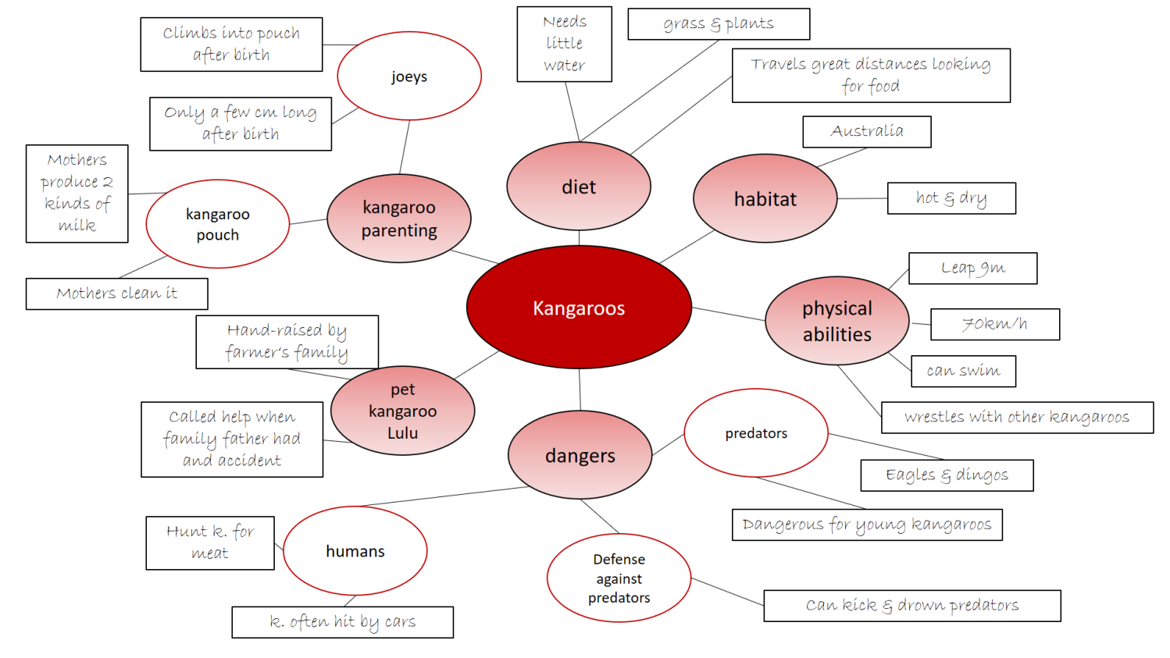
EXERCISE 4 Individual answer – suggestions:
“I didn’t know before that kangaroos are good swimmers.”
“What surprised me most was that there are pet kangaroos.”
“I think it’s interesting that kangaroo mothers clean their pouches – I never thought of that before.”
EXERCISE 5 Individual answer – suggestions:
“Salt water crocodiles live in India, Australia and Southeast Asia. They can be up to 5 meters long and weigh 1300 kilos. They can swim very far and very fast and they can go without food for a long time. Young crocodiles eat small animals like fish, frogs and insects. Large crocodiles eat almost all animals. Crocodiles don’t usually attack people. In Australia, there has only been one attack in the last ten years. However, people hunt crocodiles and destroy their habitat.”
„Koalas only live in Australia. They can be up to 85 centimeters tall and weigh up to 15 kilos. They can climb well and they need very little water – their name actually means “without water”! Koala babies live in their mothers’ pouches. Koalas only eat eucalyptus leaves. They sleep 20 hours a day to save energy. People love koalas. You often see them in games, on TV or as toys. Cars and dogs kill many koalas.”

Image sources:

Hopping kangaroo: Picture: PanBK, CC BY-SA 3.0, via Wikimedia Commons: https://commons.wikimedia.org/wiki/File:Kangaroo-in-flight.jpg
Kangaroo with baby: By SeanMack - Own work, CC BY 2.5, https://commons.wikimedia.org/w/index.php?curid=552810
Kangaroos fighting: Dellex, CC BY-SA 3.0, via Wikimedia Commons (https://commons.wikimedia.org/wiki/File:-_fighting_red_kangaroos_1.jpg)
Kangaroo road sign: By Jpp - Made by Jpp, CC BY-SA 3.0, https://en.wikipedia.org/wiki/Kangaroo#/media/File:Kangaroo_Sign_at_Stuart_Highway.jpg
Man bottle-feeding kangaroo: NBC Television, Public domain, via Wikimedia Commons (https://commons.wikimedia.org/wiki/File:Marlin_Perkins_Wild_Kingdom.JPG)

marsupial: Beuteltier
zerstören: to destroy
marsupial: Beuteltier
English: eucalyptus leaves

