Comment on a newspaper article: Time to raise the drinking age?
TASK 1a Describe the graph on the left.
1b In your opinion, which of the alternatives given in the graph is the most reasonable? Why?

TASK 2 Now read the text. In which paragraph ([1]-[4]) does the author say the following things?
- Teenagers who drink may not be able to learn and remember things well.
- Because there is no ban, teenagers think that drinking is safe.
- Teenagers may get hurt or hurt others when they’re drunk.
Time to Raise the Drinking Age
It is high time that Germany’s irresponsible drinking age of 16 is raised – to the age of 21. / Caleb Nicholson, 10/10/2016.
[1] It sounds unbelievable to American ears: The drinking age in Germany is neither 21 nor 18 - it’s 16. And excessive drinking is taking its toll. In 2015, 21.907 teenagers under the age of 19 were hospitalized for alcohol poisoning. There have even been deadly incidents: In 2007, a 16-year-old student died after drinking 50 tequila shots. If the German government cares about their youths, they should act quickly. The drinking age must be raised instantly - and not to the age of 18 but to the age of 21.
[2] There is a reason why (German) law allows trying people under the age of 21 as minors: Many do not behave like responsible adults. Consuming alcohol is an act that requires a great deal of responsibility. Under the influence of alcohol, a person might harm others or themselves; such behavior might have consequences that teens with their limited life experience cannot yet predict. For instance, drunk driving and cycling often lead to serious injuries.
[3] Speaking of self-inflicted harm: As everybody knows, alcohol is a neurotoxin that severely impairs adolescents’ brain development. At the age of 19, a young person’s brain is not yet fully developed; therefore, the consequences of increased alcohol consumption are even more drastic than in adults. Thus, frequent drinking as a teenager may affect your memory and learning ability for years to come. It’s a miracle to me why a society would stand by and watch as its young generation willingly and legally put their health at risk.
[4] A legislation like Germany’s gives teenagers the impression that excessive drinking is not only legal but even risk-free. This is by no means the case. Only a ban can make the dangers of drinking clear to young people and, that way, reduce alcohol consumption.
Vocabulary aids:  excessive = extreme, too much  to take a toll: dt. seinen Tribut / Opfer fordern  incident: dt. Vorfall | to try sb. as a minor: dt. jn. als Minderjährigen vor Gericht stellen (und somit weniger schwer bestrafen)  self-inflicted: dt. selbst verursacht  neurotoxin = a very dangerous substance that damages nerve cells

TASK 3 Go through the text again. In the table, note down the arguments, explanations and examples the author gives (paragraphs [1]-[3]. The argument of the paragraph is usually given right at the beginning of that paragraph.
para. | argument | Explanations & examples
1 | Excessive drinking is putting teenagers’ health at risk. | 21.907 teenagers hospitalized, 1 dead
2
3

TASK 4 Now collect more arguments and examples that support (+) or refute (-) the author’s arguments. Also, find at least one new argument.
para. | (counter-)argument | (Additional) explanations & examples
1 + | I agree! | number of teenagers who say they drink regularly / a lot, or who report they’ve been drunk within the last month
1 - | People under 21 are allowed to do all kinds of dangerous activities which nobody is trying to ban. | Dangerous sports (riding motorcycles), doing dangerous jobs (e.g. serving in the military)
2 + | I agree!
2 -
3+ | I agree!
3
More arguments and examples for your own text (+ / -)

TASK 5 Now write a comment in response to the article: Sum up what the author says and explain why you (don’t) agree with him. You can organize your text like this:
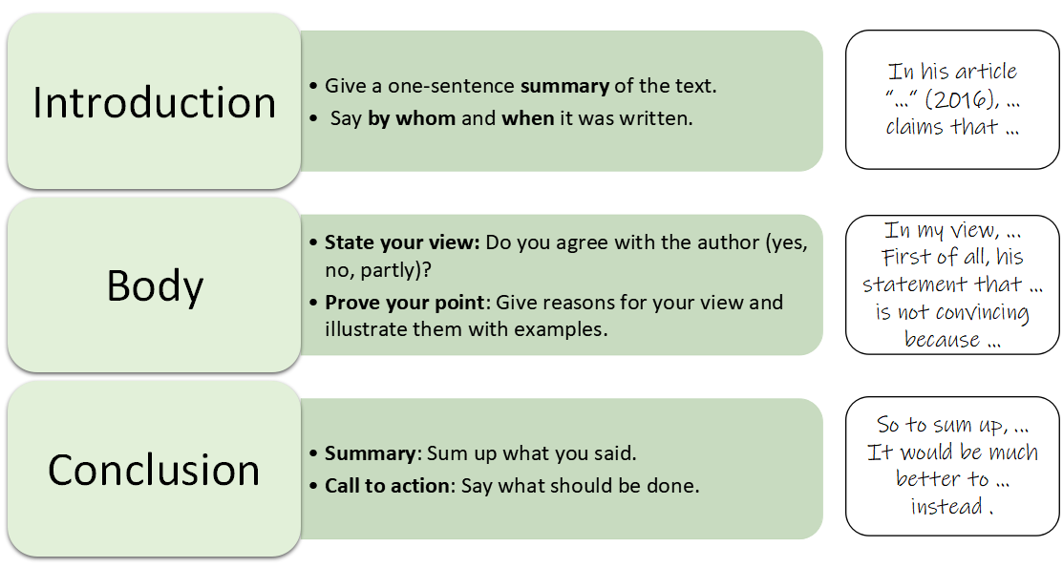
Also, pay attention to your style:
How to improve your style:
- Use complex sentences:
  - Subordinate clauses: While it’s true that …, you shouldn’t forget that …
  - Participle constructions: Weighing the pros and cons, it’s clear that we should …
  - Inversion after negative adverbials: Not only is there no legal argument, but … also …
- Use the structuring phrases on the next page (firstly … secondly … lastly …)
- Use adverbs of comment (absolutely, (un)surprisingly, undeniably...).

Commenting on an article – Useful phrases
State your topic  Summing up the author’s line of argument | In his article x, [the author Y] claims / asserts / argues that …  I would like to comment on the question if / statement that …  The author writes / claims / states / points out that ...  (S)he tries to convince the readers that ...
Giving your personal opinion | Personally, I think / believe / feel / am of the opinion that …  In my opinion / view, …  I am sure / convinced that …  As far as I am concerned, … / As I see it, … / From my point of view, …  It seems to me that …
Agreeing / disagreeing | I partly / completely (dis)agree with the (author’s) view / statement that …  I (don’t) find the author’s line of argument very convincing / compelling because …  I (don’t) share the author’s view that …  I particularly disagree with / reject the idea that …  I think the author is (partly) right when he states that … However, …  I seriously doubt the author’s claim / assertion that …
Structuring your argument | There are three / several arguments that speak for / against this.  Firstly, … Secondly, … Lastly, …  In addition, ... / Furthermore, … / Moreover, …  What is more, ... / What is worse, ...
Giving reasons | This is not very convincing because / , since / , as …  Because of / Due to these factors, we can safely say that …
Balancing the pros and cons | Even though / Although / While this is true, one must also consider that …  Despite / In spite of these arguments, I still think that (the author) is wrong.  On the one hand … but on the other hand …  [Y] is right when he says that … However / Nevertheless, one should not forget that …
Cause and effect | [x] is very cheap.  So / That’s why / For this reason, / Therefore, / As a consequence, / As a result, / Consequently, most people can afford it.
Giving examples | Smoking can have serious consequences for your health.  For example, / For instance, / To illustrate, it may cause lung cancer.
Coming to a conclusion  Call to action | All in all, / In conclusion, / To sum up, / In a nutshell, it can be said that …  Weighing the pros and cons, it’s clear that …  The evidence indicates / shows that …  If we want to avoid ..., there is only one option: ...  The next time you [see Y], [do X].  It’s high time to stop / start [doing X].
Adverbs of comment | seriously / extremely / gravely / deeply / particularly / highly  absolutely / completely / entirely; partly; hardly  definitely / clearly / obviously / naturally / certainly / undeniably / undoubtedly  (most) importantly, (un)surprisingly, (un)fortunately
Answer key

TASK 1a The graph shows at what age young people are allowed to drink alcohol. The drinking age is highest in parts of India (25) and lowest in Germany (16). In the USA it is relatively high (21) and in France it’s 18.
1b Individual solution. Example: “In my opinion, 18 makes the most sense, as that is also when you’re allowed to drive and smoke.“

TASK 2
- Teenagers who drink may not be able to learn and remember things well. [3]
- Because there is no ban, teenagers think that drinking is safe. [4]
- Teenagers may get hurt or hurt others when they’re drunk. [2]

TASK 3
para. | argument | Explanations & examples
2 | Teenagers are not responsible enough. | May have accidents under the influence of alcohol, can’t predict all the consequences
3 | Alcohol has more serious effects on teenagers’ brains | Can affect learning ability and memory

TASK 4
para. | (counter-)argument | (Additional) explanations & examples
2 + | I agree! | Risky drinking games, become victim of a crime or commit one under the influence
2 - | People ages 18 and up are allowed to vote and fight in wars | If you can trust somebody with a gun, you can trust them with a beer.
3+ | I agree! | Learning ability is particularly important during one’s teenage years - may affect future career
3 | Only true if you drink excessively;  Alcohol actually has stronger physical effects on older people | Many teenagers drink, but few develop serious drinking problems;  Bodies of older people don’t recover as quickly from alcohol poisoning, effects on liver and heart are more severe
More arguments and examples for your own text (+ / -)
 | A whole group of people are suddenly criminals although they didn’t harm anybody | Negative psychological effects on teens who get caught; more work for the police

TASK 5 Individual solution - please see next page for an example

Commenting on an article – Example essay
1. State the topic that you’re discussing.
- In his article Time to Raise the Drinking Age (2015), Caleb Nicholson argues that the drinking age in Germany should be raised to the age of 21.
2. State your view on the topic.
- I strongly disagree with the author’s view.
3. Give reasons for your view and illustrate them with examples. Make sure to respond to the author’s arguments.
- There are several reasons for this.
  - First of all, the author claims that 18-year-olds are too irresponsible to drink.
    - In my view, this is ridiculous, as 18-year-olds are allowed to vote, drive and join the military – activities which demand as much or even more responsibility than drinking.
  - Secondly, his argument that alcohol damages a young person’s brain is no reason to ban drinking altogether.
    - While it is true that alcohol is a neurotoxin that may harm the brain, this will only happen if a person drinks irresponsibly. As I have said before, we trust 18-year-olds to elect the government – so we should also trust them to drink in moderation.
  - Lastly and most importantly, I highly doubt his assertion that a ban would l stop teenagers from drinking because it is often illegal things that are the most attractive.
    - To illustrate, the situation in the United States shows that many young people drink excessively despite it being illegal.
  - I would also like to add that enforcing a ban on drinking would create new problems.
    - For example, many young people would be facing criminal charges even though they did not harm anybody, which would have terrible psychological consequences for them. In addition, it would mean a lot of extra work for the police.
    - Drinking in secrecy could, in turn, lead to more issues. Maybe students at a party would not call medical help for a friend with alcohol poisoning because they are afraid of the legal repercussions.
4. Come to a conclusion; give it a personal twist if you like to.
- So, to sum up, I reject the author’s proposal to raise the drinking age. Not only is there no argument that would justify such a law, but it might also be counterproductive and make drinking even more attractive. Therefore, it is not a solution to the problem of excessive drinking among teenagers. Instead, I would support initiatives that teach young people how to drink responsibly and that offer advice.

Please note that this is not a real newspaper article; the name of the author is fictitious.
No comma before conjunctions, with the exception of for, as, nor, but, or, yet, so (Merkwort „FANBOYS“).

