DICK WHITTINGTON AND HIS CAT
Richard Whittington (1354-1423) war ein reicher Kaufmann und Bürgermeister von London. Über seine Jugend erzählt man sich diese Geschichte.

Dick Whittington was a poor little boy who lived in the country. His father and mother were both dead. Poor little Dick always wanted to work, but sometimes there was no work for him. So he often had nothing to eat.
Dick was a clever boy. He kept both ears open to hear what was said around him. He had heard many times about the great city of London. Men said that in this great city the people were rich. Dick had even heard that the streets were paved with gold.
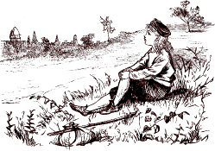"I want to visit that great city," thought Dick, "I could pick up gold from the streets!"
Dick had earned a little money, so one day he set out to walk to London. He walked and walked and walked, but London was a long way from his home. At last a man with a wagon came along. He was a nice man, and he gave Dick a ride.
"Where are you going?" asked Dick.
"I'm going to London," said the man.
"Thanks for giving me a ride. I am going there, too," said Dick.

EXERCISE 1 Welche dieser Aussagen über Dick sind wahr (true), welche falsch (wrong)? | T | W
a) Dick is rich.
b) He lives with his parents.
c) He is from London.
d) He is clever.
e) He listens to what the people say.
f) He works to earn money.
g) He wants to walk to London.

It was dark when they reached London. That night Dick slept in a barn with the horses. The next morning he looked for the golden stones in the streets. He looked and looked, but he could only find dust and dirt.
There were many, many people in London, and Dick thought that he could soon find work. He wandered around the streets, seeking for work. He asked many people, but nobody wanted the poor little country boy.
As Dick had no money for food, he soon became very, very hungry. At last he got so weak that he fell down before the door of a great house. Here the cook found him and began to beat him with a stick.
"Run away, you lazy boy!" she cried.
Poor Dick tried to get up, but he was so weak that he could not stand. Just then the owner of the house, Mr. Fitzwarren, came up. He took pity on the poor boy and told the cook to give him some food. Then he turned to Dick and said:
"If you want to work, you can help the cook in the kitchen. There is a bed in the attic."
Dick thanked Mr. Fitzwarren again and again. The cook was very mean to Dick and beat him almost every day.

EXERCISE 2 Wer denkt das – Dick, Mr. Fitzwarren oder die Köchin? | D | F | C
a) Why is it so difficult to find work in London? I thought it would be easier.
b) I must help this poor boy.
c) I really need something to eat.
d) These lazy street kids are everywhere these days!
e) I’m so happy I can stay here.
f) I don’t like this boy. Why does Mr. Fitzwarren let him stay here?

His bed in the attic was only a pile of old rags. He soon found that there were many rats and mice in the attic. They ran over his bed and made so much noise every night that he couldn’t sleep.
"I wish I had a cat," thought Dick, "it could eat these rats and mice."
One day Dick earned a penny by blacking a man's shoes.
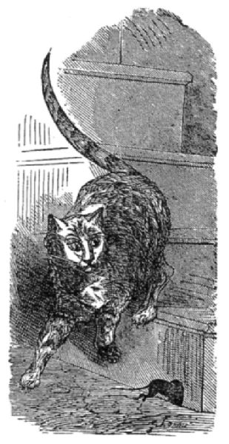"I will try to buy a cat with this penny," thought Dick.
So he set off and soon met a woman with a large cat.
"Will you sell me that cat?" said Dick. "I will give you this penny for it."
"You are a good boy," said the woman, "and you may have the cat for a penny because I know you will be nice to her."
That night Dick's bed was free from rats, and the cat had a good dinner. Dick began to love his cat very much.
Now Mr. Fitzwarren had many ships which sailed to distant lands. When a ship sailed, Mr. Fitzwarren let everyone in his house send something on it. The things were sold, and when the ship came back, each person got the money for what they had sent.
One of the ships was ready to sail. Everyone in the house except Dick had sent something.
"What is Dick going to send in the ship?" said Mr. Fitzwarren.
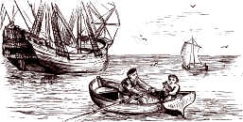"Oh, that boy has nothing to send," said the cook.
"It’s true," said poor Dick; "I have nothing but my cat."
"Well, then you must send your cat," said Mr. Fitzwarren.
How lonely poor Dick was without his cat!
The cook made fun of him for sending a cat on the ship. At last Dick became so unhappy that he made up his mind to run away. He started early in the morning, before anyone in the house was up. He had gone a short way when he heard the sound of the six great bells of Bow.
As they rang, "Ding-dong, ding-dong!" they seemed to say: “Turn back, Whittington, Lord Mayor of London!”
"It is strange that the bells speak to me," said Dick, "but if I am to be Lord Mayor of London, I will go back."
So he ran back to the house of Mr. Fitzwarren.
"I hope they haven’t missed me," said Dick, as he opened the door and stole quietly in.

EXERCISE 3 Kreuze die richtige Antwort an.
1. Dick can’t sleep at night because
a) it is too cold, b) he doesn’t have a bed, c) there are rats in his bedroom.
2. A woman sells him her cat for a penny because
a) she hates cats b) she thinks Dick will be nice to the cat c) she is allergic to cats.
3. Mr Fitzwarren
a) wants to sell Dick’s cat, b) often sails to distant countries
4. Dick runs away because
a) the cook makes fun of him, b) the cook beats him, c) Mr Fitzwarren makes fun of him.
5. Dick goes back to Mr. Fitzwarren’s house because
a) nobody has missed him, b) he gets scared, c) he hears the bells of Bow.

Dick's cat was taken across the ocean. The ship sailed and sailed until it came to a distant country.
The king and queen of this country were very rich. When they asked the captain to show his goods before them he was very happy to do so. The king and queen first gave the captain a great feast. Gold and silver dishes filled with food were brought in.
But when these dishes were placed upon the table a lot of rats came out. There were white rats, and black rats, and brown rats, and big rats, and little rats. At once they fell upon the food and ate nearly all of it.
"Why do you let the rats do this?" asked the captain.
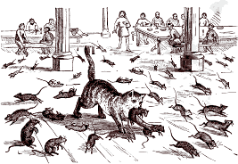"We cannot help ourselves," said the king. "I would give half my kingdom to get rid of them."
Then the captain thought of Dick Whittington's cat.
"I have an animal which will rid you of them," said the captain.
"Please bring it here at once," said the queen.
What fun Dick's cat had killing all the rats and mice in the king's palace!
"We must buy that little animal," said the queen. "I don’t care how much it costs."
The captain could hardly carry all the jewels and gold that the king gave him for the cat.
Then the ship with Dick's money came back to London, and the captain told the story to Mr. Fitzwarren.
"We must take these jewels and all this gold to Mr. Whittington," said the honest man. "He is no longer a poor boy. His cat has made him rich."
They found Dick in the kitchen cleaning the stove.
"Come with me at once into the parlor," said Mr. Fitzwarren.
Then the bags of gold and jewels were piled at Dick's feet.
"See what your cat has brought you," said Mr. Fitzwarren. "You are now a rich man and may yet be Lord Mayor of London."
And it is true that after Dick Whittington became a man, he was made Lord Mayor of London.
EXERCISE 4 Bringe die Sätze in die richtige Reihenfolge. Die Buchstaben ergeben ein Lösungswort (der erste und letzte Satz sind schon angegeben). Ergänze das letzte Wort, das dem Lösungssatz fehlt!
L Dick was a poor country boy.
O He wanted to go to London because he thought that people there were rich.
A There were many mice and rats in the attic.
R The ship came to a distant country. There were lots of rats, but no cats.
M Mr. Fitzwarren gave him work and let him sleep in the attic.
O The king of the country bought Dick’s cat for a lot of money.
Y Dick bought a cat to kill the mice and rats.
R But when he got to London, he couldn’t find a job and was very hungry.
O Dick sent the cat on one of Mr. Fitzwarren’s ships.
D He fell down in front of Mr. Fitzwarren’s house.
F So Dick Whittington became a rich man, and in the end he became:
L _ _ _ _ _ _ _ _ _ F _____________________________

Lösungen
EXERCISE 1 Welche dieser Aussagen über Dick sind wahr (true), welche falsch (wrong)? | T | W
a) Dick is rich. |  | x
b) He lives with his parents. |  | x
c) He is from London. |  | x
d) He is clever. | x
e) He listens to what the people say. | x
f) He works to earn money. | x
g) He wants to walk to London. | x

EXERCISE 2 a) Dick b) Mr. Fitzwarren c) Dick d) die Köchin e) Dick f) die Köchin
EXERCISE 3 1c; 2b; 3a; 4a; 5c
EXERCISE 4 Lösungswort: Lord Mayor of London

O He wanted to go to London because he thought that people there were rich.
R But when he got to London, he couldn’t find a job and was very hungry.
D He fell down in front of Mr. Fitzwarren’s house.
M Mr. Fitzwarren gave him work and let him sleep in the attic.
A There were many mice and rats in the attic.
Y Dick bought a cat to kill the mice and rats.
O Dick sent the cat on one of Mr. Fitzwarren’s ships.
R The ship came to a distant country. There were lots of rats, but no cats.
O The king of the country bought Dick’s cat for a lot of money.

paved: gepflastert
give sb. a ride: jemanden (im Auto / Wagen) mitnehmen
barn: Stall
dust: Staub
dirt: Dreck
owner: Eigentümer
take pity on sb.: mit jm. Mitleid haben
attic: Dachboden
a pile of old rags: ein Haufen Lumpen
to earn: verdienen
distant: weit entfernt
make up sb’s mind: sich entschließen
Lord Mayor: Bürgermeister
If I am to be …: Wenn ich … sein soll
kingdom: Königreich
to get rid of sth.: etwas loswerden
honest: ehrlich
stove: Herd
parlor: Stube, Salon
were piled: wurden aufgehäuft

