**Guessing game: What’s your hobby?**

**EXERCISE 1** Was sind die Hobbys der Kinder? Setze ein:   
*listen – cakes – watch – camping – piano – read – ride – football – swim – cards*

1. **Jack:** I often play _________________ in the park. It’s my favourite sport because I love to be outside with my friends.

2. **Ben:** In the evening I always ____________________ a good book. It’s very relaxing. I like the Harry Potter books best.

3. **Haley:** I always _________________ to music on my MP3 player when I’m on the bus. ‘Metallica’ are my favourite band.

4. **Sarah:** I like to _________________ TV. There are so many great TV series and films. I really love ‘House MD’ and ‘Emergency Room’. My favourite film is ‘Pirates of the Caribbean’.

5. **Sam:** I love music, so I’m learning to play the _______________. It’s a bit difficult, but it’s fun. At the moment I’m playing a piece by Beethoven. It’s really beautiful!

6. **Mike:** I like to play ___________________ with my family. I like ‘Uno’ best. However, my brother doesn’t like it at all – because he never wins!

7. **Jenny:** In the summer I like to _________________ my bike. It’s fun and it’s really good for you. I usually go to school by bike, too.

8. **Carl:** When we’re on holiday I often ____________________ in the sea. It’s nice on a hot day. However, I don’t go to the pool at home. Pools are really boring.

9. **Sam:** I often help my mum in the kitchen, and I really like to cook and to make chocolate _________________. They’re delicious.

10. **Lindsay**: In the summer holidays I always go ________________ with my family. It’s much cheaper than a hotel, and I think it’s more fun. We swim in the lake every day and we play volleyball.

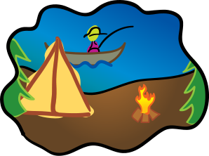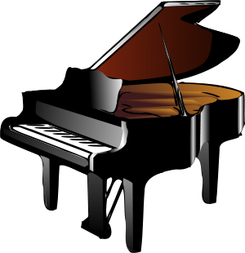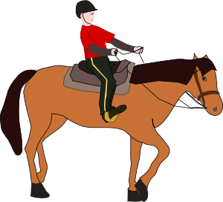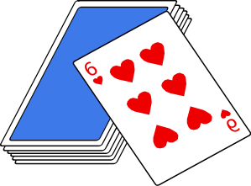

**EXERCISE 2** Was kann man mit diesen Dingen tun? Füge die passenden Verben ein.

a) You can __________________ a book, a magazine, or a text.   
b) You can __________________ to music, to a CD, or to a band.   
c) You can __________________ football, cards, or the piano.   
d) You can __________________ your bike or a horse.   
e) You can __________________ in the sea, in a lake, or in a pool.   
f) You can __________________ TV, a DVD, a film or a series.   
g) You can __________________ a cake.

**EXERCISE 3** Wann und wo machst du was? Vervollständige die Sätze.

a) In the evening I often …   
b) When I’m on the bus …   
c) When we’re on holiday …   
d) In the summer …   
e) When I’m at home …   
f) Every day …

**EXERCISE 4** Fülle die Tabelle mit Informationen über dich aus!

|  |  |
| --- | --- |
| What’s your favourite sport? |  |
| What do you like to read? |  |
| What’s your favourite film? |  |
| What’s your favourite card game? |  |
| What do you like to watch on TV? |  |
| What’s your favourite band? |  |

**Lösung:**

**EXERCISE 1** 1. football 2. read 3. listen 4. watch 5. piano 6. cards 7. ride 8. swim 9. camping  
**EXERCISE 2** a) read b) listen c) play d) ride e) swim f) watch g) make; eat