The judge and the Devil
Based on a fairy tale by Ludwig Bechstein

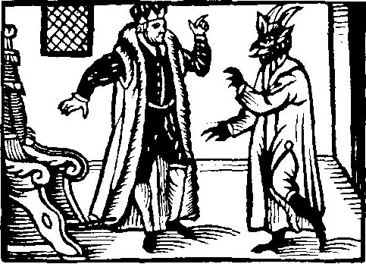
Once upon a time there was a judge. He was a rich man; he had a lot of money, a big house and a lot of land. But he was evil and unfair. He punished poor people hard and took away everything they owned, but he let rich evildoers get away.
One day the judge met a stranger in town. The judge asked him who he was.
“It’s better for you not to know,” said the stranger. The judge didn’t like to hear that. He snarled at the stranger:
“You are in my town. Here I am in charge! Tell me who you are, or you’ll be arrested!”
“Fine,” said the stranger. “I’m the Devil.”
“The Devil …,” the judge whispered. He could hardly believe his ears. “And what do you want here?”
“Today I have the power to go into this town and to take everything with me that people wish to hell, provided that that they really mean it,” answered the Devil.
“I have to see that!” said the judge. He got very excited. “Let me come with you.”
“That’s not a good idea,” the Devil warned him. But the judge didn’t want to listen.
“I have told you once: In this town, I am in charge. In God’s name, I command you to take everything with you that people wish to hell, and to let me watch!”
The Devil was scared when he heard the name of God. “You’re leaving me no choice; you can come with me, but I am sure that you will regret it!”
“Regret it? Rubbish,” said the judge. “Let’s go!”
It was a market day, and the streets were crowded. After a while they met a woman who was trying to lead a pig on a leash. But the pig ran to the left and to the right and didn’t want to follow her at all.
“Go to hell!” she screamed furiously.
“Did you hear that?” the judge asked. “She wished the pig to hell, now you can take it!”
“Unfortunately, I can’t,” the Devil replied. “She didn’t mean it. She would be sad for a year if I took the pig.”
A little later they met a woman and her child. The child was screaming and crying and wouldn’t listen to his mother at all. Finally, the mother had had enough, and she shouted: “If you don’t shut up, the Devil shall come and get you!”
“You will surely take this child with you, won’t you?” the judge asked. But again, the Devil shook his head.
“She doesn’t mean it. She wouldn’t give me the child, even if I offered her a hundred, a thousand or ten thousand pieces of gold.”
They had arrived at the market place. It was so crammed with people that they couldn’t walk on. They were standing next to a poor old woman. When she saw the judge, she started to cry and screamed:
“It is you! You took away my only cow! It was all I had, and you took it away without mercy! I hope that God will grant me one favor: The Devil shall come and get you and take you to hell with him!”
“See?” the Devil said. “That’s what it sounds like when they mean it!”
And the Devil grabbed the judge and flew away with him. Everybody was startled and scared, and a few wise men said: “It’s a bad idea to get involved with the Devil. Nothing good can come of it.”

EXERCISE 1. Put the sentences into the right order.
A. Unlike the other two women, she really meant it.
B. One day, this judge met the Devil.
C. The Devil would take neither the pig nor the child.
D. The Devil told him that he had come to take something with him that people wished to hell.
E. The judge wanted the Devil to take him along while he worked.
F. The old woman cursed the judge because …
G. The Devil warned him, but the judge didn’t listen.
H. The met a woman with a pig.
I. Once upon a time, there was an evil judge.
J. So the Devil took the judge to hell.
K. … he had taken away her cow.
L. They met a woman with a child.
M. They met an old, sick woman.
The right order:
__ __ __ __ __ __ __ __ __ __ __ __ __

EXERCISE 2. Imagine these people could comment on what happened afterwards. What would they say?
The judge:
____________________________________________________________________________________________________________________________________________________________________________
______________________________________________________________________________________
The Devil:
____________________________________________________________________________________________________________________________________________________________________________
______________________________________________________________________________________
The old woman:
____________________________________________________________________________________________________________________________________________________________________________
______________________________________________________________________________________

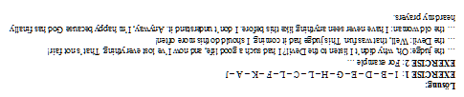

snarl: anschnauzen
provided that: unter der Bedingung
command: Befehl
crowed: voller Menschen
grant sb. a favor: jm. einen Wunsch gewähren

