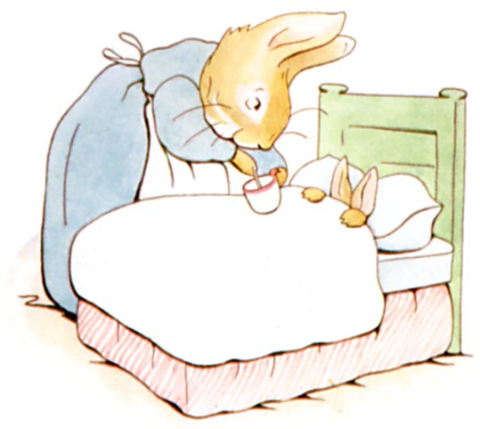

THE TALE OF PETER RABBIT

BY

BEATRIX POTTER

(abridged and simplified version)
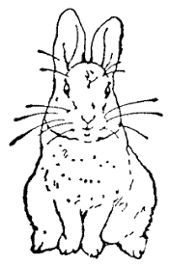

FREDERICK WARNE

FREDERICK WARNE

First published 1902

Frederick Warne & Co., 1902

Printed and bound in Great Britain by William Clowes Limited, Beccles and London

rabbit hole: Kaninchenloch | 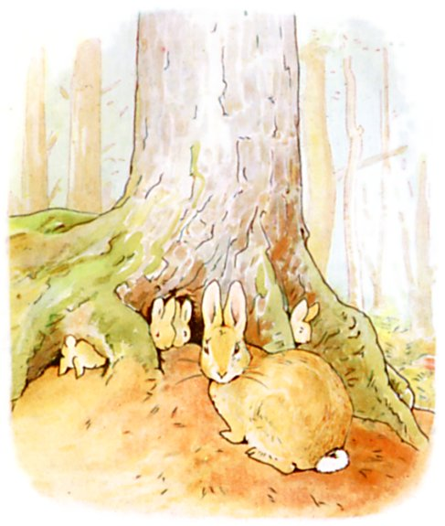 |  |  | Once upon a time there were four little Rabbits, and their names were Flopsy, Mopsy, Cotton-tail, and Peter.  They lived with their mother in a rabbit hole under a big fir tree.
lane: Weg  accident: Unfall  pie: Pastete | 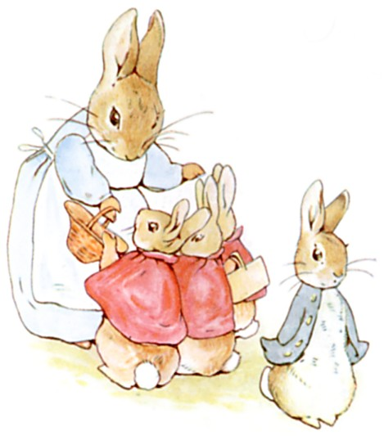 |  |  | 'Now, my dears,' said old Mrs. Rabbit one morning, 'you can go into the fields or down the lane, but don't go into Mr. McGregor's garden. Your father had an accident there; Mrs. McGregor put him in a pie.'
 | 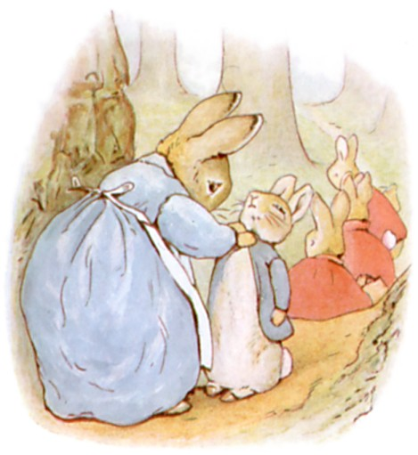 |  |  | 'Now run along, and don't get into trouble. I am going out.'
a basket:  the wood: | 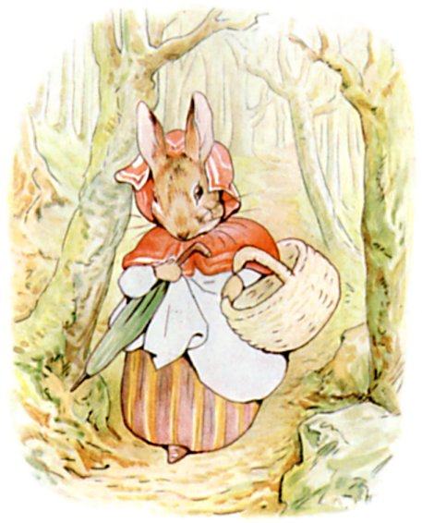 |  |  | Then old Mrs. Rabbit took a basket and her umbrella, and went through the wood to the baker's. She bought some bread.
TASK 1 True or wrong? Find the information in the text.
a. The little rabbits mustn’t play in the fields.  b. They mustn’t go into Mr. McGregor’s garden. c. Peter’s dad is dead. |  |  |  |  | d. Mr. McGregor is married.  e. Peter’s mum goes shopping.  f. She takes a bag with her.
to gather: sammeln  a blackberry: | 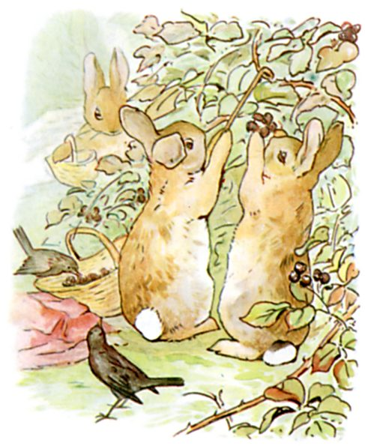 |  |  |  | Flopsy, Mopsy, and Cotton-tail were good little bunnies. They went down the lane to gather blackberries.
straight away: geradewegs  to squeeze: sich quetschen  a gate: | 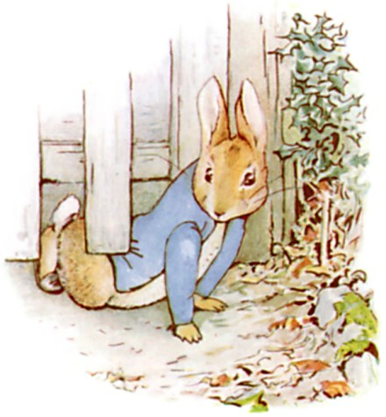 |  |  |  | But Peter ran straight away to Mr. McGregor's garden, and squeezed under the gate!
lettuce:  beans:  radishes: | 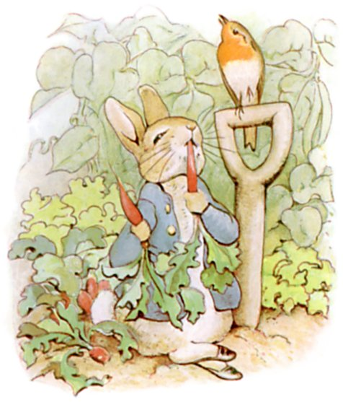 |  |  |  | First he ate some lettuce and some French beans; and then he ate some radishes.
parsley:  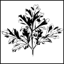 | 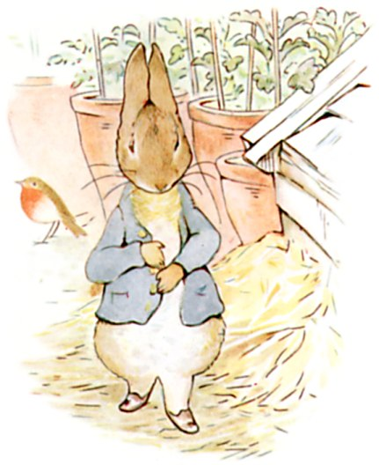 |  |  |  | Then he felt rather sick. He went to look for some parsley.
TASK 2 When do they think or say this? Match the sentences and the four pictures.
a. I want to see Mr. McGregor’s garden!  b. Let’s get some berries for dinner! |  |  | c. These vegetables are delicious.  d. I think I’ve eaten too much.
 | 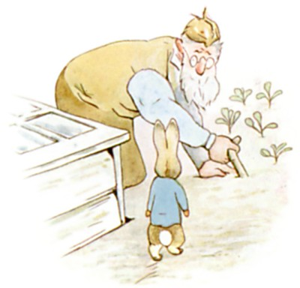 |  |  |  | But there he met Mr. McGregor!
to plant out: umpflanzen  a cabbage:  a rake: | 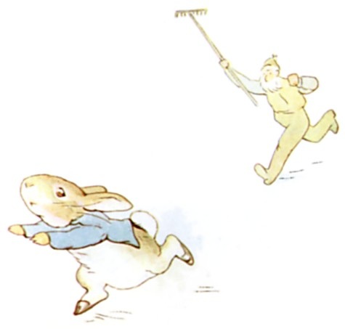 |  |  |  | Mr. McGregor was on his hands and knees. He was planting out young cabbages, but he jumped up and ran after Peter. He waved a rake and called out, 'Stop, thief!’
 | 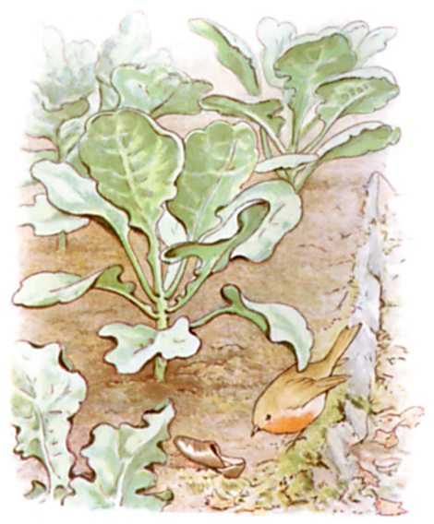 |  |  |  | Peter was terribly frightened; he ran all over the garden because he had forgotten the way back to the gate.  He lost one of his shoes among the cabbages, and the other shoe among the potatoes.
gooseberries:  net: Netz  a button:  brass: Messing | 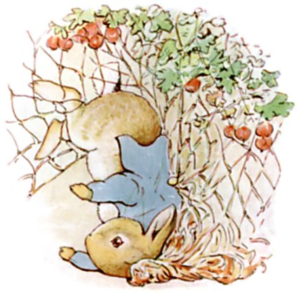 |  |  |  | Then he ran on four legs and went faster. He might have got away if he had not run into a gooseberry net, and got caught by the buttons on his jacket. It was a blue jacket with brass buttons, quite new.
TASK 3 Tick the correct answers; there may be more than one right answer.
a. Mr. McGregor is angry because …
1. he hates rabbits, 2. Peter is stealing his vegetables, 3. Peter has lost his shoes.
b. Peter tries to run away but …
1. Mr. McGregor catches him, 2. he is lost, 3. gets stuck in a net.
to implore: anflehen  sparrow: Spatz  to exert himself: sich anstrengen | 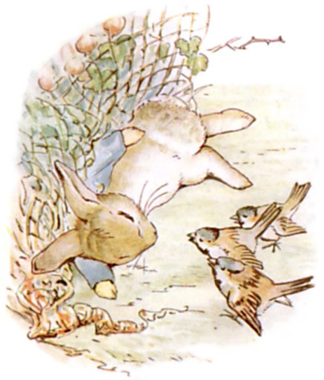 |  |  |  | Peter gave himself up for lost, and cried; but some friendly sparrows heard him. They flew to him, and implored him to exert himself.
a sieve:  to wriggle out: sich herauswinden | 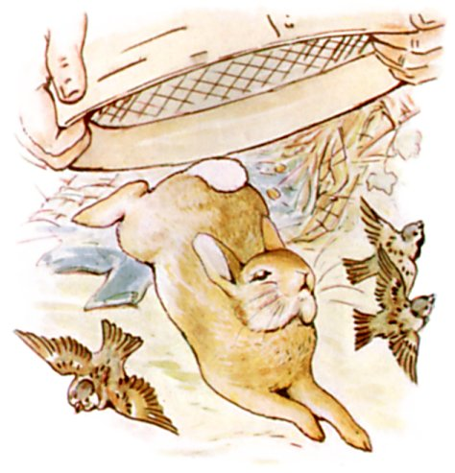 |  |  |  | Mr. McGregor came up with a sieve. He wanted to pop it upon the top of Peter; but Peter wriggled out just in time. He left his jacket behind him.
a tool shed: 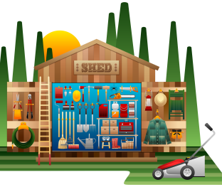 | 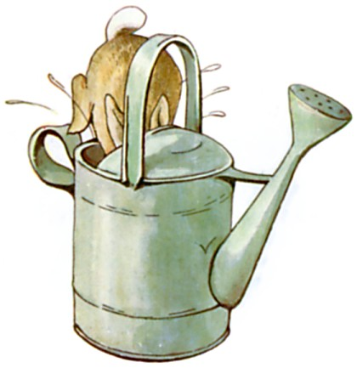 |  |  |  | … and rushed into the tool-shed, and jumped into a can. The can was full of water.
a flower pot:  to sneeze: | 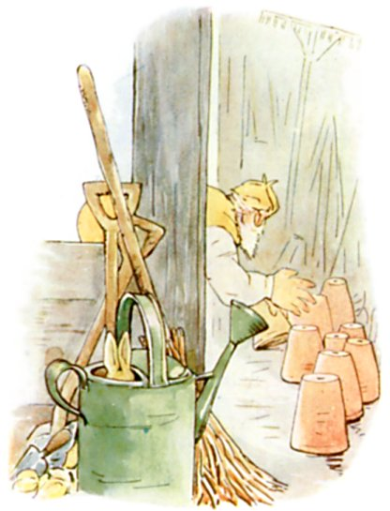 |  |  |  | Mr. McGregor was sure that Peter was somewhere in the tool-shed, perhaps under a flower pot. He began to turn them over, and looked under each.  Presently Peter sneezed—'Kertyschoo!' Mr. McGregor was after him in no time.
TASK 4 Who says or thinks it – Peter, Mr. McGregor, or the sparrows?
a. You can get out! Try harder!  b. Where are you? I’ll find you! |  | c. Oh no, I’m caught!  d. This looks like a good place to hide!
to upset (hier): umkippen  to be tired of sth.: auf etw. keine Lust mehr haben | 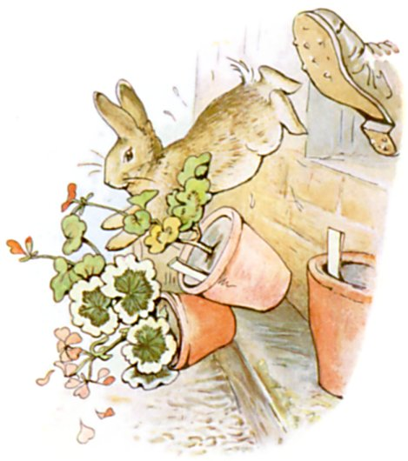 |  |  |  | … and tried to put his foot upon Peter, who jumped out of a window, upsetting three plants. The window was too small for Mr. McGregor, and he was tired of running after Peter. He went back to his work.
out of breath: außer Atem  to wander about: umherlaufen | 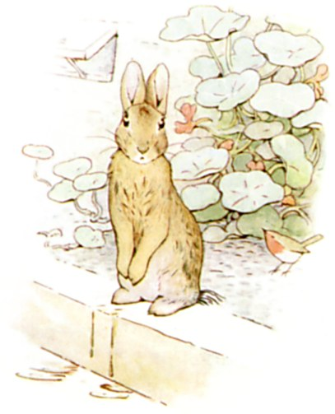 |  |  |  | Peter sat down; he was out of breath and frightened, and he didn’t know which way to go. And he was very wet because he had sat in the can.  After a time he began to wander about and looked all round.
locked and open:  peas: | 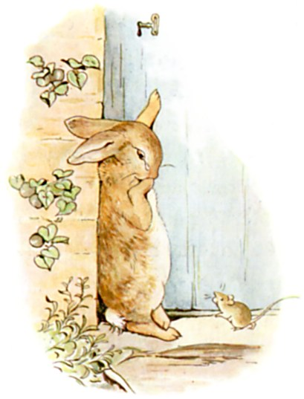 |  |  |  | He found a door in a wall; but it was locked.  An old mouse was running in and out over the stone doorstep. She was carrying peas and beans to her family. Peter asked her for the way to the gate, but she had such a large pea in her mouth that she could not answer. She only shook her head. Peter began to cry.
puzzled: verwirrt  a pond: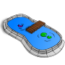  tail: Schwanz  to twitch: zucken | 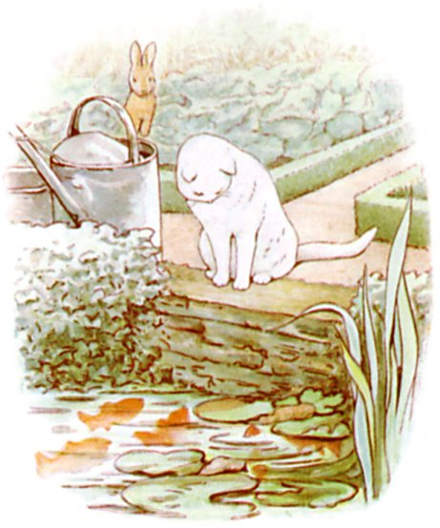 |  |  |  | Then he tried to find his way straight across the garden, but he became more and more puzzled. He came to a pond where Mr. McGregor filled his water-cans. A white cat was staring at some gold-fish. She sat very, very still, but now and then the tip of her tail twitched. Peter thought it best to go away without speaking to her.
TASK 5 Fill in words from the text.
Peter runs away and ____________________ stops following him. But he has a problem: He doesn’t know the ____________________. So he asks a ____________________, but she doesn’t ____________________ his question. Next, he sees a white ____________________, but Peter doesn’t ____________________ to her.
a hoe: 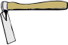  his back was turned towards Peter: Er hatte Peter den Rücken zugewandt | 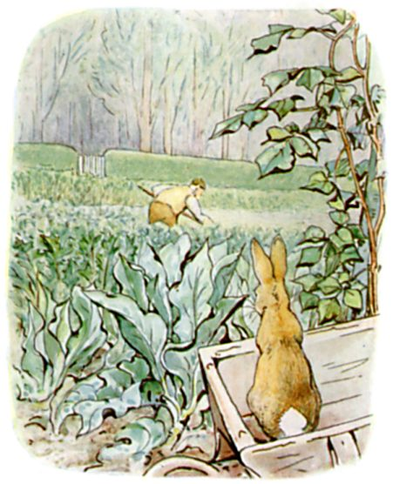 |  |  |  | He went back towards the tool-shed, but suddenly he heard the noise of a hoe—scr-r-ritch, scratch, scratch, scritch. Peter jumped underneath the bushes. But as nothing happened, he came out, and climbed upon a wheelbarrow and looked around. The first thing he saw was Mr. McGregor. His back was turned towards Peter, and behind him was the gate!
corner: Ecke  to slip: durchschlüpfen | 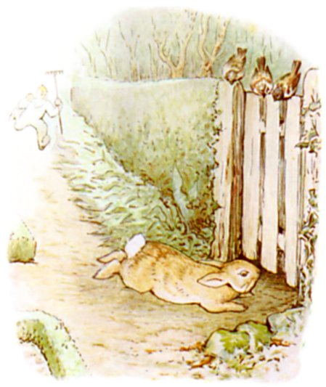 |  |  |  | Peter got down very quietly off the wheelbarrow and started running as fast as he could.  Mr. McGregor was at the corner, but Peter did not care. He slipped underneath the gate, and was safe at last in the wood outside the garden.
 | 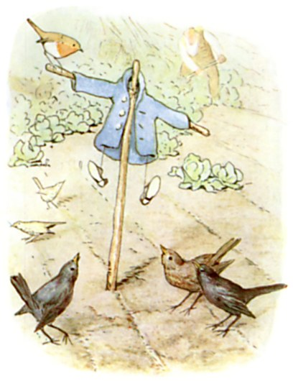 |  |  |  | Mr. McGregor hung up the little jacket and the shoes for a scare-crow to frighten the blackbirds.  Peter never stopped running or looked behind him till he got home.
TASK 6 What do you call these things? Find the right words in the text.
________________ ________________ 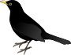 ________________
a fortnight = two weeks | 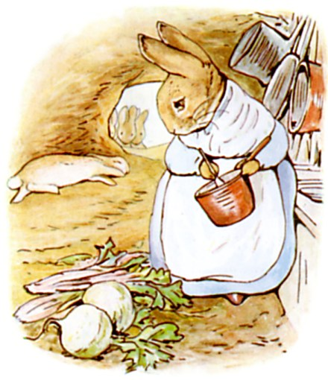 |  |  |  | He was so tired that he fell down upon the nice soft sand on the floor of the rabbit-hole and closed his eyes. His mother was cooking. She wondered what he had done with his clothes. It was the second little jacket and pair of shoes that Peter had lost in a fortnight!
chamomile:  one table-spoonful: ein Teelöffel voll | 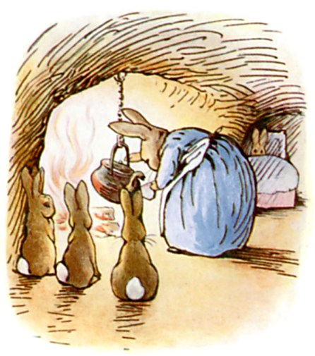 |  |  |  | Peter was not very well during the evening.  His mother put him to bed, and made some chamomile tea; and she gave a dose of it to Peter!  'One table-spoonful to be taken at bed-time.'
supper = dinner | 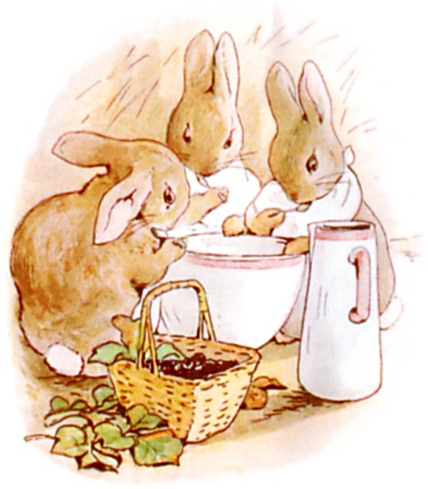 |  |  |  | But Flopsy, Mopsy, and Cotton-tail had bread and milk and blackberries for supper.
TASK 8 True or wrong?
a) Peter’s mum is angry.
b) Peter doesn’t eat dinner.
c) Peter’s siblings drink tea for dinner.

.

TASK 9 Content. Underline the right words!
Peter is a little dog / boy / rabbit. One day his mother / father / sister goes out to buy blueberries / bread / milk. She tells Peter and his friends / brothers and sisters / cousins that they must not go down the lane / into Mr. McGregor’s garden / into the fields. However, Peter doesn’t listen. He jumps over / squeezes under / walks through the gate into the garden. There he sleeps / eats / plays a lot. But then he sees Mr. McGregor / a cat / a tool shed. He is angry and tries to shoot / kill / catch Peter. Peter runs away, but loses his shoes and his trousers / jacket / hat. Then he hides in a watering can / flower pot / wheelbarrow. When Mr. McGregor finds him there, he escapes through a small door / hole / window. After that, Mr. McGregor goes back to work / into the tool shed / into the house. But Peter is very happy / frightened / wet because he doesn’t know the way out of the garden. In the end he sees the gate / the wood / the cat and runs for it. In the evening, Peter doesn’t feel bad / good / tired.

TASK 10 Vocabulary: In the garden. Fill in the words from the box.
scarecrow – wheelbarrow – potatoes – peas – sparrow – mice – pond – blackberries – chamomile – holes – tool shed

a) Mr McGregor makes a _______________________ with Peter’s jacket to frighten the birds.
b) Chips are usually made from _______________________.
c) A _______________________ is a little bird.
d) You can keep fish in a _______________________.
e) _______________________ tea helps when you’re sick.
f) Rabbits live in _______________________ in the ground.
g) The hoes and the rakes are in the _______________________.
h) Cats like to hunt and eat _______________________.
i) _______________________ are small, round and green.
j) _______________________ are sweet and delicious.
k) If something is too heavy to carry, you can use a _______________________ to transport it.

TASK 11 Grammar: The simple past / irregular verbs. Fill in the right verb in the simple past!
find – fly – eat – lose – meet – sit – jump – run – make – want – hide
a) Peter _______wanted__________ to go into Mr. McGregor’s garden.
b) There he _______________________ lots of vegetables.
c) Then he _______________________ Mr. McGregor.
d) Peter _______________________ away from him.
e) While he was running, he _______________________ his shoes.
f) When he got caught in a net, a few birds _____________________ to him.
g) He _______________________ in a watering can.
h) But Mr. McGregor _______________________ him.
i) Peter _______________________ out of the window.
j) He saw a cat. The cat _______________________ by the pond.
j) In the evening, his mother _______________________ him some chamomile tea.

TASK 12 Grammar: The negation of the simple past. These sentences are wrong. Negate them using didn’t + infinitive. Then correct them using the phrases from the box. Use the simple past!
go down the lane – have milk, bread and blackberries – buy bread – go back to work – eat lettuce and radishes

a) Flopsy, Mopsy and Cotton-tail went into Mr. McGregor’s garden. -
No, they __didn’t go__ into Mr. McGregor’s garden. They __went down the lane__.
b) Mr. McGregor caught Peter. – No, he _______________________ Peter. He __________________________________________________________________.
c) Peter ate lots of apples. – No, he _______________________ any apples. He __________________________________________________________________.
d) Mrs. Rabbit bought some sugar. – No, she _______________________ any sugar. She _______________________________________________________________.
e) Flopsy, Mopsy and Cotton-tail drank coffee for dinner. – No, they _______________________ coffee. They _________________________________ ___________________________________________________________________.

TASK 13 Grammar: Fill in the verbs in the simple past (I walked) and the past progressive (I was walking).
REMEMBER:
Das simple past bildet man mit –ed oder der 3. Spalte der unregelmäßigen Verben. Man verwendet es für kurze, plötzliche Handlungen.
Das past progressive bildet man mit was / were + ing-Form. Man verwendet es für länger andauernde Handlungen, die sich noch im Verlauf befinden.

The students were working on their projects when the teacher came back.
Andauernde Handlung………………….wird von kurzer, plötzlich einsetzender unterbrochen.

While Bob and Kate were reading, I was watching TV.
Zwei längere Handlungen laufen parallel ab.

a) Mr. McGregor _______________________ (plant) cabbages when he suddenly _______________________ (see) a rabbit.
b) Peter’s mother _______________________ (cook) when Peter _______________________ (come) home.
c) While Peter _______________________ (steal) food from Mr. McGregor’s garden, his brothers and sisters _______________________ (gather) blueberries.
d) Peter _______________________ (walk) past a cat that _______________________ (stare) at some goldfish in the pond.
e) Peter _______________________ (run) past Mr. McGregor while the old man _______________________ (work) in the garden.

TASK 14 Writing. The next day, Peter’s cousin Benjamin comes to visit. Benjamin wants to go back into Mr. McGregor’s garden to fetch Peter’s jacket and shoes. Write down what happens to the two rabbits.

Lösungen:

TASK 1 True or wrong? Find the information in the text.
a. The little rabbits mustn’t play in the fields. – W  b. They mustn’t go into Mr. McGregor’s garden. – T  c. Peter’s dad is dead. – T | d. Mr. McGregor is married. – T  e. Peter’s mum goes shopping. – T  f. She takes a bag with her. – W

TASK 2 When do they think or say this? Match the sentences and the four pictures.
a. I want to see Mr. McGregor’s garden! – 2  b. Let’s get some berries for dinner! – 1 | c. These vegetables are delicious. – 3  d. I think I’ve eaten too much. – 4

TASK 3 Tick the correct answers; there may be more than one right answer.
a. Mr. McGregor is angry because …
1. he hates rabbits, 2. Peter is stealing his vegetables, 3. Peter has lost his shoes.
b. Peter tries to run away but …
1. Mr. McGregor catches him, 2. he is lost, 3. gets stuck in a net.

TASK 4 Who says or thinks it – Peter, Mr. McGregor, or the sparrows?
a. You can get out! Try harder!  b. Where are you? I’ll find you! | c. Oh no, I’m caught!  d. This looks like a good place to hide!

TASK 5 Fill in words from the text.
Peter runs away and Mr. McGregor stops following him. But he has a problem: He doesn’t know the way. So he asks a mouse, but she doesn’t answer his question. Next, he sees a white cat, but Peter doesn’t speak to her.

TASK 6 What do you call these things? Find the right words in the text.
scarecrow wheelbarrow blackbird

TASK 8 True or wrong?
a) Peter’s mum is angry. – wrong
b) Peter doesn’t eat dinner. – true
c) Peter’s siblings drink tea for dinner. – wrong

TASK 9 Circle the right words!
Peter is a little dog / boy / rabbit. One day his mother / father / sister goes out to buy blueberries / bread / milk. She tells Peter and his friends / brothers and sisters / cousins that they must not go down the lane / into Mr. McGregor’s garden / into the fields. However, Peter doesn’t listen. He jumps over / squeezes under / walks through the gate into the garden. There he sleeps / eats / plays a lot. But then he sees Mr. McGregor / a cat / a tool shed. He is angry and tries to shoot / kill / catch Peter. Peter runs away, but loses his shoes and his trousers / jacket / hat. Then he hides in a watering can / flower pot / wheelbarrow. When Mr. McGregor finds him there, he escapes through a small door / hole / window. After that, Mr. McGregor goes back to work / into the tool shed / into the house. But Peter is very happy / frightened / wet because he doesn’t know the way out of the garden. In the end he sees the gate / the wood / the cat and runs for it. In the evening, Peter doesn’t feel bad / good / tired.

TASK 10
a) Mr McGregor makes a scarecrow (Vogelscheuche) with Peter’s jacket to frighten the birds.
b) Chips are usually made from potatoes (Kartoffeln).
c) A sparrow (Spatz) is a little bird.
d) You can keep fish in a pond. (Teich)
e) Chamomile (Kamille) tea helps when you’re sick.
f) Rabbits live in holes (Löcher) in the ground.
g) The hoes and the rakes are in the tool shed. (Werkzeugschuppen)
h) Cats like to hunt and eat mice. (Mäuse)
i) Peas (Erbsen) are small, round and green.
j) Blackberries (Brombeeren) are sweet and delicious.
k) If something is too heavy to carry, you can use a wheelbarrow (Schubkarre) to transport it.

TASK 11 Grammar: The simple past / irregular verbs. Fill in the right verb in the simple past!
find – fly – eat – lose – meet – sit – jump – run – make – want – hide
a) Peter _______wanted__________ to go into Mr. McGregor’s garden.
b) There he ate lots of vegetables.
c) Then he met Mr. McGregor.
d) Peter ran away from him.
e) While he was running, he lost his shoes.
f) When he got caught in a net, a few birds flew to him.
g) He hid in a watering can.
h) But Mr. McGregor found him.
i) Peter jumped out of the window.
j) He saw a cat. The cat sat by the pond.
j) In the evening, his mother made him some chamomile tea.

TASK 12 Grammar: The negation of the simple past. These sentences are wrong. Negate them using didn’t + infinitive. Then correct them using the phrases from the box. Use the simple past!
go down the lane – go back to work – eat lettuce and radishes – buy bread – have milk, bread and blackberries

a) Flopsy, Mopsy and Cotton-tail went into Mr. McGregor’s garden. -
No, they __didn’t go__ into Mr. McGregor’s garden. They __went down the lane__.
b) Mr. McGregor caught Peter. – No, he didn’t catch Peter. He went back to work.
c) Peter ate lots of apples. – No, he didn’t eat any apples. He ate lettuce and radishes.
d) Mrs. Rabbit bought some sugar. – No, she didn’t buy any sugar. She bought some bread.
e) Flopsy, Mopsy and Cotton-tail drank coffee for dinner. – No, they didn’t drink coffee. They had milk, bread and blackberries.

TASK 13 Grammar: Fill in the verbs in the simple past (I walked) and the past progressive (I was walking).
a) Mr. McGregor was planting cabbages when he saw Peter.
b) Peter’s mother was cooking when Peter came home.
c) While Peter was stealing food from Mr. McGregor’s garden, his brothers and sisters were gathering blueberries.
d) Peter walked past a cat that was staring at some goldfish in the pond.
e) Peter ran past Mr. McGregor while he was working in the garden.

