Inspector Graham and the Diamond Necklace
TASK 1 - COMPREHENSION Skim the text and answer the wh-questions:
a. Who: What are the names of the six people in the story?
b. Where: Where does the story take place?
c. What: What is the crime?
Today Inspector Graham’s old friend, Jane Myers, is celebrating her 40th birthday. Inspector Graham takes an early train to help Jane with the party preparations. Jane opens the door. She is already in her pretty red evening dress, and she looks very happy and excited. “Jordan Graham! It’s so nice to see you! Would you like something to drink? My sister Aubrey has made lemonade, it’s delicious ...“
A
“Thanks, Jane,“ the inspector says. “And happy birthday! What can I do to help?“
“Well, you can help Aubrey in the kitchen,“ Jane says. “Or you can help Nick, Heather and Marcus - I think they’re decorating the living room.“

Inspector Graham helps himself to a glass of lemonade; then he goes into the kitchen, where Aubrey is preparing snacks. They’re making small ham and cheese sandwiches when suddenly the kitchen door opens. It’s Jane, but now she doesn’t seem happy at all. Her face is very white. “Jordan, I have to talk to you,“ she says quietly. “Can you come with me, please?“
B
“Jane, what’s wrong?“ Aubrey asks, worried. “Are you OK?“
“I’ll tell you later. Don’t worry,“ Jane answers, but her voice is shaking.
Inspector Graham follows Jane. They walk up the stairs and into Jane’s bedroom; then Jane closes the door behind them.
“What’s the problem, Jane?“ he asks. His friend takes a deep breath. Then she opens the drawer of her night table. It is empty.
“My diamond necklace was in here,“ she says. She sounds close to tears. “It’s very expensive - that’s why I usually keep it in my safe. Fifteen minutes ago, I wanted to put it on, but then Aubrey called me from the kitchen because she couldn’t find the knives. I didn’t want to unlock the safe again, so I just put the necklace in the drawer and went back downstairs. While I was helping Aubrey, you arrived. And when I came back here, the necklace was gone!“
“Don’t worry, dear, we’ll find it,“ Inspector Graham says. “I’m afraid the thief might be one of your guests.“
“What? No!“, Jane gasps. “That’s impossible!“
“Well,“ Inspector Graham says, “the thief knew where the necklace was. Did you close the curtains and the door when you took it out of the safe?“
“I closed the curtains earlier this afternoon,“ Jane says, wringing her hands, „but I think the door was open.“
“Then somebody was in the corridor on the second floor,“ Inspector Graham says, „and they saw you put the necklace in the drawer. I’ll talk to everybody.“
Nick, Marcus and Heather are still in the living room. Inspector Graham calls each of them into the kitchen - one after the other - and asks them one question: „What were you doing 15 minutes ago?“

Nick: “I was decorating the living room. I was alone. I think Heather had gone to the bathroom and Marcus wanted to fetch some drinks from the cellar. Oh, and I was listening to music, so I didn’t hear anything. Perhaps somebody climbed in through a window - I think I saw earlier that the window in Heather’s office was open!“
C

Marcus: “I wanted to get a bottle of wine from the cellar while the others were decorating the living room. But I couldn’t find anything to drink - even though I searched for at least five minutes! Anyways, I can’t believe that somebody just walked into the house and stole something right from Jane’s night table drawer. You’re not even safe in your own home these days!“
D
E
Heather: “Poor Jane! Who would do such a thing - and on her birthday, too! Unfortunately, I didn’t hear or see anything. Nick and I were hanging garlands in the living room, but then I looked into the mirror and saw that my make-up was all smudged. So I went to the bathroom to fix it. I hope you’ll find the person who did this!“
TASK 2 - COMPREHENSION Which picture fits best? Explain your choice.
Pictures created with storyboardthat.com
- 1. 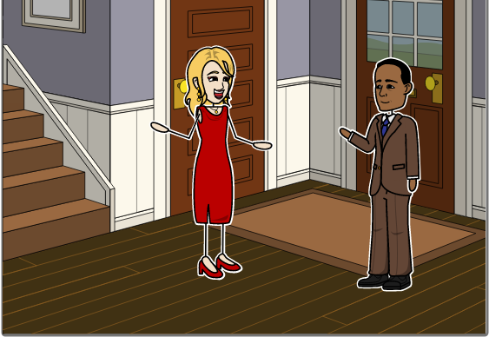 2. 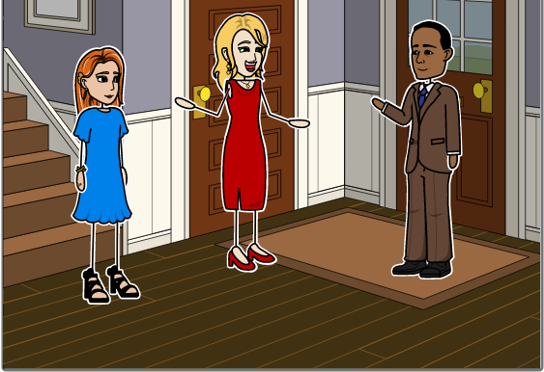 3. 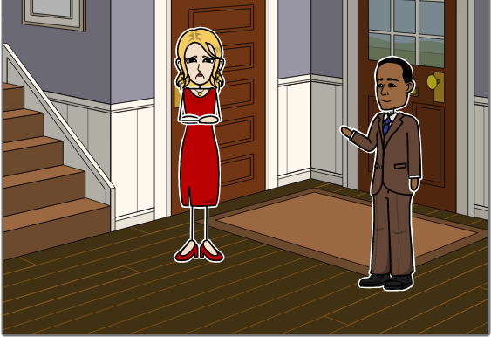
- 1. 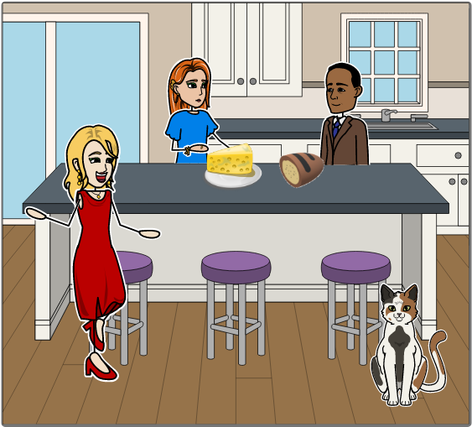 2. 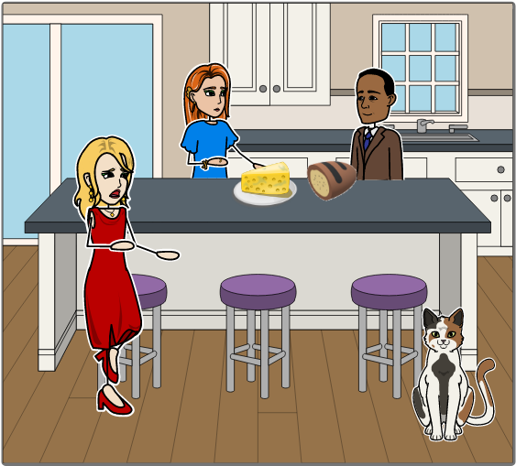 3. 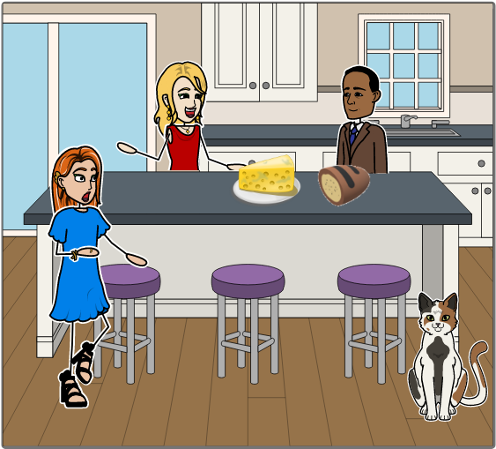
- 1. 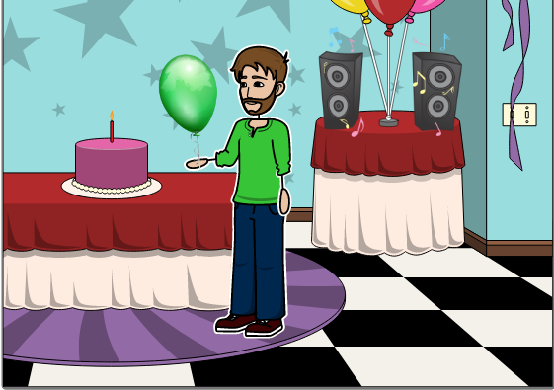 2. 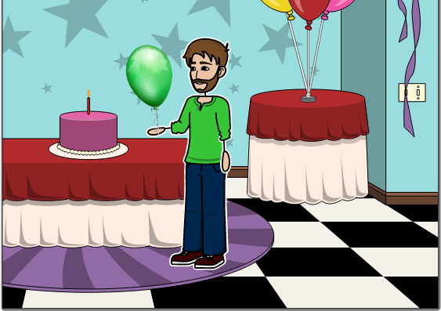 3. 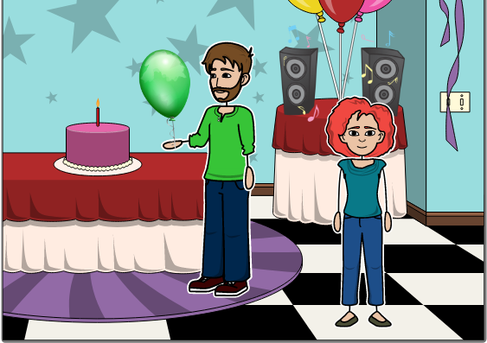
- 1. 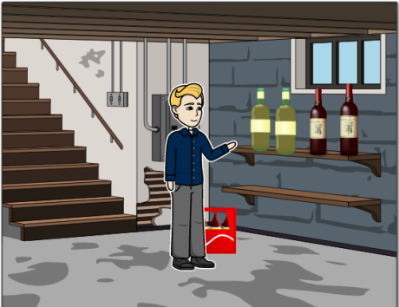 2. 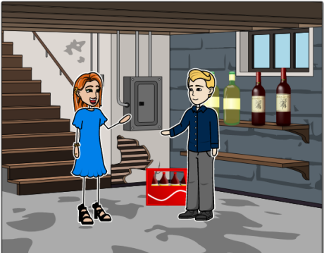 3. 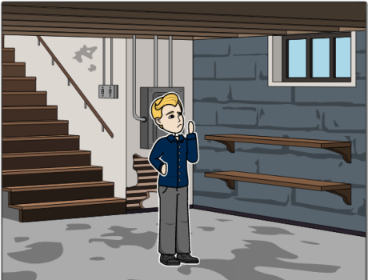
- 1. 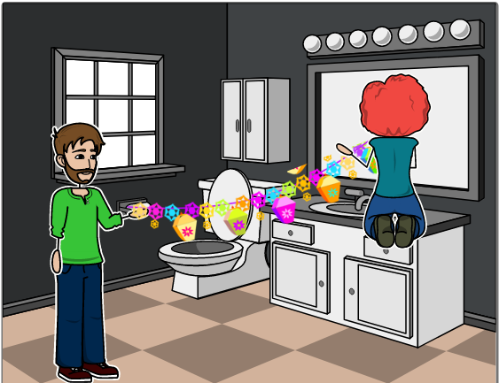 2. 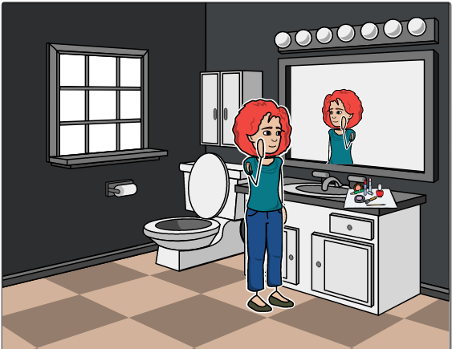3. 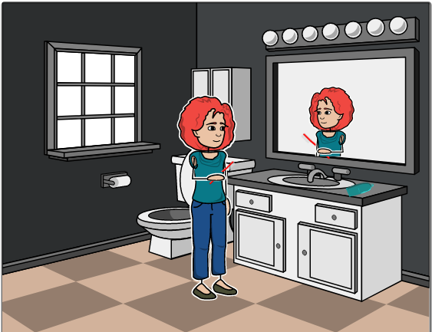

TASK 3 - COMPREHENSION Put the events in the right order.
 | - Aubrey calls from the kitchen.
 | - Inspector Graham arrives.
 | - Jane returns to her room and discovers that the necklace is gone.
1 | - Jane goes upstairs to put on her diamond necklace. Somebody sees her put it in the drawer.
 | - Jane goes downstairs to help Aubrey.

TASK 4 After the interviews, Inspector Graham listens to the guests’ statements again. Suddenly, he realizes that one person has lied to him. Who is it?

TASK 5 Vocabulary: In the house. Put the words together from the syllables in the box.
cel ● cur ● cor ● dor ● draw ● en ● er ● fice ● ing ● kitch ● lar ● liv ● mir ● of ● ri ● ror ● tain
- You can see yourself in it. | M | I | R | R | O | R
- You make food in the ... |  |  |  |  |  | 1
- It’s below the ground floor. |  |  |  |  | 2
- When you close the ...s, it gets dark. |  |  |  | 3
- You can pull it out and keep things in it. |  |  |  | 4 | 5
- There’s a PC and a printer in my ... | 6
- There’s a TV and a couch in the ... room.
- A passage with doors.

TASK 6 Grammar: The past progressive. Inspector Graham has written a report about the events. Fill in the verbs in the simple past and the past progressive.

REMEMBER Simple past and past progressive
Tense | The simple past | The past progressive
Form | infinitive + ed / “2nd column“  to walk → I walked  To come → I came | was / were + infinitive + ing  to walk → I / he / she / it was walking  You / we / they were walking
Use | For a short action:  When I came in,  Actions happening one after the other:  (First) I came in and (then) I saw Tim and Lisa. | For a longer or repeated action:  Tim was reading a book. (longer action)  Lisa was sticking post-its onto the wall. (repeated action)  Actions happening at the same time:  While Tim was reading a book, Lisa was sticking post-its onto the wall.

- When I ___________________________ (to arrive), Jane and her sister ___________________________ (to work) in the kitchen.
- At the same time, Nick ___________________________ (to decorate) the living room and___________________________ (to listen) to music.
- While Heather ___________________________ (to re-do) her make-up, Marcus ___________________________ (to look) for drinks in the basement.
- When Jane ___________________________ (to return) to her room, she ___________________________ (discover) that the necklace was gone.
- She ___________________________ (to walk) into the kitchen while I ___________________________ (to make) sandwiches.

Answers

TASK 1
Who: Inspector Graham, Jane (Inspector Graham’s friend who is celebrating her birthday), Aubrey (Jane’s sister); other guests: Nick, Heather and Marcus
Where: At Jane’s house, where she is celebrating her birthday
What: Somebody steals Jane’s diamond necklace.

TASK 2
A1: Jane looks happy and she is alone; Aubrey is in the kitchen at the time.
B2: It’s Jane who has just entered the room, and she looks unhappy.
C1: Nick is alone (Heather is in the bathroom), and he is listening to music.
D3: Marcus said he couldn’t find any drinks; also, Aubrey was in the kitchen at the time.
E2: Heather is fixing her make-up, not decorating the bathroom or brushing her teeth.

TASK 3
2A, 4B, 5C, 1D, 3E

TASK 4
Marcus is lying. He says that he was in the living room (on the ground floor) and in the cellar. But he knew that the necklace had been in Jane’s night table although Graham hadn’t told him. Jane said that she didn’t usually keep the necklace there, which means Marcus was watching her when she put it in the drawer.

TASK 5
A. mirror; B: kitchen; C: cellar; D: curtains; E: drawer; F: office; G: living; H: corridor

TASK 6
- arrived (short action) / were working (longer action)
- was decorating / (was) listening (two actions happening at the same time)
- was re-doing / was looking (two actions happening at the same time)
- returned / discovered (two short actions)
- walked / was making (short action interrupts longer action)

garland: Girlande
smudged: verschmiert

