RIKKI-TIKKI-TAVI
A story by Rudyard Kipling, abridged and simplified
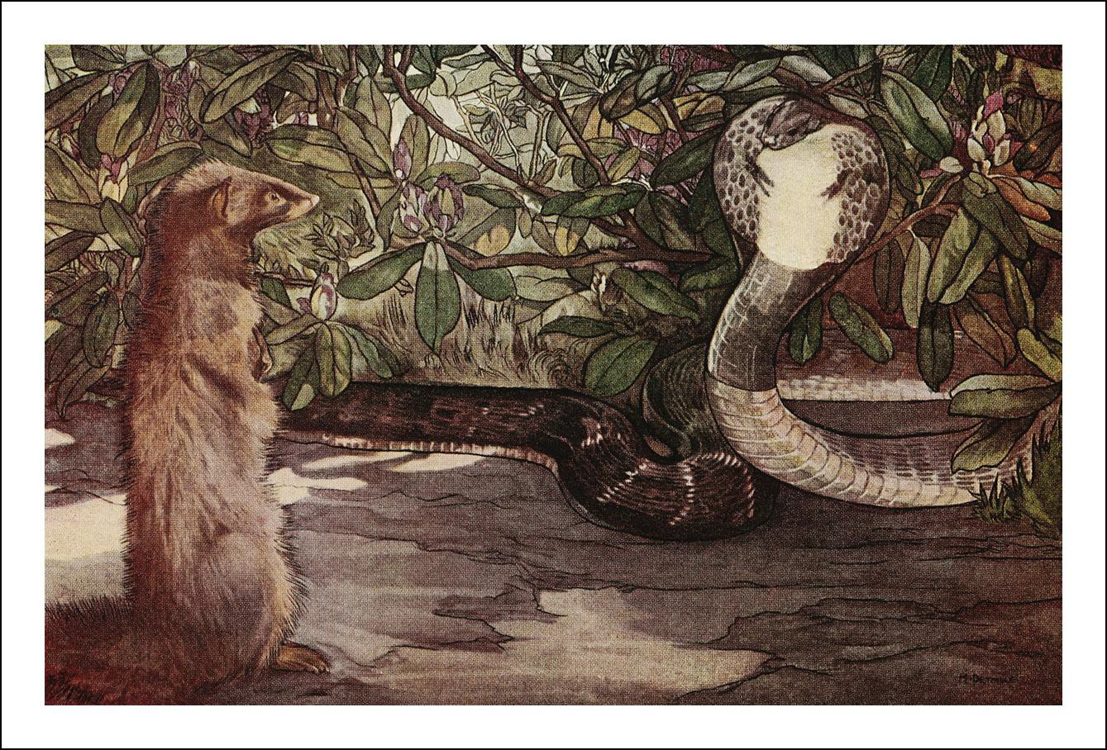
Rikki-Tikki-Tavi was a mongoose. He looked a little like a cat, but his head looked more like a weasel’s. His eyes and nose were pink; he could fluff up his tail till it looked like a bottle-brush, and his cry as he ran through the long grass was: "Rikk-tikk-tikki-tikki-tchk!"
One day, a flood washed him out of the hole where he lived with his father and mother, and carried him down a roadside ditch. He clung to a piece of wood as long as he could, but finally he fainted. When he woke up, he was lying in the hot sun in a garden, and a small boy was saying: "Here's a dead mongoose. Let's bury1 him."
"No," said his mother; "let's take him inside and dry him. Perhaps he isn't really dead."
They took him into the house, and a big man picked him up and said he was not dead; so they wrapped him in cotton-wool, and warmed him, and he opened his eyes and sneezed.
"Now," said the big man (he was an Englishman who had just moved into the bungalow); "don't frighten him, and we'll see what he'll do."
It is the hardest thing in the world to frighten a mongoose, because he is full of curiosity2. Rikki
looked at the cotton-wool, decided that it was not good to eat, ran all round the table, sat up and put his fur3 in order, and jumped on the small boy's shoulder.
"Don't be frightened, Teddy," said his father. "That's his way of making friends." "Ouch! He's tickling4 under my chin," said Teddy.

1 bury: begraben
2 curiosity: Neugier
3 fur: Fell

Rikki-tikki looked into the boy’s shirt, snuffed5 at his ear, and climbed down to the floor, where he sat rubbing6 his nose.
"Good gracious," said Teddy's mother, "and that's a wild animal! He must be so tame7 because we've been nice to him."
"All mongooses are like that," said her husband. "If Teddy doesn't pick him up by the tail, or try to put him in a cage, he'll run in and out of the house all day long. Let's give him something to eat." They gave him a little piece of meat. Rikki-tikki liked it a lot, and when it was finished he went out into the veranda and sat in the sunshine and fluffed up his fur to make it dry completely. Then he felt better.
"There are many things to find out about in this house," he said to himself, "and I will stay and find out."
He spent the day running around in the house and looking at everything. When Teddy went to bed Rikki-tikki climbed up too; but he had to get up and listen to every noise all through the night, and find out what made it. Teddy's mother and father came in to look at their boy, and Rikki-tikki was awake on the pillow. "I don't like that," said Teddy's mother; "he could bite the child." "He won’t do that," said the father. "Teddy's safer with that little animal than if he had a bloodhound to watch him. If a snake came into the room now—"
But Teddy's mother wouldn't think of anything so awful.
EXERCISE 1 Tick the right answers. Sometimes more than one answer is correct.
1. Rikki-Tikki-Tavi …
a) is a wild animal b) used to live in a garden with his mother c) eats cotton-wool d) is frightened
2. Teddy …
a) runs around the table b) is a boy c) tries to put Rikki in a cage d) finds Rikki in the garden
3. Mongooses …
a) have a fluffy tail b) are scared of people c) look like little dogs d) have pink ears
4. Teddy’s mother …
a) thinks that Rikki is dead b) is surprised by Rikki’s behavior c) thinks Rikki shouldn’t sleep in Teddy’s bed

Early in the morning Rikki-tikki came to breakfast in the veranda riding on Teddy's shoulder, and they gave him banana and some boiled egg; and he sat on all their laps.
Then Rikki-tikki went out into the garden. It was a large garden, with big bushes, lime and orange trees, bamboo, and high grass. Rikki-tikki licked his lips. "This is a good hunting-ground," he said, and he ran up and down the garden, snuffing here and there, till he heard very sad voices in a thorn- bush.

4 tickle: kitzeln
5 snuff: schnüffeln
6 rub: reiben
7 zahm

It was Darzee, the tailor-bird, and his wife. They had made a beautiful nest and had filled it with soft cotton. The nest swayed to and fro, as they sat on the rim8 and cried.

"What is wrong?" asked Rikki-tikki.
"We are very miserable," said Darzee. "One of our babies fell out of the nest yesterday and Nag ate him."
"Hm!" said Rikki-tikki," that is very sad—but I am a stranger here. Who is Nag?"
Darzee and his wife only hid in the nest without answering. From the high grass there came a low hiss—a horrible cold sound that made Rikki-tikki jump back. Then out of the grass rose up the head and spread hood of Nag, the big black cobra. He looked at Rikki-tikki with the evil snake's eyes that never change their expression.
EXERCISE 2 Find words in the text that mean the following:
gekocht ( ), Schoß ( ), Jagdgebiet
( ), schnüffeln ( ), hin- und herschwanken
( ), Zischen ( ), Nackenschild ( )

"Who is Nag?" he said. "I am Nag. The great god Brahm put his mark upon all our people when the first cobra spread his hood to keep the sun off Brahm as he slept. Look, and be afraid!"
He spread out his hood more than ever, and Rikki-tikki saw the spectacle-mark9 on the back of it.
He was afraid for the minute; but it is impossible for a mongoose to stay frightened for a long time. Rikki-tikki had never met a live cobra before, his mother had fed him on dead ones, and he knew that all a mongooses had to fight and eat snakes. Nag knew that too, and at the bottom of his cold heart he was afraid.
"Well," said Rikki-tikki, and his tail began to fluff up again, "marks or no marks, do you think it is right to eat baby birds?"
Nag was thinking to himself, and watching the grass behind Rikki-tikki. He knew that mongooses in the garden meant death sooner or later for him and his family; but he wanted to get Rikki-tikki off his guard. So he dropped his head a little, and put it on one side.
"Let us talk," he said. "You eat eggs. Why should not I eat birds?" "Behind you! Look behind you!" sang Darzee, the tailor-bird.
Rikki-tikki knew that he had to be quick. He jumped up in the air as high as he could, and just under him whizzed by the head of Nagaina, Nag's wicked wife. She had crept up behind him to kill him; and he heard her angry hiss as she missed him. He came down almost across her back. If he had been an old mongoose, he would have known what to do: to break her back with one bite. But he was afraid of the terrible return-stroke of the cobra. He bit her, but did not bite long enough. Nagaina was wild and angry.

8 rim: Rand
9 spectacle-mark: brillenförmige Zeichnung

"Evil, evil Darzee!" said Nag and tried to reach the nest in the bush; but Darzee had built it high up in the bush.
Rikki-tikki felt his eyes growing red and hot (when a mongoose's eyes grow red, he is angry). He looked all around him, but Nag and Nagaina had disappeared into the grass. Rikki-tikki did not follow them because he wasn’t sure that he could kill two snakes at once. So he sat down to think. It was a serious matter10 for him.

EXERCISE 3 What do these pictures show? Find words in the text.
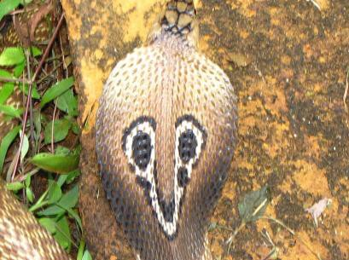  Jayendra Chiplunkar, CC BY-SA 3.0, via Wikimedia Commons (cropped) | 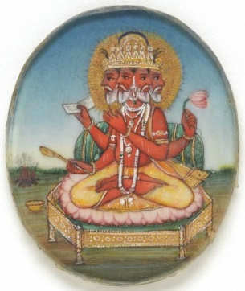  Unknown author, Public domain, via Wikimedia Commons | Bucknill, John A. S.; Chasen, Frederick N.; Kloss, C. Boden; Levett-Yeats, G. A., CC BY 2.0, via Wikimedia Commons (cropped)
a) s_ _ _ _ _ _ _ _ m_ _ _ | b) the god B _ _ _ _ | c) two t _ _ _ _ _- _ _ _ _s

The old books of natural history say that when the mongoose fights the snake and gets bitten, he runs off and eats some herb11 that cures12 him. That is not true. It is only his quickness that saves him. And as no eye can follow the motion of a snake's head when it attacks, that makes things much more wonderful than any magic herb. Rikki-tikki was pleased that he had just escaped a cobra although he was still very young. When Teddy came running down the path, Rikki-tikki was ready to be petted. But just as Teddy was stooping13, something moved a little in the dust, and a low voice said: "Be careful. I am death!" It was Karait, the dusty brown snake that lies on the dusty earth; and his bite is as dangerous as the cobra's. But he is so small that nobody thinks of him, and so he kills many people.
Rikki-tikki's eyes grew red again, and he danced up to Karait. If Rikki-tikki had only known that he was doing a much more dangerous thing than fighting Nag! Karait is very small and very quick. But Rikki did not know: his eyes were all red, and he jumped back and forth, looking for a good place to bite. Karait attacked. Rikki jumped sideways and tried to run in, but the little dusty gray head almost touched his shoulder, and he had to jump over the body.
Teddy shouted to the house: "Oh, look here! Our mongoose is killing a snake!"; and Rikki-tikki heard a scream from Teddy's mother. His father ran out with a stick, but by the time he came up, Rikki had already bitten Karait in the neck and killed him.

10 a serious matter: eine ernste Angelegenheit
11 herb: Pflanze
12 cure: heilen
13 stoop: sich herunterbeugen

He went away for a dust-bath under the bushes, while Teddy's father beat the dead Karait. "Why is he doing that?" thought Rikki-tikki. "I have killed him"; and then Teddy's mother picked him up and hugged him. She cried and said that he had saved Teddy from death. Teddy looked scared. Rikki- Tikki was amused; of course, he did not understand why they were so excited. But Rikki was really enjoying himself.
EXERCISE 4 Answer the questions.
- What do old history books say about mongooses?
- Does the narrator of the story agree with the explanation?
- Why is Karait so dangerous?

That night, at dinner, he could have eaten lots of nice things; but he remembered Nag and Nagaina. A full meal makes a mongoose slow and lazy; and he didn’t want to be slow.
Teddy carried him off to bed. But as soon as Teddy was asleep he went off for his nightly walk round the house, and in the dark he met Chuchundra, the muskrat14.

"Don't kill me," said Chuchundra, almost crying. "Rikki-tikki, don't kill me." "Do you think a snake-killer kills muskrats?" said Rikki-tikki scornfully15.
"Those who kill snakes get killed by snakes," said Chuchundra, more sadly than ever. "And how can I be sure that Nag won't mistake me for you some dark night?"
"Don’t worry," said Rikki-tikki; "Nag is in the garden, and I know you don't go there." "My cousin Chua, the rat, told me—" said Chuchundra, and then he stopped.
"Told you what?"
"H'sh! Nag is everywhere, Rikki-tikki. You should have talked to Chua in the garden." "I didn't—so you must tell me. Quick, Chuchundra, or I'll bite you!"
Chuchundra sat down and cried. "I am a very poor man," he sobbed. "I mustn't tell you anything. Can't you hear, Rikki-tikki?"
Rikki-tikki listened. The house was as still as still, but he thought he could just hear a soft scratch- scratch —the dry scratch of a snake's scales on brickwork.
"That's Nag or Nagaina," he said to himself; "and he is crawling into the bath-room sluice16."
He ran to Teddy's bath-room, but there was nothing there, and then to Teddy's mother's bath- room. There was a brick pulled out to make a sluice for the bath-water, and as Rikki-tikki stole in, he heard Nag and Nagaina whispering together outside in the moonlight.
"When there are no more people in the house," said Nagaina to her husband, "he will have to go away, and then the garden will be our own again. Go in quietly, and bite the big man who killed Karait first. Then come out and tell me, and we will hunt for Rikki-tikki together."
"But are you sure that there is anything to be gained by killing the people?" said Nag.

14 muskrat: Bisamratte
15 scornful: verächtlich
16 sluice: Abflussrohr

"Everything. When there were no people in the bungalow, did we have any mongoose in the garden? As long as the bungalow is empty, we are king and queen of the garden; and when our eggs in the melon-bed hatch17, our children will need room and quiet."
EXERCISE 5 Fill in the words that fit: Rikki – scared – bathroom – kill – stick – hides – neck – shakes – holds – shoots – leave – muskrat – hatch – sound – fight – father

After Teddy has fallen asleep, Rikki meets Chuchundra, the . He is too
to tell Rikki anything, but Rikki finds out that Nag and Nagaina are up to something.
Then Rikki hears a scratching . Nag is crawling into Teddy’s parents’
. He wants to Teddy’s in the morning when he doesn’t have his with him. Nagaina thinks that
will when the people are gone. She also says that her eggs will
soon.

"I had not thought of that," said Nag. "I will go, but there is no need that we should hunt for Rikki- tikki afterward. I will kill the big man and his wife, and the child if I can. Then the bungalow will be empty, and Rikki-tikki will go."
Rikki-tikki was full of anger and hatred when he heard this. Then Nag's head came through the sluice, and his long cold body followed it. Angry as he was, Rikki-tikki was very frightened when he saw how big the snake was. Nag raised his head, and looked into the bath-room in the dark, and Rikki could see his eyes glitter.
"Now, if I kill him here, Nagaina will know; and if I fight him on the open floor, the odds are in his favor18. What can I do?" said Rikki-tikki-tavi.
Nag said: "Now, when Karait was killed, the big man had a stick. He may have that stick still, but when he comes in to bathe in the morning, he will not have it with him. I will wait here till he comes. Nagaina—do you hear me?—I will wait here till daytime."
There was no answer from outside, so Rikki-tikki knew Nagaina had gone away. Nag hid at the bottom of the water-jar, and Rikki-tikki stayed still. After an hour he began to move, muscle by muscle, toward the jar. Nag was asleep, and Rikki-tikki looked at his big back, wondering which would be the best place to bite. "If I don't break his back at the first jump," said Rikki, "he can still fight; and if he fights—O Rikki!" He looked at the neck below the hood, but it was too much for him; and a bite near the tail would only make Nag angry.
"It must be the head," he said at last: "the head above the hood; and, when I am there, I must not let go."

17 hatch: schlüpfen
18 the odds are in his favour: er ist im Vorteil

Then he jumped and bit Nag in the neck. Nag shook him wildly - up and down, and round in great circles; but Rikki’s eyes were red, and he held on. As he held on, he closed his jaws slowly. He was dizzy, aching, and felt shaken to pieces when something went off like a thunderclap just behind him; a hot wind knocked him senseless and red fire singed19 his fur. The big man heard the noise, and had fired a shot-gun into Nag just behind the hood.
Rikki-tikki held on with his eyes shut. Now he was quite sure he was dead; but the head did not move, and the big man picked him up and said: "It's the mongoose again, Alice; the little chap has saved our lives now." Then Teddy's mother came in with a very white face, and saw what was left of Nag, and Rikki-tikki dragged himself to Teddy's bedroom.
When morning came he was very stiff, but pleased with his work. "Now only Nagaina is left, and she will be worse than five Nags, and I can’t know when their eggs will hatch. I must go and see Darzee," he said.
Without waiting for breakfast, Rikki-tikki ran to the thorn-bush where Darzee was singing a song of triumph. The news of Nag's death was all over the garden, because the body was lying on the rubbish heap.
"Oh, you stupid bird!" said Rikki-tikki, angrily. "Is this the time to sing?"
"Nag is dead—is dead—is dead!" sang Darzee. "The brave Rikki-tikki caught him by the head and held fast. The big man brought the bang-stick and Nag fell in two pieces! He will never eat my babies again."
"That’s true; but where's Nagaina?" said Rikki-tikki, looking carefully round him.
"Nagaina came to the bath-room sluice and called for Nag," Darzee went on; "and Nag came out on the end of a stick—and he was thrown on the rubbish-heap. Let us sing about the great, the red-eyed Rikki-tikki!" and Darzee sang.
"Stop singing, please!” Rikki said. “Where is Nagaina, for the third time?"
"On the rubbish-heap by the stables, mourning for20 Nag. Great is Rikki-tikki with the white teeth." "Bother my white teeth! Do you know where she keeps her eggs?"
"In the melon-bed, next to the wall, where the sun strikes nearly all day. She had them there weeks ago."
"And you never thought to tell me? The end next to the wall, you said?" "Rikki-tikki, you are not going to eat her eggs?"
"Not eat exactly; no. Darzee, can you help me? Please fly to the rubbish-heap and pretend that your wing is broken, and let Nagaina chase you away. I must get to the melon-bed, and if I went there now she'd see me."
EXERCISE 6 At this point in the story, where is …
- Nag?
- Nagaina?

19 singe: versengen
20 mourn: trauern

- their eggs?
- Darzee?
- What does Rikki want Darzee to do?

Darzee was not a very clever bird; and just because he knew that Nagaina's children were born in eggs like his own, he didn't think that it was fair to kill them. But his wife was smarter than him, and she knew that cobra's eggs meant young cobras later on; so she flew off from the nest, and left Darzee to keep the babies warm.
She fluttered21 in front of Nagaina by the rubbish-heap, and cried out, "Oh, my wing is broken! The
boy in the house threw a stone at me and broke it." Then she fluttered more desperately than ever. Nagaina lifted up her head and hissed, "You warned Rikki-tikki when I wanted to kill him. Really, you've chosen a bad place to be lame in." And she moved toward Darzee's wife.
"The boy broke it with a stone!" cried Darzee's wife.
"Well! You can be happy. When I’ve eaten you, I will kill the boy. My husband lies on the rubbish- heap this morning, but before night the boy in the house will lie very still. Why are you trying to run away? I will catch you. Look at me!"
Darzee's wife knew better than to do that. A bird that looks at a snake's eyes gets so frightened that she cannot move. Darzee's wife fluttered on, and Nagaina moved faster.
Rikki-tikki heard them and ran to the end of the melon-patch near the wall. There he found twenty-five eggs.
He had come just in time. He could see the baby cobras inside the eggs, and he knew that the minute they were hatched they could each kill a man or a mongoose. He bit off the tops of the eggs as fast as he could and killed the young cobras. At last there were only three eggs left, and Rikki-tikki began to laugh, when he heard Darzee's wife screaming:
"Rikki-tikki, I led Nagaina toward the house, and she has gone into the veranda, and—oh, come quickly—she means killing!"
EXERCISE 7 Complete the sentences.
- Darzee’s wife …
- Nagaina says that she is going to …
- Rikki runs to …
- Darzee’s wife warns Rikki that …

Rikki-tikki smashed two eggs and ran to the veranda with the last egg in his mouth. Teddy and his mother and father were there at breakfast; but they weren’t eating anything. They sat stone-still, and their faces were white. Nagaina was next to Teddy's chair.

21 flutter: flattern

"Son of the big man that killed Nag," she hissed, "stay still. I am not ready yet. Wait a little. Keep very still, all you three. If you move I will bite you, and if you do not move I will bite you. Oh, stupid people, who killed my Nag!"
Teddy looked at his father, but his father could only whisper, "Sit still, Teddy. You mustn't move. Teddy, keep still."
Then Rikki-tikki came up and cried: "Turn round, Nagaina; turn and fight!"
"All in good time," said she, without moving her eyes. "You’re next. Look at your friends, Rikki- tikki. They are still and white; they are afraid. They don’t move, and if you come a step nearer I will attack them."
"Look at your eggs," said Rikki-tikki, "in the melon-bed near the wall. Go and look, Nagaina." The big snake turned half round, and saw the egg on the veranda. "Ah-h! Give it to me," she said.
Rikki-tikki put his paws22 one on each side of the egg, and his eyes were blood-red. "What price for
a snake's egg? For a young cobra? For a young king-cobra? For the last—the very last of your children? The ants are eating all the others down by the melon-bed."
Nagaina turned around; and Teddy's father caught Teddy by the shoulder, and dragged him out of reach of Nagaina.
"Tricked! Tricked! Tricked! Rikk-tck-tck!" laughed Rikki-tikki. "The boy is safe, and it was I—I—I that caught Nag by the hood last night in the bath-room." Then he began to jump up and down, all four feet together, his head close to the floor. "He threw me to and fro, but he could not shake me off. He was dead before the big man shot him. I did it. Rikki-tikki-tck-tck! Come then, Nagaina. Come and fight with me."
Nagaina saw that she had lost her chance of killing Teddy, and the egg lay between Rikki-tikki's paws. "Give me the egg, Rikki-tikki. Give me the last of my eggs, and I will go away and never come back," she said.
"Yes, you will go away, and you will never come back; you will go to the rubbish-heap with Nag. Fight, widow! The big man has gone to get his gun! Fight!"
Rikki-tikki was jumping all round Nagaina. His little eyes were red, like hot coals. Nagaina attacked him. Rikki-tikki jumped up and backward. Again and again and again she tried to bite him, but Rikki was faster.
He had forgotten the egg. It still lay on the veranda, and Nagaina came nearer and nearer to it, till at last she caught it in her mouth, turned to the veranda steps, and fled, with Rikki-tikki behind her.
Rikki-tikki knew that he had to catch her, or all the trouble would begin again. She raced towards the long grass by the thorn-bush and Rikki followed her. When she plunged23 into the rat-hole where she and Nag used to live, his little white teeth were clenched on her tail, and he went down with her. Very few mongooses dare to follow a cobra into its hole. It was dark in the hole, but Rikki held on.

22 paw: Pfote
23 plunge: eintauchen

Then the grass by the near the hole stopped moving, and Darzee said: "It is all over with Rikki-tikki! We must sing his death-song. Brave Rikki-tikki is dead! Nagina has killed him underground.”
So he sang a very sad song, and just as he got to the most touching part the grass moved again, and Rikki-tikki came out of the hole. Darzee stopped with a little shout. "It is all over," Rikki said. "Nagaina will never come out again." And the red ants that live in the grass heard him, and began to walk down one after another to see if he had spoken the truth.
Rikki-tikki lay down in the grass and slept—slept and slept till it was late in the afternoon. He had done a hard day's work.
"Now," he said, when he awoke, "I will go back to the house.”
When Rikki got to the house, Teddy and Teddy's mother (she looked very white still) and Teddy's father came out and almost cried over him; and that night he ate a lot and went to bed on Teddy's shoulder, where Teddy's mother saw him when she came to look late at night.
"He saved our lives and Teddy's life," she said to her husband. "Just think, he saved all our lives." Rikki-tikki woke up, because all the mongooses are light sleepers.
"Oh, it's you," said he. "What’s up now? All the cobras are dead; and if they weren't, I'm here."
Rikki-tikki had a right to be proud of himself; but he did not grow too proud, and he kept that garden as a mongoose should keep it, till never a cobra dared show its head inside the walls.
EXERCISE 8 Fill in the right word: egg – hole – comes – Teddy – dead – reach – follows

Rikki runs to the veranda with the last in his mouth. Nagaina is already there; she is about to bite and his parents. Rikki shows her the egg, and Teddy’s father drags the boy out of Nagaina’s . Nagaina takes the egg and escapes into her
, but Rikki her. Darzee thinks that Rikki is
, but then the mongoose out of the hole.

EXERCISE 9 In this story, Rikki-tikki is the hero while the two cobras are the villains. Discuss: Could we also see Rikki-tikki and Teddy’s family as the villains here?

EXERCISE 10 Creative writing: Retell the story from Nagaina’s or Nag’s point of view.

Lösungen:

EXERCISE 1 1a+b, 2b+d, 3a, 4b+c

EXERCISE 2 Find words in the text that mean the following:
gekocht (boiled), Schoß (lap), Jagdgebiet (hunting ground), schnüffeln (snuff), hin- und herschwanken (sway (to and fro)), Zischen (hiss), Nackenschild (hood)

EXERCISE 3 a) spectacle mark, b) Brahm, c) tailorbird

EXERCISE 3 a) They say that mongooses eat an herb that cures them when they have been bitten by a snake.
b) The author says that this isn’t true, and that it is only the mongoose’s quickness that saves him.
b) Karait is extremely venomous and also hard to see because he is brown like the dust on the ground.

EXERCISE 5 a) on the rubbish heap, b) by the rubbish heap, c) in the melon-bed, d) in a thorn bush, e) He wants him to distract Nagaina so he can get to the melon-bed without Nagaina noticing him.

EXERCISE 6 a) pretends that her wing is broken and distracts Nagaina. b) Nagaina says that she is going to eat Darzee’s wife and kill Teddy. c) Rikki runs to the rubbish heap and kills Nagaina’s babies.
d) Darzee’s wife warns Rikki that Nagaina is going to the veranda.

EXERCISE 7 Rikki runs to the veranda with the last egg in his mouth. Nagaina is already there; she is about to bite Teddy and his parents. Rikki shows her the egg, and Teddy’s father drags the boy out of Nagaina’s reach. Nagaina takes the egg and escapes into her hole, but Rikki follows her. Darzee thinks that Rikki has died, but then the mongoose comes out of the hole.

Bildnachweise: Rikki-Tikki: Illustration by Detmold, Charles Maurice, and Detmold, Edward Julius.
The Common Indian Cobra or Spectacled Cobra. Jayendra Chiplunkar, CC BY-SA 3.0 (https://creativecommons.org/licenses/by-sa/3.0), via Wikimedia Commons: https://commons.wikimedia.org/wiki/File:The_Common_Indian_Cobra_or_Spectacled_Cobra_10.JPG; Bildausschnitt.
Wellcome Library, London A roundel of Brahma, the creator of the universe. 19th century. Unknown author, Public domain, via Wikimedia Commons: https://commons.wikimedia.org/wiki/File:A_roundel_of_Brahma.jpg
Bucknill, John A. S.; Chasen, Frederick N.; Kloss, C. Boden; Levett-Yeats, G. A., CC BY 2.0 (https://creativecommons.org/licenses/by/2.0), via Wikimedia Commons: https://commons.wikimedia.org/wiki/File:The_birds_of_Singapore_Island_(17868329411).jpg; Bildausschnitt.

