School Words & Object Pronouns
EXERCISE 1 Wörter aus der Schule. Fülle das Kreuzworträtsel mit den richtigen Wörtern aus.
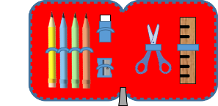  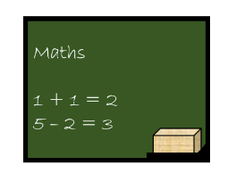 | ACROSS / HORIZONTAL:  3: Bleistift  5: Schultasche  6: Tafel  9: Lineal  10: Stift  DOWN / VERTIKAL:  1: Mäppchen  2: Klassenzimmer  4: Radiergummi  7: Mülleimer  8: Schüler
EXERCISE 2 Personal pronouns. Setze das richtige Objektpronomen ein:
them – me – us – you – her – him
TIPP:
Subjektpronomen stehen in einem Satz vor dem Verb: I am from London. (Ich bin aus London.)
Objektpronomen stehen nach dem Verb: Come and visit me! (Komm und besuch mich!)
Die Pronomen im Englischen lauten:
I – me; you – you; he – him; she – her; it – it; we – us; they – them.
a) Susan is in the garden. Can you see ___________________ (Susan)?
b) We need some help. Can you help ___________________ (uns)?
c) The boy is playing the piano. Can you hear ____________________ (the boy)?
d) You are all alone. Can I help _____________________ (dir)?
e) Tim and Bob are outside. Let’s call ____________________ (Tim and Bob).
f) I want to play. Do you want to play with _____________________ (mir)?

Lösung
EXERCISE 1 Wörter aus der Schule.
1 pencil case, 2 classroom, 3 pencil, 4 rubber, 5 school bag, 6 blackboard, 7 bin, 8 pupil, 9 ruler, 10 pen
EXERCISE 2
a) Susan is in the garden. Can you see her?
b) We need some help. Can you help us?
c) The boy is playing the piano. Can you hear him?
d) You are all alone. Can I help you?
e) Tim and Bob are outside. Let’s call them?
f) I want to play. Do you want to play with me?

Images and crossword puzzle: © www.englischtipps.com – CC-BY 4.0

