Activities 13 - Halloween
EXERCISE 1 Kreuze die richtigen Antworten an.
1 On Halloween, people carve pumpkins and put lights in them. What are these pumpkin lanterns called?  - Jack-o-Lantern  - Mike-o-Lantern  - Maggie-o-Lantern | 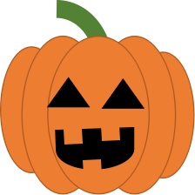 | 2 Which country is Halloween originally from?  - The USA  - France  - Ireland
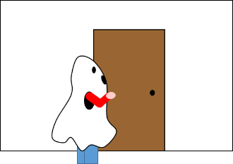 | 3 Children go from door to door and ask for candy. This tradition is called ...  - Joke-or-Sweets  - Trick-or-Treating  - Door-Ringing | 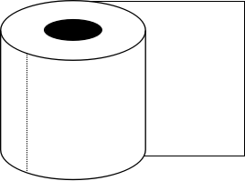 | 4 If your Halloween costume is made only of toilet paper, you are probably dressed up as a ...  - werewolf  - mummy  - vampire
5 The witch Esmeralda has three pets: a bat, a cat and a spider. How many legs do her pets have together?  - ten  - sixteen  - fourteen | 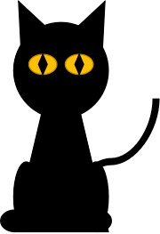 | 6 Which of the following is still alive?  - A skeleton  - A wizard  - A ghost | 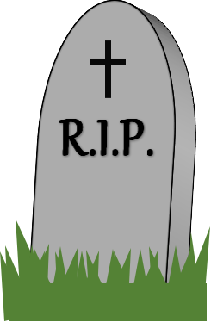

VOCABULARY 2 Setze die Halloween-Begriffe aus den Buchstabenblöcken in der grauen Box zusammen. Jeder Buchstabenblock darf nur einmal benutzt werden. Die lila unterlegten Felder ergeben als Lösungswort ein sehr bekanntes Monster!
BAT ● BER ● CAN ● COS ● DER ● DY ● GHO ● KIN ● LE ● MUM ● MY ● OC ● PIRE ● PUMP ● SPI ● SKE ● ST ● TO ● TON ● TUME ● VAM ● WERE ● WI ● WOLF ● ZARD

1 It’s sweet and tasty. |  |  |  |  |  |  | C | A | N | D | Y
2 He/She is afraid of the full moon.
3 A monster from Egypt.
4 An orange vegetable.
5 The spirit of a dead person.
6 A small animal with eight legs.
7 People who can do magic: witches and ...
8 They drink blood.
9 Halloween is in this month.
10 When you dress up, you wear a...
11 It’s inside your body.
12 An animal that flies at night.

The name of the famous monster is: ___________________________________________________

Lösung
EXERCISE 1 1a, 2c, 3b, 4b (mummy = Mumie), 5c (bat = Fledermaus (2 Beine), cat = Katze (4 Beine), spider = Spinne (8 Beine)), 6b (wizard = Zauberer)
EXERCISE 2 1 candy (Süßigkeiten), 2 werewolf (Werwolf), 3 mummy (Mumie), 4 pumpkin (Kürbis), 5 ghost (Geist), 6 spider (Spinne), 7 wizard (Zauberer), 8 vampire (Vampir), 9 October (Oktober), 10 costume (Kostüm), 11 skeleton (Skelett), 12 bat (Fledermaus)
Lösungswort: Count Dracula (Graf Dracula)

