Reducing your carbon footprint

EXERCISE 1 You’re going to watch a video about the carbon footprint of products. Before watching, discuss in class:
- What do you know about carbon dioxide (= CO2) and its effect on the environment?
- How are people trying to reduce the amount of CO2 that is released into the atmosphere?

EXERCISE 2 Vocabulary. Fill in the blanks with the words from the box. Use a dictionary if necessary.

polluted ● petrol station ● factories ● to manufacture ● delivered ● footprints ● emit

- You can buy fuel for your car at a ______________.
- ‘To produce’ is another word for ‘______________’.
- You can order products online and have them ______________ to your home.
- Cars ______________ a lot of CO2.
- When you walk along the beach, you leave ______________ in the sand.
- Most goods these days are produced in ______________.
- This part of the ocean has been ______________ by an oil spill. Many sea birds and fish have died.

EXERCISE 3a Describe the following pictures from the video. You can use the words from exercise 1.
(Video and images by simpleshow, CC BY 3.0, via Wikimedia Commons)

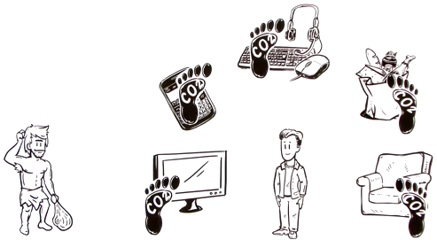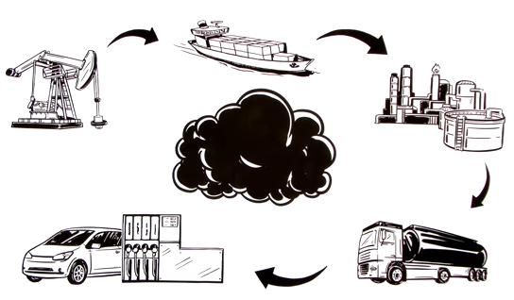

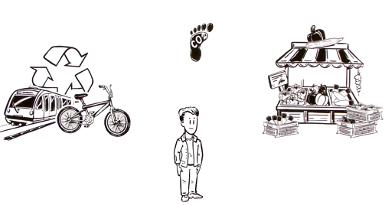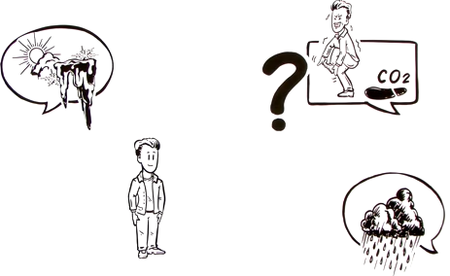

3b Now decide which picture goes with which quote (A-D) from the video. Give reasons for your choice.
- „You’ve probably been hearing a lot about climate change and how you should reduce your carbon footprint. But what is that exactly?“
- „So unless you live in a cave, everything you own has its carbon footprint.“
- „Consider the carbons that are emitted just to get the fuel into the tank.“
- „Think about your actions and choices, and you’ll be able to reduce your carbon footprint after all.“

EXERCISE 4 Now watch the video (→ Wikimedia Commons) and decide if the following statements are true or wrong. Explain your choice.  - All your actions that produce CO2 emissions increase your carbon footprint.  - When you drive your car, the only carbons you release come from the engine.  - Reading a book reduces your carbon footprint.  - Apples may have grown a far away from the supermarket where they are sold.  - Everybody who tries hard enough can reduce their carbon footprint to zero. | simpleshow, CC BY 3.0, via Wikimedia Commons

EXERCISE 5 With a partner, make a list with tips for consumers who want to reduce their carbon footprints. You can use the internet to find more information. Afterwards discuss:
- In your opinion, which tips are the best?
- Which are the easiest / the hardest to follow?
- Are you likely to follow any of the suggestions in the future? If so, which one(s)?

Answer Key

EXERCISE 1 You’re going to watch a video about the carbon footprint of products. Before watching, discuss in class:
- E.g. released when you burn things (wood, oil, gas ...), humans breathe out CO2, contributes to global warming / climate change
b) cycling / using public transportation instead of driving, using electric cars

EXERCISE 2 petrol station, b) to manufacture, c) delivered, d) emit, e) footprints, f) factories, g) polluted

EXERCISE 3a Before watching, describe the following pictures from the video. You can use the words from exercise 1.
- On the left, there’s a cavement with a club. On the right, there’s a modern human. He is surrounded by objects (a TV/screen, a calculator, a keyboard, mouse and headset, a bag of groceries and an armchair. There is a black footprint labelled ‘CO2’ on each product.
- In this picture, you can see how fuel is extracted from the earth, then shipped to a factory and finally taken to a petrol station. A car is parked next to a gas pump. There are four arrows connecting the steps. In the center, there is a large black cloud.
- In the third picture, you can see the same person as in the first picture. There is another carbon footprint symbol above his head. To his left, there are several symbols that represent environmentally friendly behaviors (travelling by train / bike, recycling). To his right, there is a market stall with different foods.
- The last picture shows the same man. He is surrounded by three speech bubbles. One shows a sun, a cloud and some icicles. The one in the top-right corner shows a man standing on one foot. He seems to be shaking and holding his foot. There is a carbon footprint symbol right behind him and a question mark next to this speech bubble. The last speech bubble shows a rain cloud.

3b Now decide which picture goes with which quote (A-D) from the video. Give reasons for your choice.
- You’ve probably been hearing a lot about climate change and how you should reduce your carbon footprint. But what is that exactly? - These two sentences go with the last picture. Two of the speech bubbles show symbols that might represent climate change. The question mark indicates an open question.
- So unless you live in a cave, everything you own has its carbon footprint. - The first picture shows a cave man (who lives in a cave) and a man who owns a lot of things which are all marked with a carbon footprint symbol.
- Consider the carbons that are emitted just to get the fuel into the tank. - This sentence goes with the second picture, as you can see a car next to a gas pump. The picture also shows how the fuel gets to the gas station.
- Think about your actions and choices, and you’ll be able to reduce your carbon footprint after all. - The third picture shows several environmentally friendly choices that the man can make.

EXERCISE 4 Now watch the video and decide if the following statements are true or wrong. Explain your choice.
- All your actions that produce CO2 emissions increase your carbon footprint. - true
- When you drive your car, the only carbons you release come from the engine. - wrong; the production and delivery of the gas causes lots of emissions
- Reading a book reduces your carbon footprint. - wrong; producing and delivering books also causes emissions
- Apples may have grown a far away from the supermarket where they are sold. - true; it says that the apples may have travelled thousands of miles to the supermarket
- Everybody who tries hard enough can reduce their carbon footprint to zero. - no; the video says it’s almost impossible

EXERCISE 5 Examples: Using public transportation instead of taking the car, eating less meat, using your electronics less, buying regional/seasonal products, buying used products / avoid waste

Example: For me, using public transportation is easy because we don’t even have a car. Eating less meat also wouldn’t be such a big problem, either, though I’d find it really hard not to eat any meat at all because I really like chicken nuggets. Using my electronics less would be the hardest for me because I use my phone and laptop a lot; I also need it for school. I could ask my parents to buy more regional products, but I think it would make shopping more stressful. You’d need to plan ahead where you’re going to shop. So I’m not sure they’d do it. However, they do like buying used products because it’s also cheaper.

VOCABULARY

atmosphere
carbon
cave
delivery
distribute (v)
emit (v)
engine
factory
footprint
fossil fuel
gas
manufacture (v)
oil
petrol station
pollution
put (v) the boot in sth.
reduce (v)
refinement
release (v)
transportation
utensil

