World Food Production Also Having Big Effect on Climate Change
EXERCISE 1a Describe the graph below (Data source: https://www.bbc.com/news/science-environment-46459714). The phrases from the box can help you.
1b What do you think: Why do the carbon footprints of the foods in the graph differ so much?
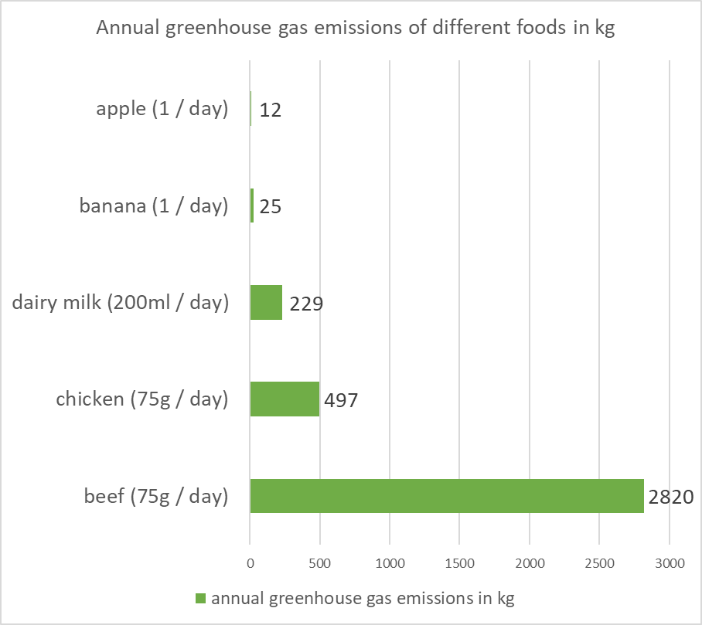
Describing charts & graphs
- The graph shows / indicates / illustrates …
- It compares …
- You can easily see that …
- … is responsible for the largest amount of …
- … causes (by far/slightly) more/fewer greenhouse emissions than …
- … is in first/second/last place.
Speculating about reasons
- A reason for … could be that …
- Maybe the amount of emissions is linked to …
- … might also affect / have an influence on the C0₂ footprint of ...
EXERCISE 2a Skim the text and tick the sections of the text ([A]-[D]) in which the following questions (a-f) are answered. One of them is not answered in the text (tick [X]).
 | [A] | [B] | [C] | [D] | [X]
- Why does food production have an effect on climate change? | □ | □ | □ | □ | □
- What are positive side effects of reducing the CO₂ footprint of food production? | □ | □ | □ | □ | □
- How many CO₂ emissions can we avoid by tackling the problem? | □ | □ | □ | □ | □
- Which fruits and vegetables cause the least CO₂ emissions? | □ | □ | □ | □ | □
- How many CO2 emissions do we have to save to reach the U.N. climate goals? | □ | □ | □ | □ | □
- Who was involved in the study? | □ | □ | □ | □ | □
2b Now answer the questions from 2a in your own words.
2c Now read the text again. The five sentences below are missing from the text. Match the sentences (a-e) and the gaps in the text (❶ -❺). Explain your choice.
STUDY TIP
This exercise asks you to look at words that make connections between sentences. Look for:
- Pronouns (he, she, they …)
- Words that connect sentences logically (e.g. contradiction (but, however) or reason (because))
- Structuring words (“first … second”, “for example”, “in the following” …)

- The researchers predict that even if fossil fuel emissions were halted now, emissions from the world food system would make it impossible to reach current international climate change targets.
- He said in a statement that the research clearly demonstrates that food has a much greater effect on climate change than is widely known.
- Most of the efforts aimed at reducing climate change center on reducing the use of fossil fuels.
- Other causes include land-clearing operations and deforestation.
- The study makes the following predictions:

World Food Production Also Having Big Effect on Climate Change
November 15, 2020 | Bryan Lynn
1  5  10  15  20  25 | [A] ❶ But a new study warns that pollution caused by the world’s food production system is also a major driver of rising temperatures on the planet.  The study found that if the world food system stays on its current growth path, it will produce nearly 1.4 trillion metric tons of greenhouse gases over the next 80 years.  That pollution is expected to come from fertilizers used in agriculture, mismanaged soil, food waste and methane gas released from cows and other animals. ❷  [B] Researchers from the University of Minnesota and the University of Oxford in Britain led the study, which recently appeared in the publication Science.  ❸ They say that emissions from food production alone could push world temperatures past 1.5 degrees Celsius by the middle of this century and above 2 degrees Celsius by the end of the century.  A main goal of the 2015 United Nations Paris Agreement on climate change is to keep rises in the Earth’s temperature during this century to between 1.5 to 2 degrees Celsius. The U.N. has said that in order to stay below the 1.5 Celsius level, emissions must fall at least 7.6 percent each year through 2030.  The new study calls for immediate “improvements in farming practices, as well as changes in what we eat and how much food we waste,” to help reach the Paris Agreement goals. | 30  35  40  45  50  55 | Jason Hill is a professor of biosystems engineering at the University of Minnesota. He helped lead the study. ❹  [C] Hill also noted that fixing the problem would not require the world’s population to completely stop eating meat. “The whole world doesn’t have to give up meat for us to meet our climate goals,” he told the Associated Press. “We can eat better, healthier foods. We can improve how we grow foods. And we can waste less food.”  The researchers say such efforts are achievable and can also lead to many other improvements beyond controlling climate change. These include making humans healthier, reducing water pollution, improving air quality, preventing animal extinctions and improving farm profitability.  [D] ❺  A nearly complete change to a plant-rich diet around the world could cut nearly 650 billion metric tons of greenhouse gases.  If almost everyone ate the right number of calories based on age - around 2,100 calories a day for many adults - it would reduce emissions by about 410 billion metric tons.  If farming could reduce carbon levels - by using less fertilizer, managing soil better and doing better crop rotation - it would cut greenhouse gases by nearly 540 billion metric tons.  And if people wasted less food (…), emissions could be cut by about 360 billion metric tons.
EXERCISE 3 Your opinion: Do you agree with the demands from section [D]? In your opinion, do they go too far or not far enough? And do you think these goals can be achieved by 2030?
EXERCISE 4 Make a glossary of important technical terms from the text and add your own definitions.
Ex. Agriculture: farming (growing crops and keeping animals)

EXERCISE 5 Imagine you’re starting an initiative to combat climate change. Make a brochure to educate members of your community about the effect that food has on climate change. Work in groups of 3-5 students.
5a In your group, decide which information you would like to include in the brochure, such as
- Information on your initiative and contact info,
- Reasons why people should be aware of their food’s carbon footprint,
- Practical tips: What do people need to watch out for when they buy food? How can they avoid food wastage?
- Links, further resources, etc.: Where can they find more information and help?
Don’t be afraid to get creative! You could also include ideas such as …
- A low-CO₂ recipe your readers can try at home,
- A quiz or contest where your readers can submit their answers (and maybe win a prize?)
- A QR code that links to a website with further information …
5b Now draw the layout of your brochure on a sheet of paper: Note down where the texts and pictures will go. Also, divide the tasks among yourselves. Don’t forget that you will also need a proof-reader and a designer who takes care of the pictures and the layout.
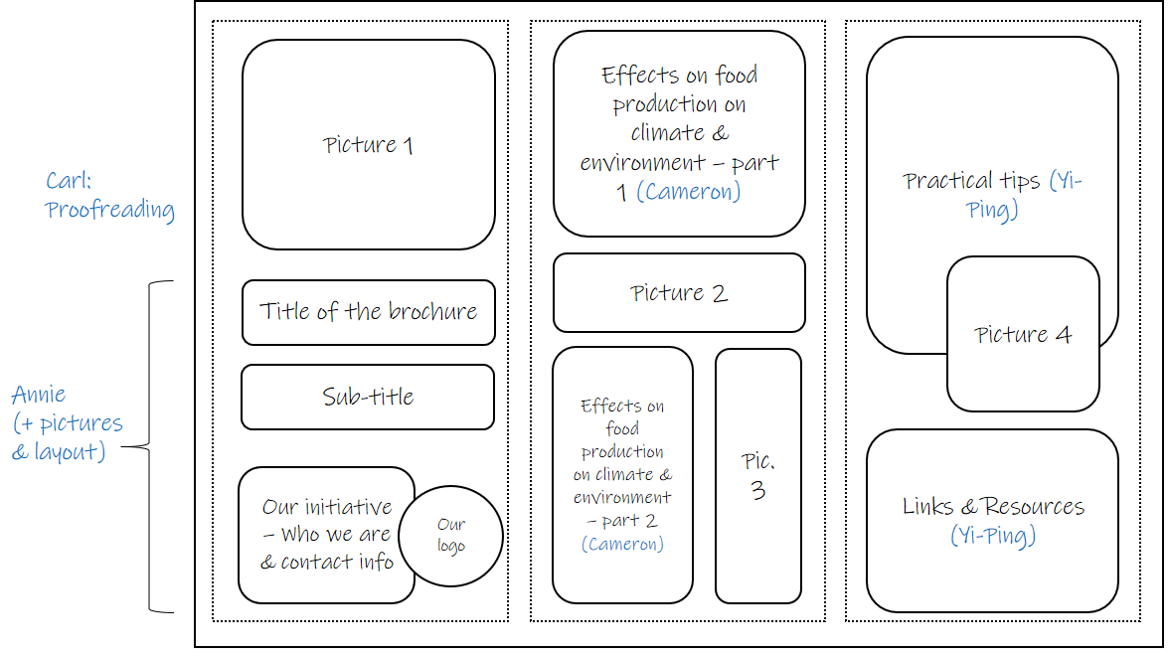
Important note on copyright:  - You can use the internet to search for information, but do not simply copy and paste images or text!  - Writers: Use your own words!  - Designers: Use pictures you have taken yourself, which are in the public domain or which have been published under a Creative Commons (cc) licence. You can find suitable pictures on pages like Wikimedia Commons. Don’t forget to reference the author, platform, and licence. You can see an example of such a citation in the picture on the right. | 

Vocabulary list
agriculture
aimed at
carbon
climate change
crop
crop rotation
current
to cut
deforestation
to be a driver of
effort
emission
engineering
extinction
fertilizer
greenhouse gases
growth
to halt
methane
mismanage
to release
to rise
pollution
practice
to predict
to prevent
profitability
soil
to reduce
(to) waste

Answer key
EXERCISE 1ab The graph shows the annual greenhouse gas emissions of different foods. You can easily see that there are huge differences between the different products. For example, apples produce very few emissions (12 kg per year), whereas beef is responsible for the largest amount of emissions (2820 kg). A reason for this may be that beef is much more expensive to produce. The cows need to be fed for quite some time before they are ready to be killed and eaten. You can also see that bananas produce more emissions than apples. A reason for this difference might be that they can’t be grown locally and have to transported, which also releases CO2.
1b What do you think: Why do the carbon footprints of the foods in the graph differ so much?

EXERCISE 2a Skim the text and tick the sections of the text ([A]-[D]) in which the following questions (a-f) are answered. One of them is not answered in the text (tick [X]).
 | [A] | [B] | [C] | [D] | [X]
- Why does food production have an effect on climate change? | ☑ | □ | □ | □ | □
- What are positive side effects of reducing the CO₂ footprint of food production? | □ | □ | ☑ | □ | □
- How many CO₂ emissions can we avoid by tackling the problem? | □ | □ | □ | ☑ | □
- Which fruits and vegetables cause the least CO₂ emissions? | □ | □ | □ | □ | ☑
- How many CO2 emissions do we have to save to reach the U.N. climate goals? | □ | ☑ | □ | □ | □
- Who was involved in the study? | □ | ☑ | □ | □ | □
2b Now answer the questions from 2a in your own words.
2c Now read the text again. The five sentences below are missing from the text. Match the sentences (a-e) and the gaps in the text (❶ -❺). Explain your choice.
- The researchers predict that even if fossil fuel emissions were halted now, emissions from the world food system would make it impossible to reach current international climate change targets. - [3]
- He said in a statement that the research clearly demonstrates that food has a much greater effect on climate change than is widely known. - [4]
- Most of the efforts aimed at reducing climate change center on reducing the use of fossil fuels. - [1]
- Other causes include land-clearing operations and deforestation. - [2]
- The study makes the following predictions: [5]

2d Your opinion: Do you agree with the demands from section [D]? In your opinion, do they go too far or not far enough? And do you think these goals can be achieved by 2030?
Example: I absolutely agree with the text that it’s very important to try and reach these goals. Knowing that such a large share of the emissions are caused by food production, we just can’t ignore this factor if we want to combat climate change. In addition, the measures suggested in the text would also be beneficial to people and animals. Reducing your calorie intake might also help reduce obesity. However, I don’t think we’ll be able to reach these goals by 2030. We’re just so used to eating lots of meat and throwing away food that many people will find it very hard to change their behavior.
EXERCISE 4 see vocabulary list
EXERCISE 5 individual answer

https://learningenglish.voanews.com/a/world-food-production-also-having-big-effect-on-climate-change/5658495.html last accessed on 23/04/2021

