A postcard from Edinburgh
Rob is on holiday in Scotland. He has written a postcard to his friend Emma. Read the postcard and decide which picture (A, B or C) is on the back of the card.
Dear Emma, June 24  My mum and I are spending a few days in Edinburgh. We’re having a great time because there are so many things to do here! Yesterday it was a bit cold and rainy, so we visited Edinburgh Castle. We learned a lot about the city’s history there. You can see the castle in the picture on the postcard. Doesn’t it look cool? Only one thing happened that was NOT cool: When we were leaving the castle, someone tried to steal my bag! Luckily, I noticed him just in time, and he ran away!  Today it’s sunny and warm – perfect for a walk in the center. And tomorrow we’re going to visit the Edinburgh Dungeon - a scary museum about Edinburgh’s history! I’m excited!  I hope you’re enjoying your holidays, too!  See you next week!  Love, Rob | Emma Brook  39 Catherine Grove  LONDON_______________  SE10 8BG______________

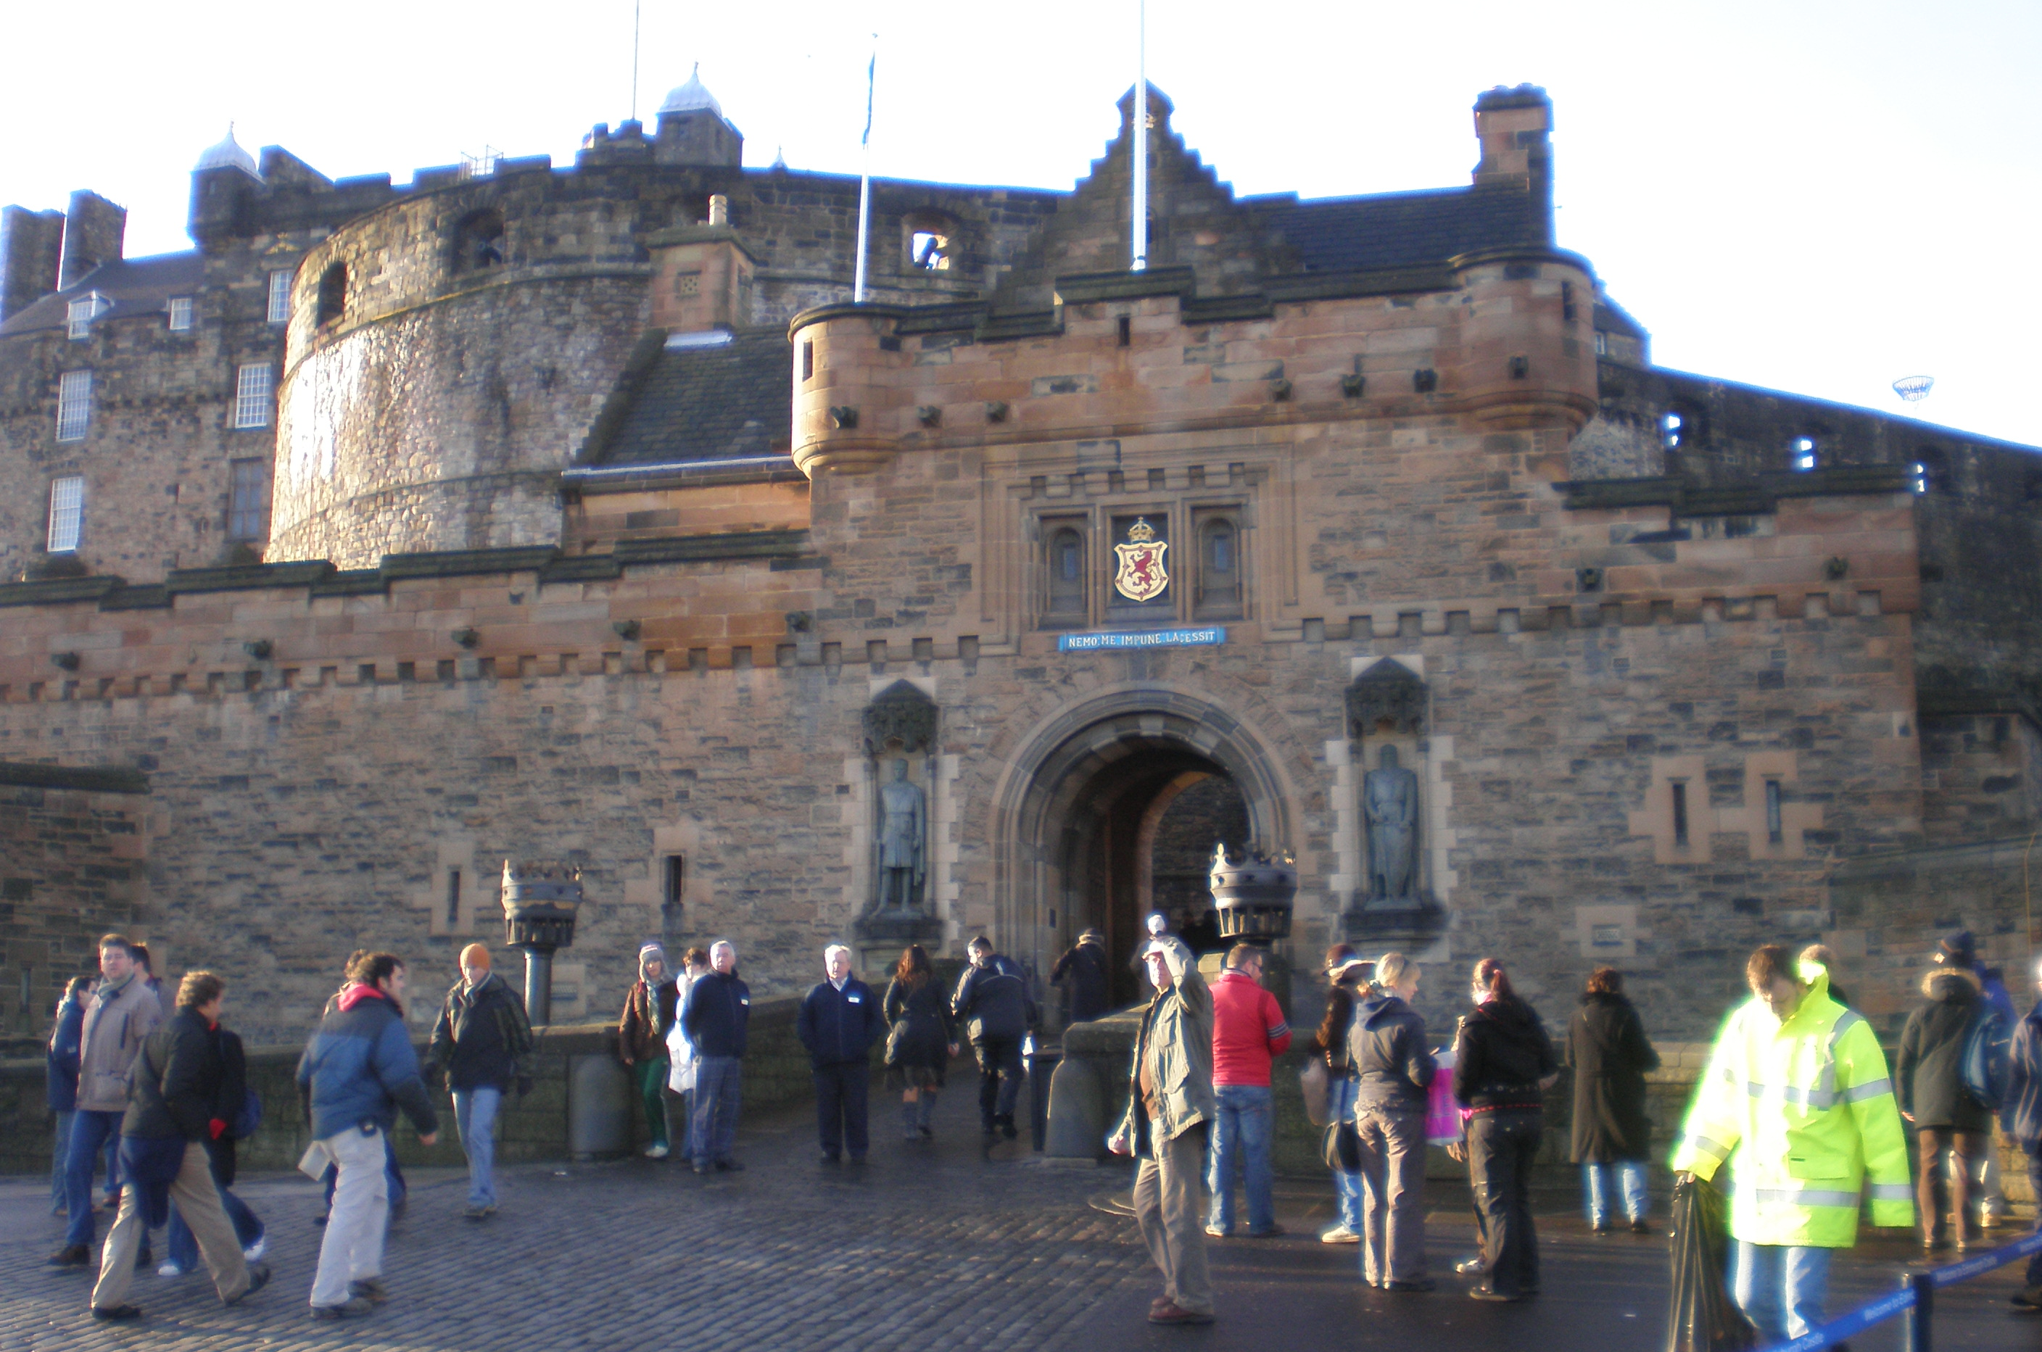  Picture A | 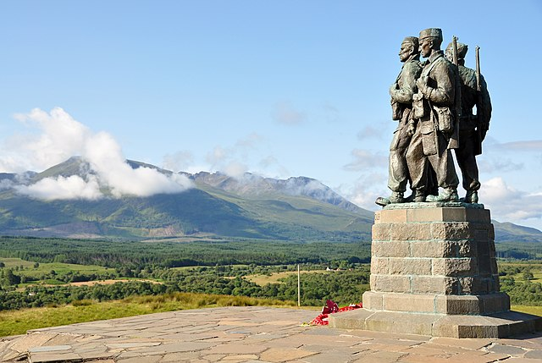  Picture B | 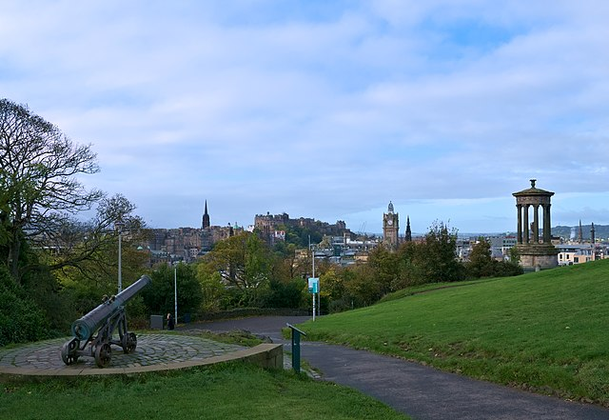  Picture C
Chris Sherlock (Ta bu shi da yu), CC BY-SA 3.0, via Wikimedia Commons | Nilfanion, CC BY-SA 3.0 , via Wikimedia Commons | Daniel Kraft, CC BY-SA 3.0, via Wikimedia Commons

EXERCISE 2 Emma’s mum wants to know what Rob wrote about. Tick “yes” or “no”. Then answer the questions in full sentences.
Example: a) Yes, he did. He said was cold and rainy the day before, but it was sunny and warm when he wrote the card.
 | YES | NO
a) “Did he say what the weather is like?” | ☑ | □
b) “Did he say anything about the food?” | □ | □
c) “Did he say that he likes it there?” | □ | □
d) “Did anything special happen to him?” | □ | □
e) “Did he say who is with him?” | □ | □
f) “Did he say anything about the nice picture on the postcard?” | □ | □
g) “Did he say if the hotel is ok?” | □ | □
h) “Did he say when he wrote the postcard?” | □ | □
i) “Did he say what he has already done?” | □ | □
j) “Did he say what he’s going to do soon?” | □ | □

EXERCISE 3 Complete the crossword puzzle with words from the text.
- This city is the capital of Scotland.
2. Today it's ***. You should take an umbrella!
3. 500 years ago, a king lived in this ***.
4. I need some fresh air. Let's go for a *** outside.
5. Ghosts and vampires are ***.
6. I really *** our trip. It was so much fun!
7. It's really *** today. Don't forget your sun creme!
8. In summer, we always go on ***.
9. I love museums because I'm interested in ***.
10. Yesterday, today, ***

Answer key
EXERCISE 1 It’s Picture A.
EXERCISE 2
 | YES | NO
a) “Did he say what the weather is like?” | ☑ | □
b) “Did he say anything about the food?” | □ | ☑
c) “Did he say that he likes it there?” | ☑ | □
d) “Did anything special happen to him?” | ☑ | □
e) “Did he say who is with him?” | ☑ | □
f) “Did he say anything about the nice picture on the postcard?” | ☑ | □
g) “Did he say if the hotel is ok?” | □ | ☑
h) “Did he say when he wrote the postcard?” | ☑ | □
i) “Did he say what he has already done?” | ☑ | □
j) “Did he say what he’s going to do soon?” | ☑ | □

- Yes, he did. He said was cold and rainy the day before, but it was sunny and warm when he wrote the card.
- No, he didn’t.
- Yes, he’s having a great time.
- Yes, someone tried to steal his bag.
- Yes, his mum is with him.
- Yes, he says it’s a picture of Edinburgh Castle.
- No, he didn’t say anything about the hotel.
- Yes, he wrote it on June 24.
- Yes, he visited Edinburgh Castle and the center of the city.
- Yes, he’s going to visit the Edinburgh Dungeon.

EXERCISE 3
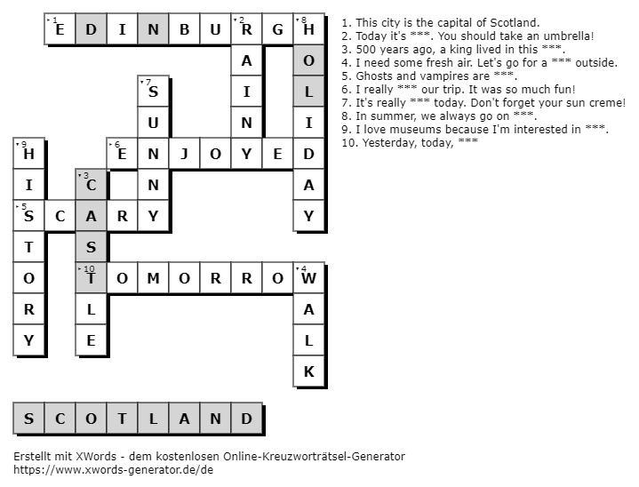

Created with xWords: https://www.xwords-generator.de/de

