Writing a postcard
TASK 1a Before you read: Have you ever written a postcard? What did you write about?
1b Now read the texts on the three postcards. Match the texts and the pictures on the next page.
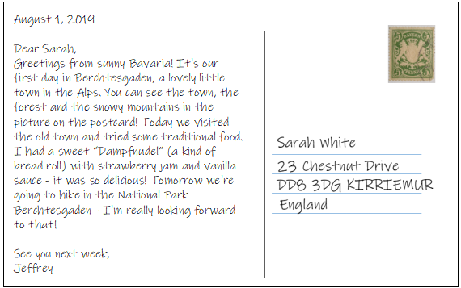
Pictures:
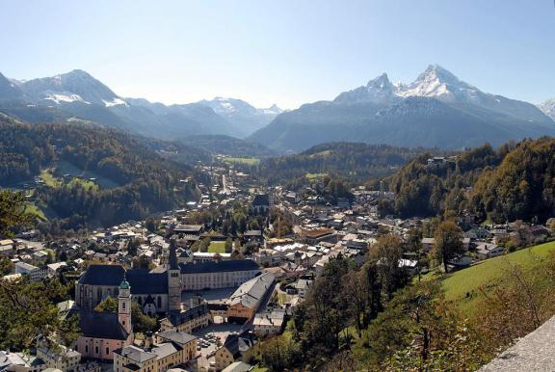  - By User: Bbb auf wikivoyage shared, CC BY-SA 3.0 | 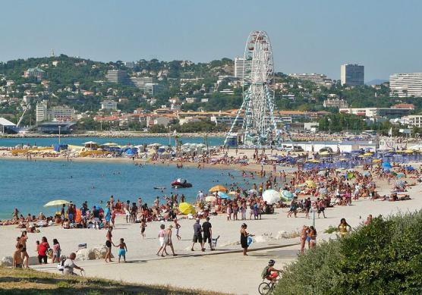  - By Ximonic, Simo Räsänen - Own work, CC BY 2.5 |  |  |  | 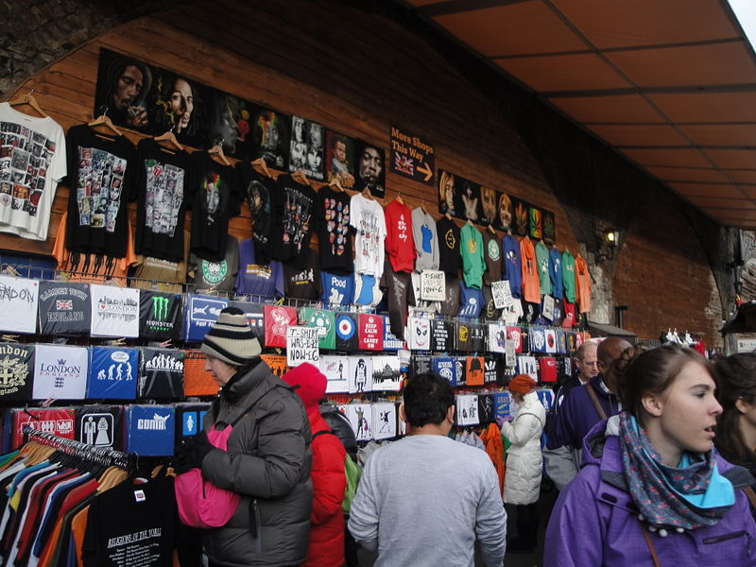  - By Editor5807 - Own work, CC BY-SA 3.0
TASK 2 Now read the texts again. Who answers these questions? Write + or - and mark the text passages in the postcards. |  | Sarah | Jeffrey |  |  | Christine
- Where are they? |  | + |  | + |  |  | +
- Who is on holiday with them?
- What have they done already?
- What are they going to do next?
- What’s the weather like?
- What’s the food like?
- What’s in the picture on the postcard?

3a Now write your own postcard. First, decide on a holiday destination - for example, a place you have visited before. Then find a nice picture for your postcard on the internet.
b Make a mindmap with information about your destination. You can also use the internet to look for information. Your mindmap can look like this:
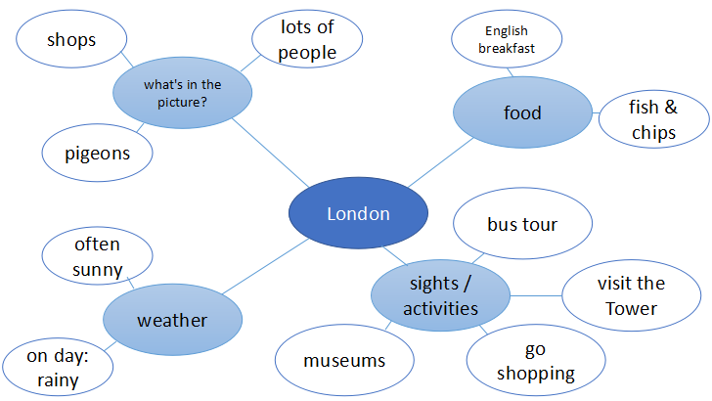
3c Now write your postcard. You can use the writing ideas aond useful phrases on the next page. Also, don’t forget to add the recipient’s name and address!
Some writing ideas… | … and some useful phrases
1. Say hi and write the date.  2. Say where you are.  3. Say who is with you.  4. Say where you have already been.  5. Say what you did there.  - Say how you liked it.  7. Say what’s in the picture.  8. Say if something surprising happened.  9. Say what the weather is like.  - Say what the food is like.  11. Say what you’re going to do soon.  12. Say goodbye and write your name. | June 15, 2018  Dear Tom, / Hi Tom!  Sarah and I are having a great time in Scotland at the moment.  It’s our second day in London.  My parents and I are staying at a nice hotel / camp side in ...  Yesterday we went to … / visited …  We looked at / tried / learned a lot about … there.  After that, we went sightseeing / swimming / hiking and ...  It was lots of fun / fantastic / kind of boring / OK / terrible.  I really liked / loved / enjoyed the ...  However, the hotel / food / weather wasn’t great.  In the photo, you can see / there is …  You’re not going to believe this: When we were there, we suddenly saw / found a …  The weather is (not) great. It’s very sunny / rainy / windy / warm / cold…  I absolutely love / hate the food.  Today we had lunch at a nice little restaurant. I tried ...  Tomorrow we’re going to take a boat ride / a bus tour …  We want to visit ... next. I’m really looking forward to that!  Miss you! / I wish you were here, too!  Bye, … / Love, … / See you soon, …  Robert

Answer key
EXERCISE 1a Individual solution
EXERCISE 1b 1st postcard - picture C, 2nd postcard - picture A, 3rd postcard - picture B
EXERCISE 2
- Where are they? | + | + | +
- Who is on holiday with them? | + | - | +
- What have they done already? | + | + | +
- What are they going to do next? | - | + | -
- What’s the weather like? | - | + | -
- What’s the food like? | + | + | -
- What’s in the picture on the postcard? | - | + | +

EXERCISE 3 Individual solution
Pictures:
General Post Office of the United Kingdom of Great Britain and Ireland [Public domain]. https://commons.wikimedia.org/wiki/File:Penny_black.jpg, accessed on 23 March 2019.
Timbre Baviere armoiries relief 1867-1904. Public Domain, https://commons.wikimedia.org/w/index.php?curid=103256
Timbre français pour l'île de la Réunion (océan Indien), émis en 1907 et représentant une carte de l'île. Dessiné et gravé par MM. Chauvet et Puyplat. Public Domain, https://commons.wikimedia.org/w/index.php?curid=82750
Camden Market, Camden (borough), London. By Editor5807 - Own work, CC BY-SA 3.0, https://commons.wikimedia.org/w/index.php?curid=28399279
Berchtesgaden: Zentrum vorne Schloss, Schlossplatz mit Stiftskirche und direkt links davon kath. Kirche St.Andreas. Hintergrund: Berchtesgadener Alpen, Blickrichtung Königssee. By User: Bbb auf wikivoyage shared, CC BY-SA 3.0, , https://commons.wikimedia.org/w/index.php?curid=22656891
A beach in southern Marseille in 2009 July. By Ximonic, Simo Räsänen - Own work, CC BY 2.5, https://commons.wikimedia.org/w/index.php?curid=7939971

