Tenses Quartets

Für: 4 Spieler
Übt: Fragen und Kurzantworten in verschiedenen Zeiten formulieren
Dauer: ca. 10-15 Minuten
Enthält: 32 Quartettkarten, vier Set-Listen, Arbeitsblatt zur Einführung der Spielregeln

Regeln:
1. Jeder Spieler erhält die auf Seite 4 abgedruckte Liste mit den Karten und 8 Karten. Anmerkung: Man kann das Spiel natürlich auch zu dritt oder zu fünft spielen. Dann haben einige Spieler eine Karte mehr als andere.
2. Das Ziel des Spiels ist es, möglichst viele Quartette (z.B. alle vier Karten aus dem Bereich „HOUSE“) abzulegen. Das Spiel endet, wenn alle Quartette gesammelt wurden.
3. Der jüngste Spieler beginnt. Er / sie darf einen beliebigen Mitspieler mithilfe der Liste fragen, ob er eine Karte besitzt. Dazu muss er oder sie eine bestimmte, vereinbarte Zeit verwenden (z.B. present perfect): „Tim, have you bought a new shirt?“
4. Wenn Tim die Karte “buy a new shirt” besitzt, so antwortet er “Yes, I have” und muss die Karte an den ersten Spieler abgeben. Dieser darf dann noch einmal fragen. Wenn Tim sie nicht hat, sagt er „No, I haven’t“, und der nächste Spieler ist an der Reihe.
5. Wer vier Karten aus einer Kategorie zusammen hat, darf sie vor sich ablegen. Der Spieler, der am Ende die meisten Quartette hat, gewinnt.
6. Alternative für fortgeschrittene Spieler: Die Fragen müssen in unterschiedlichen Zeiten gestellt werden. Hier könnte man z.B. einen Zeitenwürfel (1 = simple present, 2 = present progressive, 3 = simple past …) einsetzen.

Hinweis für Lehrkräfte:
Zur Einführung des Spiels kann die Anleitung auf Seite 5 verwendet werden. Obwohl das Spiel Quartett den meisten Schüler*innen bekannt sein dürfte, ist es sinnvoll, im Vorfeld noch einmal die Regeln zu klären. Eine weitere Anmerkung: Die Regeln des Spiels unterscheiden sich je nach Land bzw. Region; hier wurden der Einfachheit halber die Regeln des deutschen Quartetts verwendet.

 |   At home | At home |  | At home |  | At home
 | wash the dishes  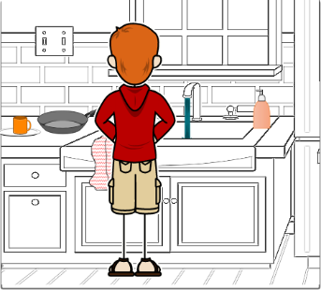 | tidy up your room  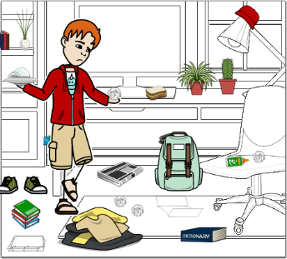 |  | help mum in the garden  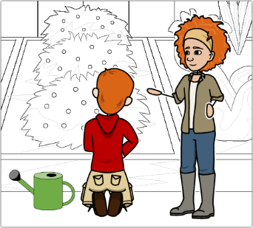 |  | clean the bathroom  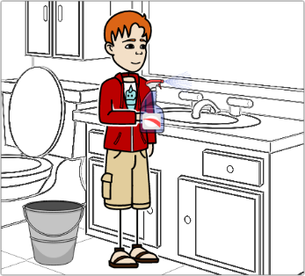
 |   Food | Food |  | Food |  | Food
 | eat an apple  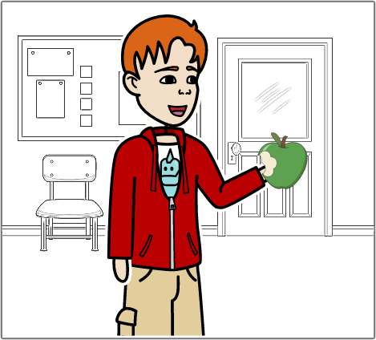 | drink milk  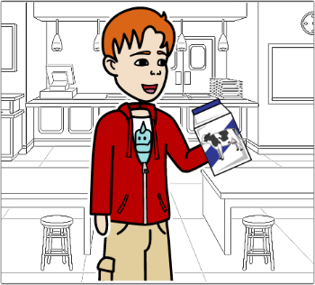 |  | make a pie  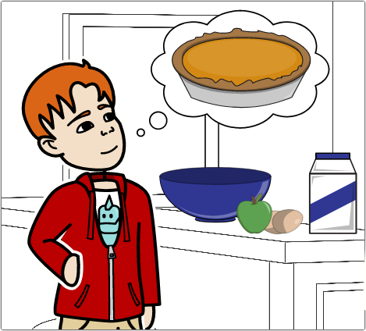 |  | have lunch  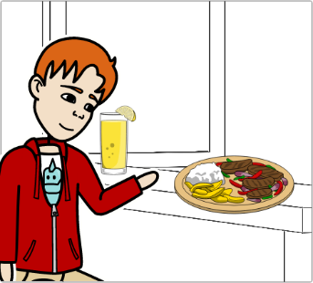
 |   Media | Media |  | Media |  | Media
 | read a book  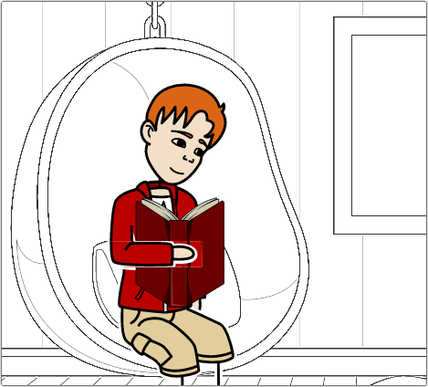 | listen to music  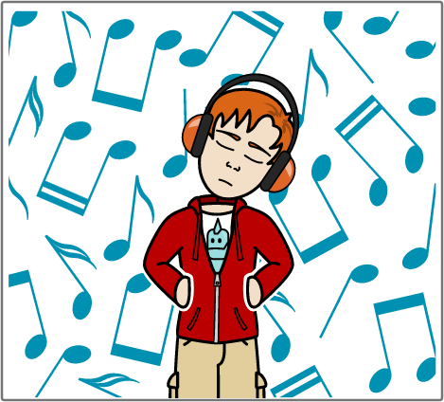 |  | go to the cinema  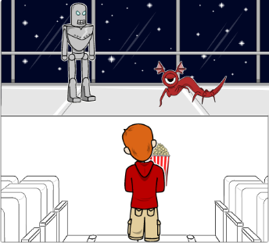 |  | watch TV  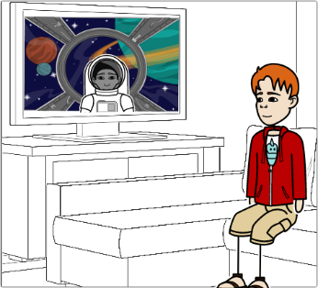
 |   Sports | Sports |  | Sports |  | Sports
 | play football  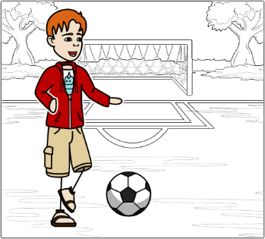 | swim in the lake  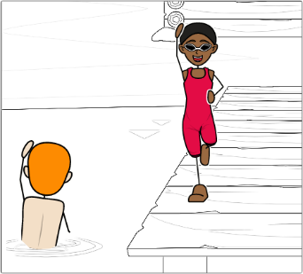 |  | ride your bike  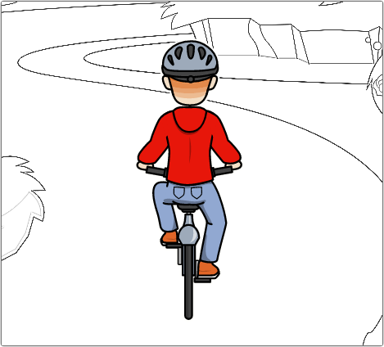 |  | skate  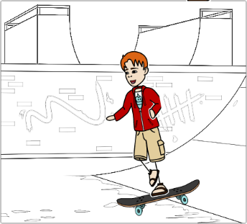
 |   School | School |  | School |  | School
 | go to school  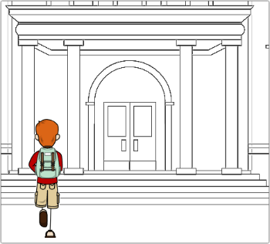 | do your homework  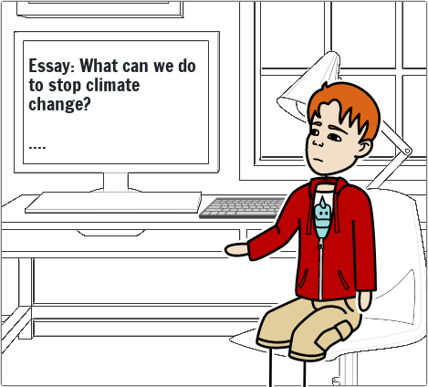 |  | study for a test  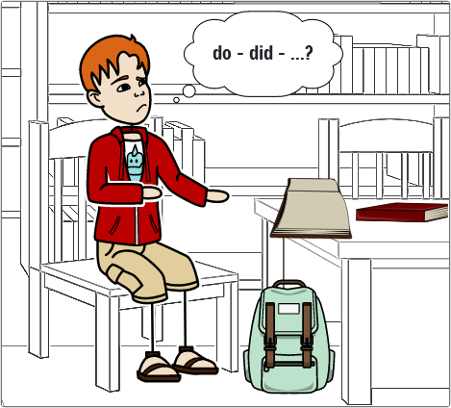 |  | look up a word  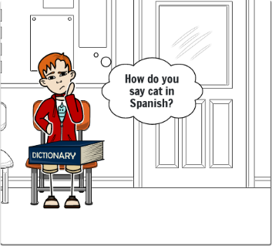
 |   Communication | Communication |  | Communication |  | Communication
 | call a friend  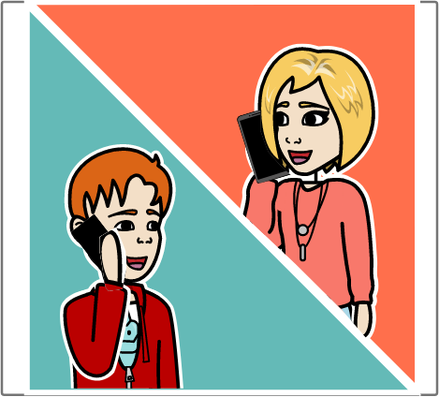 | text Josh  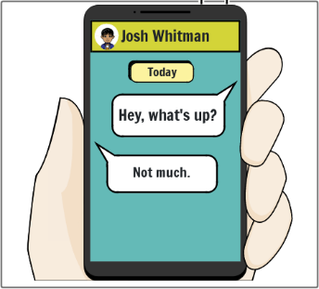 |  | talk to the teacher  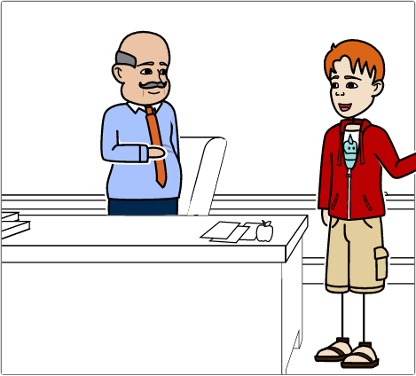 |  | write a letter  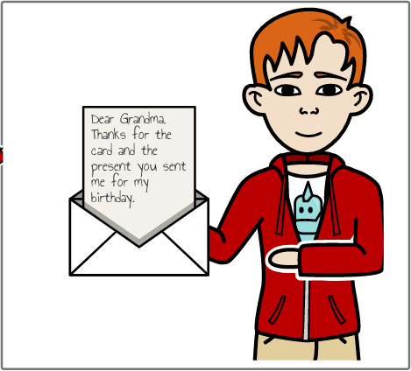
 |   Clothes | Clothes |  | Clothes |  | Clothes
 | buy a new shirt  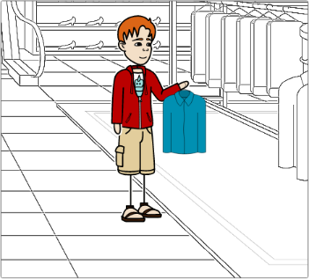 | put on your shoes  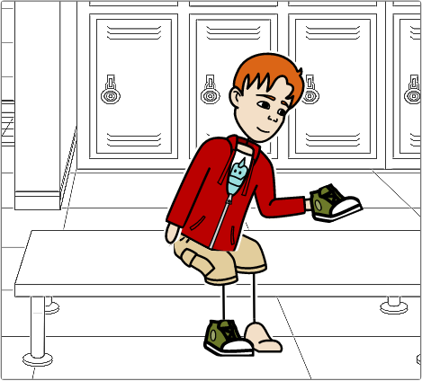 |  | try on Ben’s jacket  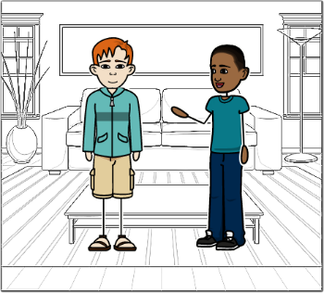 |  | wear a hat  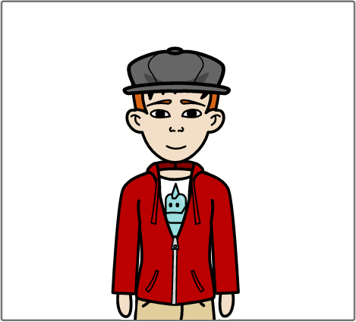
 |   Travel | Travel |  | Travel |  | Travel
 | visit a museum  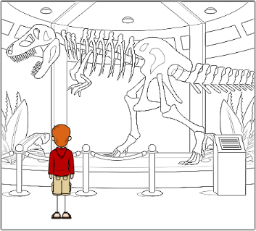 | travel by plane  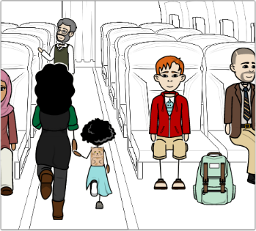 |  | go sightseeing  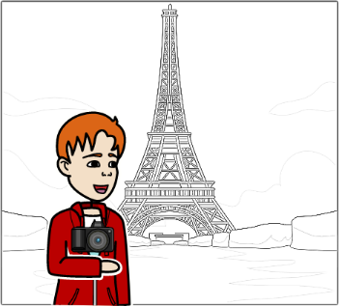 |  | stay at a hotel  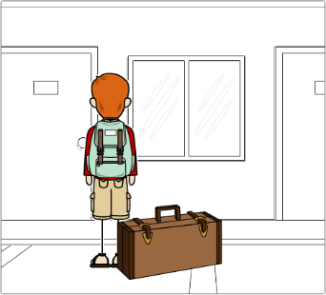
List of the sets
At home |  |  | Food |  | Media |  | Travel
□ wash the dishes  □ tidy up your room  □ help mum in the garden  □ clean the bathroom |  |  | □ eat an apple  □ drink milk  □ make a pie  □ have lunch |  | □ read a book  □ watch TV  □ go to the cinema  □ listen to music |  | □ visit a museum  □ go sightseeing  □ travel by plane  □ stay at a hotel
Sports |  |  | Clothes |  | School |  | Communication
□ play football  □ swim in the lake  □ ride your bike  □ skate |  |  | □ put on your shoes  □ try on Ben’s jacket  □ buy a new shirt  □ wear a hat |  | □ go to school  □ do your homework  □ study for a test  □ look up a word |  | □ write a letter  □ call a friend  □ text Josh  □ talk to the teacher

List of the sets
At home | Food | Media | Travel
□ wash the dishes  □ tidy up your room  □ help mum in the garden  □ clean the bathroom | □ eat an apple  □ drink milk  □ make a pie  □ have lunch | □ read a book  □ watch TV  □ go to the cinema  □ listen to music | □ visit a museum  □ go sightseeing  □ travel by plane  □ stay at a hotel
Sports | Clothes | School | Communication
□ play football  □ swim in the lake  □ ride your bike  □ skate | □ put on your shoes  □ try on Ben’s jacket  □ buy a new shirt  □ wear a hat | □ go to school  □ do your homework  □ study for a test  □ look up a word | □ write a letter  □ call a friend  □ text Josh  □ talk to the teacher

List of the sets
At home | Food | Media | Travel
□ wash the dishes  □ tidy up your room  □ help mum in the garden  □ clean the bathroom | □ eat an apple  □ drink milk  □ make a pie  □ have lunch | □ read a book  □ watch TV  □ go to the cinema  □ listen to music | □ visit a museum  □ go sightseeing  □ travel by plane  □ stay at a hotel
Sports | Clothes | School | Communication
□ play football  □ swim in the lake  □ ride your bike  □ skate | □ put on your shoes  □ try on Ben’s jacket  □ buy a new shirt  □ wear a hat | □ go to school  □ do your homework  □ study for a test  □ look up a word | □ write a letter  □ call a friend  □ text Josh  □ talk to the teacher

List of the sets
At home | Food | Media | Travel
□ wash the dishes  □ tidy up your room  □ help mum in the garden  □ clean the bathroom | □ eat an apple  □ drink milk  □ make a pie  □ have lunch | □ read a book  □ watch TV  □ go to the cinema  □ listen to music | □ visit a museum  □ go sightseeing  □ travel by plane  □ stay at a hotel
Sports | Clothes | School | Communication
□ play football  □ swim in the lake  □ ride your bike  □ skate | □ put on your shoes  □ try on Ben’s jacket  □ buy a new shirt  □ wear a hat | □ go to school  □ do your homework  □ study for a test  □ look up a word | □ write a letter  □ call a friend  □ text Josh  □ talk to the teacher
How to play quartets
EXERCISE 1 You are going to play a game. Read the instructions below. Then look at the cartoon at the bottom of the page. Match the speech bubbles (A.-F.) and the texts ([1]-[6]).
Tenses Quartets is a card game for four players. There are eight sets of cards (32 cards in total) and a list of all the sets.
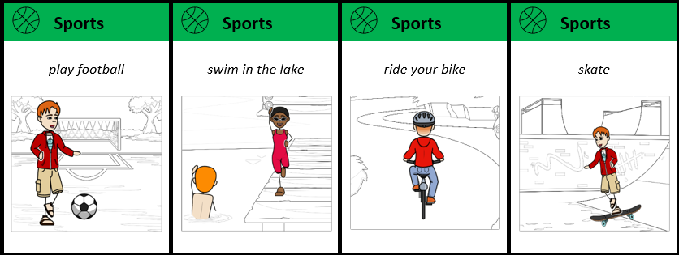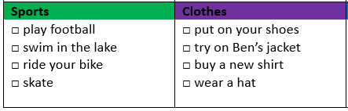
- Shuffle the cards and deal them to the players. In addition, each player gets a list of all the sets. Don’t let the other players see your cards!
- The goal of the game is to collect as many sets as possible. For example, when a player has the cards “ride your bike”, “swim in the lake” and “skate”, they may decide to collect all the cards from the sports set. On the set list, they can see that they’re missing the “play football” card.
- The youngest player goes first. They can ask any other player for a specific card. They have to use the words on the set list to ask a question. Your teacher will tell you which tense to use. For example, if your teacher tells you to use the simple present, a player could ask the following question:
Player A:
“Do you play football?”
- If the other player has that card, they have to pass the card to player A and player A gets another turn. If they don’t have it, it’s the next player’s turn. For example:
Player B:
“Yes, I do.” (→ Player B passes the card to player A and player A may ask any player for a different card.)
“No, I don’t.” (→ It’s the next player’s turn.)
- If you collect all cards from one set (“sports”, “media”, “school” …), you have to place the set in front of you.
- The game continues until all sets have been collected. The player with the most sets wins.
to shuffle: mischen; to deal: austeilen; a specific card: eine bestimmte Karte; to get another turn: noch mal dran sein

[1] No, I’m not. It’s Lia’s turn now. • [2] Hmm, I already have three cards from the “sports” set. Let me check the list to see which card I’m missing … oh, it’s “play football”. • [3] Great! Look, I’ve completed the “sports” set! And I get another turn. Boris, are you putting on your shoes? • [4] OK, it’s my turn. Let me think … • [5] Lia, are you playing football? • [6] Yes, I am. Here you go.
Example: Speech bubble A. goes with [4].

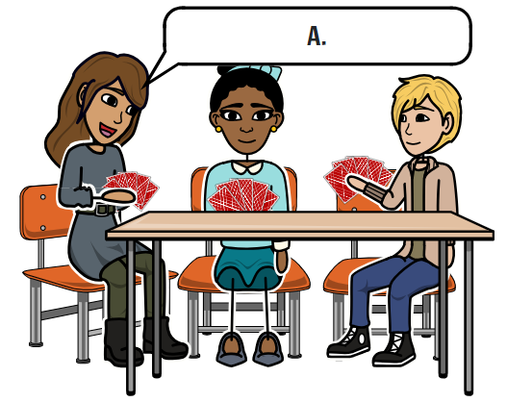 | 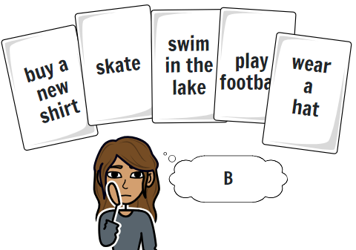 | 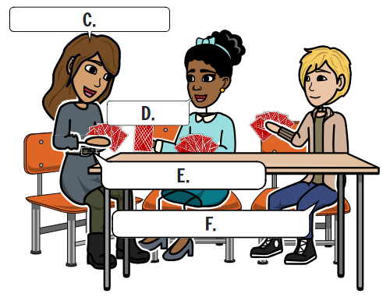

EXERCISE 2 One of your group members doesn’t understand the instructions. Answer their questions in German.
- “Wie viele Spieler können das Spiel spielen?“
- „Wie viele Karten bekommt jeder Spieler?“
- „Wer gewinnt das Spiel?“
- „Wie bekomme ich die Karten, die ich brauche?“
- „Wenn ich die Karte, die ich wollte, bekommen habe, ist dann der nächste Spieler an der Reihe?“
- „Was muss ich machen, wenn ich ein Set komplett habe?“
EXERCISE 3 Useful phrases for playing quartets. Connect the English phrases and the German translations.
1. It’s my turn now. |  | a. Wer ist dran?
2. Whose turn is it? |  | b. Hier, bitteschön.
3. I have completed a set. |  | c. Ich darf noch mal.
4. Here you go. |  | d. Ich habe ein Set zusammen.
5. I get another turn. |  | e. Lasst uns unsere Quartette zählen.
6. The game is over. |  | f. Ich bin jetzt dran.
7. Let’s count our quartets. |  | g. Hannah hat gewonnen.
8. Hannah’s the winner. |  | h. Das Spiel ist vorbei.

Answer key
EXERCISE 1 A4, B2, C5, D6, E3, F1
EXERCISE 2
- Vier Spieler.
- Jeder Spieler bekommt acht Karten (32 : 4 = 8).
- Die Person, die die meisten Quartette / Vierer-Sets sammelt, gewinnt das Spiel.
- Man fragt einen Spieler seiner Wahl. Wenn dieser die passende Karte hat, muss er sie einem geben.
- Nein. Wenn man die gewünschte Karte bekommen hat, darf man noch mal fragen.
- Man muss das Set vor sich offen auf den Tisch legen.
EXERCISE 3 1f, 2a, 3d, 4b, 5c, 6h, 7e, 8g

